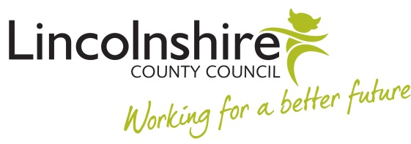

# LETTER 6 INVITE TO FINAL REVIEW MEETING

**STRICTLY PRIVATE & CONFIDENTIAL**

Dear

**FINAL PROBATION REVIEW MEETING**

In line with the Council’s Probation Procedure I am writing to invite you to a final Probation Review Meeting to be held *(date, time, location).*

Whilst this is a formal process, in order to minimise unnecessary formality and apprehension, the electronic, audio or video recording by any device of this meeting will not be permitted. Should you think that there are exceptional circumstances where this should be allowed (for instance, due to a disability) this should be raised in advance with the person due to conduct the meeting, the chair of the hearing or the relevant HR Adviser. Due consideration will then be given to your request and you will be advised of the outcome of that consideration.

Where the nominated note taker at meetings and/or hearings associated with the process feels it is necessary to make an audio recording in order to support with the preparation of the notes, the requirement to make the recording will be clarified with all present at the start of the meeting.

Please do not hesitate to contact me if you have any queries about the contents of this letter.

Yours sincerely

Manager