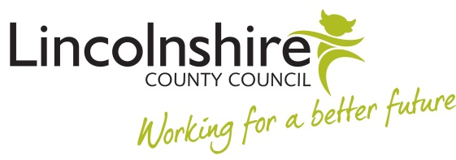

LETTER 4 TO EMPLOYEE RE PROGRESS REVIEW – IMPROVEMENTS MADE

STRICTLY PRIVATE & CONFIDENTIAL

Dear

PROBATION REVIEW: REVIEW MEETING
Following our meeting held on (date) to review progress against the action plan put in place to address concerns regarding your (performance/conduct/timekeeping/ sickness absence/attendance delete as appropriate) in your role, I am pleased to confirm that you have now achieved the expected level of (performance/conduct/timekeeping/ sickness absence/attendance delete as appropriate).
We will meet for a Final Probation Review Meeting on (date, time, and location) to review your continued progress. I must remind you that failure to maintain your improved performance by our next meeting may result in an extension to your probation period or dismissal.

I am pleased to acknowledge the commitment you have shown in achieving the improvement plan and reiterate that you must consistently continue to perform at this acceptable level.

Please do not hesitate to contact me if you have any queries about the contents of this letter.

Yours sincerely

Manager

