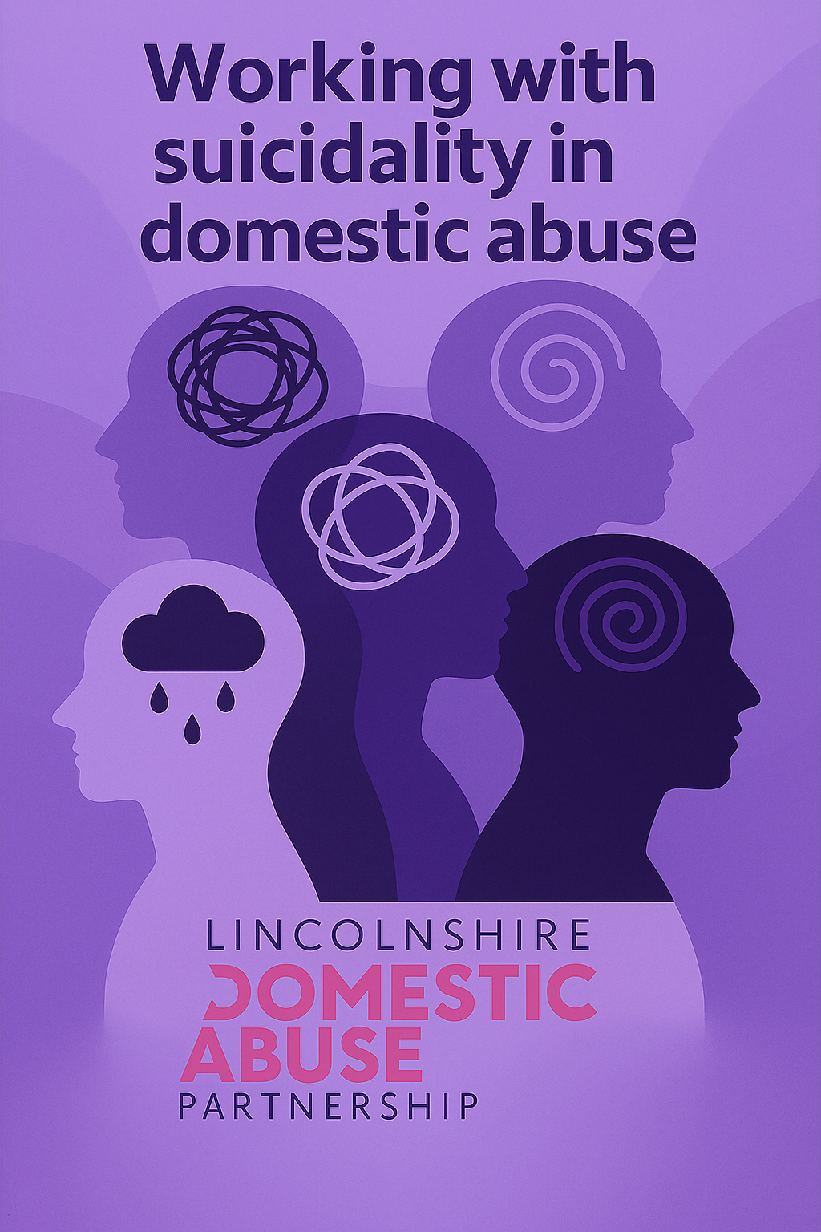

Introduction
Living with suicidal thoughts and feelings is a profound and often isolating challenge faced by many individuals in our society. The recent launch of the Government’s Suicide Prevention Strategy has highlighted the complexity of this issue, drawing attention to the wide range of risk groups and contributing factors that must be considered in any meaningful response. This can also be seen in Lincolnshire’s Suicide Prevention Strategy.
Among these risk groups, research consistently shows that adult victims, child victims, and perpetrators of domestic abuse are all at heightened risk of engaging in self-harming or suicidal actions. This recognition has led to a significant shift in how we understand and respond to suicide in the context of domestic abuse. One of the most important developments in this area has been the inclusion of suicides within the scope of Domestic Abuse Related Death Reviews where the individual who died had experienced domestic abuse. This was a crucial step in acknowledging the devastating and often hidden impact that abuse can have on a person’s mental health and overall sense of safety and wellbeing.
This resource has been developed with a deep understanding of the intersection between domestic abuse and suicidality. It recognises that these experiences do not exist in isolation, and that the trauma, control, and systemic barriers faced by survivors can significantly increase their vulnerability to suicidal thoughts and behaviours.
The aim of this resource is to support professionals in developing a more nuanced understanding of these intersections. By expanding awareness and encouraging reflective practice, it seeks to enhance the ability of practitioners to identify and respond to suicide risk where domestic abuse is present. Ultimately, it is about equipping professionals with the insight and tools needed to provide compassionate, informed, and effective support to those navigating the complex realities of abuse and suicidality.

Legislation
The Domestic Abuse Act 2021 provides a legal definition to help professionals identify and respond to abuse consistently and effectively.
Who does it apply to?
- People aged 16 or over
- Who are personally connected (e.g. partners, ex-partners, family members, or those sharing parental responsibility)
What counts as abuse?
Abuse can be a single incident or a pattern of behaviour, and includes:
- Physical or sexual abuse
- Violent or threatening behaviour
- Controlling or coercive behaviour
- Economic abuse – e.g. restricting access to money, work, or essentials
- Psychological, emotional, cyber, or other abuse
Children are victims too
Children who see, hear, or experience the effects of domestic abuse are recognised as victims in their own right.
Why this matters in practice
- Abuse isn’t always physical – it can be subtle, hidden, and long-term.
- Understanding the full scope of abuse helps professionals identify risk early and respond appropriately.
- This definition supports a joined-up approach across services—ensuring survivors and children get the support they need.

Suicidality
Suicidality is an umbrella term that refers to the range of thoughts, feelings, and actions related to suicide. It includes everything from fleeting thoughts about death to serious planning and attempts to end one’s life.
It typically includes:
- Suicidal thoughts (ideation) – thinking about or wishing for death
- Suicidal intent – having a desire and plan to act on those thoughts
- Suicide plans – developing a method or strategy
- Suicide attempts – engaging in actions intended to cause death
- Completed suicide – when a person dies as a result of their actions
Using “suicidality” can help professionals and support workers talk about the full spectrum of risk without assuming a person is at immediate danger. It’s especially useful in clinical assessments, safety planning, and support services.
Suicidal Thoughts (also called Suicidal Ideation):
These are thoughts about wanting to die or thinking about suicide, but they don’t necessarily involve a plan or intent to act on those thoughts. They can range from fleeting thoughts like “I feel like everyone would be better off without me” to more persistent ideas about ending one’s life.
There are two types:
- Passive suicidal thoughts: e.g., “I wish I wouldn’t wake up tomorrow.”
- Active suicidal thoughts: e.g., “I want to end my life,” possibly with some vague ideas of how.
Suicidal Intent:
This goes a step further. It means the person not only has thoughts of suicide but also has a desire and intention to act on those thoughts. It often includes:
- A specific plan (e.g., method, time, place)
- A clear intention to carry it out
- Sometimes, preparatory actions (e.g., writing a note, giving away possessions)

Death By Misadventure:
“Death by misadventure” is a term commonly used in coroner’s reports and legal proceedings to classify a death that occurs accidentally as a result of a deliberate, voluntary action that carried inherent risk. The key distinction is that the person did not intend to die, but their chosen action led to fatal consequences.
Key Characteristics
- Unintentional Outcome: The individual did not plan or intend to cause their own death.
- Voluntary Risk: The person knowingly engaged in an activity that was risky or hazardous.
- Accidental Fatality: The death was not caused by external foul play but by the consequences of their own actions.
Common Examples
- Recreational drug or alcohol use leading to overdose.
- Extreme sports or dangerous stunts gone wrong.
- Self-harm without suicidal intent (e.g., cutting for emotional relief that results in fatal injury).
- Risky sexual practices or thrill-seeking behaviours that result in death.

Indicators
Below are indicators which can show the differences between suicidal thoughts and suicidal intent:
Suicidal Thoughts
Indicator | Description
💭 Passive thoughts | “I wish I could go to sleep and not wake up.”  “Life would be easier if I just disappeared.”  “I don’t want to exist anymore.”
🌀General hopelessness | Feeling like life has no purpose or meaning  “Nothing matters anymore.”  “I can’t see a future for myself.”  “What’s the point of trying?”
🧠 No specific plan | Thoughts are vague or abstract  “Sometimes I think about not being here, but I don’t know how.”  “I just imagine being gone.”
🕰️Fleeting  or occasional | May come and go, especially during stress  “These thoughts come and go when I’m stressed.”  “It’s not all the time, just when things feel overwhelming.”
🚫 No intent to act | Person does not want to die, just wants pain to stop  “I don’t want to die, I just want the pain to stop.”  “I wouldn’t do anything, I just wish things were different.”

Suicidal Intent
Indicator | Description
🗓️Specific plan | Has thought about how, when, and where  “I’ve thought about how and when I’d do it.”  “I know where I’d go to end it.”
🧭 Clear intent | Expresses a desire to follow through  “I want to end my life.”  “I’m ready to do it.”
🧳 Preparatory actions | Giving away belongings, writing a note  “I’ve started giving away my things.”  “I wrote a note for my family.”
🧍 Sense of finality | Statements such as:  “I won’t be here much longer”  “This is goodbye.”
🚨 Urgent risk | Requires immediate intervention and support. Any combination of the above indicators—requires immediate intervention and support.

Important Note on Suicidal Ideation Spectrum
While presenting suicidal thoughts on a spectrum (from passive to active) can help us understand different levels of risk, it must not lead to assumptions that passive thoughts are harmless or low-risk.
- Even individuals expressing passive thoughts (e.g., “I wish I could go to sleep and not wake up”) may act impulsively or engage in actions that result in misadventure-related deaths.
- Movement along the spectrum can be rapid and unpredictable—someone who appears low-risk can escalate quickly.
- All disclosures of suicidal thoughts require careful assessment and vigilance, regardless of perceived intent or planning.
Key Risk Factors
- Alcohol or substance use: Impaired judgment increases likelihood of acting on thoughts.
- Hopelessness: A major indicator of heightened risk; its absence should prompt concern.
- Previous suicide attempts: Strong predictor of future risk.
- Access to means: Availability of lethal methods significantly raises danger.
- Social isolation: Lack of support networks can accelerate escalation.
- Recent major loss or trauma: Bereavement, relationship breakdown, or financial crisis.
- Chronic pain or illness: Physical suffering often correlates with suicidal ideation.
- Neurodiversity considerations: Communication differences may mask intent or distress.
- Older age: Higher lethality in attempts and less likelihood of disclosure.
- Impulsivity or poor emotional regulation: Increases risk of sudden action.
- Co-occurring mental health conditions: Depression, anxiety, PTSD, or personality disorders.

Domestic Abuse and Suicidality
Domestic abuse is a significant risk factor for suicide across all vulnerable groups. Survivors often face profound isolation and loneliness, which can persist even after the abusive relationship has ended. This isolation is frequently exacerbated by coercive control tactics that erode social and familial connections, leaving survivors without vital support networks.
The psychological impact of abuse can be long-lasting. Many survivors develop post-traumatic stress, which contributes to ongoing risks of suicide and self-harm well beyond the end of the abusive relationship. These risks are often compounded by systemic barriers—such as difficulties accessing legal support, housing, or essential services—which can further entrench feelings of helplessness and despair.
Domestic abuse also diminishes a survivor’s “psychological space for action,” impairing their ability to think clearly, make decisions, or seek help. This sense of entrapment can intensify suicidal thoughts and feelings, particularly when compounded by disruptions to the parent-child relationship. Whether caused by the perpetrator or by legal interventions, such disruptions can cause deep emotional distress for non-abusive parents.
Importantly, ending the relationship does not necessarily eliminate the risk. Survivors may continue to live with the awareness of ongoing threats, which can heighten feelings of hopelessness. Risk assessments, therefore, should focus on identifying the presence of risk factors rather than attempting to predict or grade the level of risk.
Additionally, individuals with complex childhood trauma may face an increased risk of suicide in adulthood. It is crucial to recognise that suicidal risk is dynamic and can change rapidly. As such, a comprehensive safety plan should be developed—one that addresses multiple contributing factors and prioritises reducing isolation during periods of emotional instability.
Victims of domestic abuse may experience increased suicidal thoughts following action taken against the perpetrator, such as arrest or imprisonment. This can be due to:
- Heightened fear of retaliation or loss of control.
- Increased feelings of isolation or uncertainty about the future.
- Emotional turmoil linked to the sudden change in circumstances.
It is important to remain vigilant during these periods and ensure enhanced support and safety planning is in place.
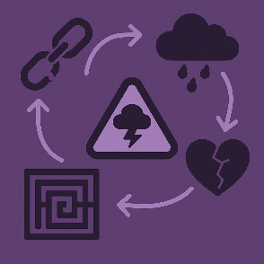

The Suicide Timeline
Professor Jane Monckton-Smith of the University of Gloucestershire has developed an eight-stage timeline that outlines a potential and gradual escalation in suicide risk. Each stage should be examined individually to understand how and why the level of risk may be increasing.

While Jane Monckton Smith’s timeline is a valuable tool for understanding patterns of coercive control and homicide/suicide risk, progression through the stages is not always linear. Risk can increase at various points, including:
- When help is offered or intervention begins.
- Following significant events such as the perpetrator’s arrest or imprisonment.
Monckton-Smith, J. et al. (2022) Building a temporal sequence for developing prevention strategies, risk assessment, and perpetrator interventions in domestic abuse related suicide, honour killing, and intimate partner homicide, Research Repository. Available at: https://eprints.glos.ac.uk/10579

Research
Overview: National Domestic Homicide Project – Fourth Annual Report (March 2025)
The National Domestic Homicide Project published its fourth annual report in March 2025, covering domestic abuse-related deaths across England and Wales. The project aims to improve understanding of risk factors and help services respond more effectively to domestic abuse, domestic homicide, and suicides linked to abuse.
What the report covers
The report looks at all deaths identified by police as being related to domestic abuse. It gathers detailed information not available from other sources, helping police and partner agencies better understand:
- Risk indicators
- Victim and perpetrator demographics
- Patterns and trends in domestic abuse-related deaths

Who runs the project?
- Funded by: Home Office
- Led by: National Police Chiefs’ Council (NPCC)
- Delivered by: Vulnerability Knowledge and Practice Programme (VKPP)
- In partnership with: College of Policing

The project also works closely with bereaved families, whose voices continue to drive change across the criminal justice system.
Key findings from April 2023 – March 2024
A total of 262 deaths were recorded as domestic abuse-related:
- 98 suspected suicides following domestic abuse (SVSDA)
- 80 intimate partner homicides (IPH)
- 39 adult family homicides
- 28 unexpected deaths
- 11 child deaths
- 6 other deaths (where the victim and suspect lived together but were not related or in a relationship)

For the second year in a row, suspected suicides following domestic abuse have overtaken the number of homicides involving current or previous partners. This reflects increased awareness and progress made against recommendations in the project’s last report, which focused on improving policing’s ability to better recognise and record the link between domestic abuse and suicide.
Safe Lives Psychological Violence Report
This report explores the prevalence of psychological abuse, the lived experiences of those affected, and the manipulative tactics used by perpetrators to exert control and instil fear.
Funded by the Oak Foundation under its Issues Affecting Women programme, the research was co-developed with survivors of domestic abuse and frontline practitioners.
- 91% of survivors experienced some form of psychological violence in their relationship

- 47% of survivors reported having suicidal thoughts due to the psychological abuse

- 85% of survivors said the perpetrator used the children to threaten and control them

- 49% experienced severe psychological manipulation with a partner threatening to take their own life following an abusive incident, or them trying to end the relationship

- 93% of practitioners supported healthy relationship education in schools and children's services to help identify psychological violence earlier

Local Research
Since 2012, Lincolnshire has been collating data on Domestic Abuse Related Death Reviews across the county.
There have been 51 notifications since 2012, with 18 of those being suicides.

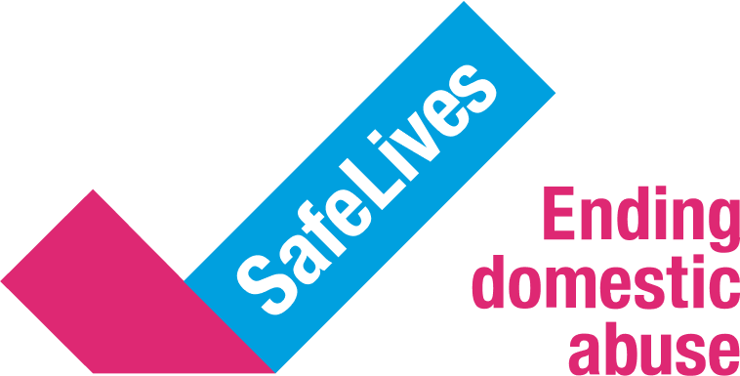

Responding with Empathy
💬 Consider the Person’s Feelings
- Approach with empathy: Understanding how someone may feel helps you respond appropriately.
- Avoid triggering language: Be mindful of words that could worsen distress.
- Take all disclosures seriously: If someone shares they’re having suicidal thoughts, always treat it with urgency and care.
- Recognise not all signs are obvious: Some people experiencing suicidal thoughts may appear calm or at peace, so it’s important not to rely only on visible distress.
✅ Be Brave and Respectful
- If you suspect someone is considering self-harm or suicide, it’s important to ask direct and clear questions:
  - “Are you thinking about hurting yourself?”

  - “Are you thinking of attempting suicide?”
These questions:
- Validate their feelings
- Encourage open conversation
- Show that you care and are listening
🚫 What to Avoid
❌ Don’t Trivialise or Soften the Situation
Avoid phrases like:
- “You don’t want to kill yourself, do you?”
- “You’re not thinking of doing anything silly, are you?”
These can:
- Make the person feel dismissed or misunderstood
- Lead to emotional or defensive reactions
- Undermine the seriousness of their experience
If someone is in immediate danger during a conversation, dial:
- 999 for emergency services, or
- 111, option 2 for urgent mental health support.
Remember: Doing nothing is not an option.

Prompt Sheet
🔗Connect
Build trust and create a safe space:
- Take time to listen and let them share their story at their own pace
- Use active listening – show empathy and avoid interrupting

- Notice body language and tone – these can say a lot
- Start with neutral topics to help them feel comfortable

Be alert to subtle signs of distress, such as:
- “I can’t carry on like this”
- “Nothing is worth it anymore”
- “I can’t see a way out”
- “Everyone would be better off without me”

🧠 Understand
Explore their thoughts and feelings with care:
- “Have you had thoughts of suicide?”
- “Have you felt this way before?”
- “Have you thought about ending your life?”
- “Let’s focus on keeping you safe – have you made any plans?”
- Acknowledge their pain: “You’ve been through a lot, and I don’t want to add to that.”
Listen for moments of uncertainty or change:
- “I just don’t know…”
- “I suppose so…”
Check you’re on the same page:
- “Are we talking about your thoughts and feelings around suicide, and what we can do to help?”
🤝 Assist
Work together to plan next steps:
- Create a plan for different situations (see Safe for Now plan)
- “Who can you turn to for support right now?”
- “Are there things that help you feel a bit better – activities, distractions?”
- If needed, explore whether they should be with someone now or go to A&E
- Encourage, don’t pressure – support them to make safe choices
- “I hear how hard this is – let’s talk and see if we can make things feel a bit clearer

Training Available

Training Course | Duration | Topics Covered | Access Link
Zero Suicide Alliance (ZSA) Training | Short, self-paced online modules | - Recognizing warning signs of suicide  - How to have a direct conversation about suicide  - Supporting someone in crisis  - Safety planning and signposting to help | https://www.zerosuicidealliance.com/training
Active Training (SPARK, SPOT, SPEAK, ASIST) | SPARK: 30 mins; ASIST: 2 days | - SPARK (30 mins):Intro to suicide prevention  - SPOT (90 mins):Prevalence, language, signs of suicide, community role  - SPEAK (3.5 hrs): Myths, stigma, signs, safe conversations  - ASIST (2 days): Applied suicide intervention skills, safety planning, risk assessment | https://www.papyrus-uk.org/active-training/
Self-Harm and Suicide Awareness and Prevention (Level 2 Certificate) | Self-paced; 2–3 hrs/week recommended | - Definitions of self-harm and suicide  - Triggers and societal attitudes  - Recognizing signs and initial response  - Role of conversation and support networks  - Treatment options and coping strategies  - Grief and bereavement support after suicide | https://www.boston.ac.uk/courses/find-a-course/area/distance-learning/self-harm-and-suicide-awareness-and-prevention-certificate-level-2/
Domestic Abuse and Suicide Training | 2.5 hours | - Links between domestic abuse, self-harm, and suicide  - Case studies and real-life scenarios  - Identifying abuse through self-harm or suicide attempts  - Insights from homicide reviews involving suicide | https://equation.org.uk/training/domestic-abuse-and-suicide/
Suicide Prevention in the Context of Domestic Abuse - Intermediate | Approx. 6 hours (based on similar intermediate) | - Trauma-informed approaches to suicide prevention  - Supporting children, young people, and carers  - Long-term suicide prevention strategies  - Bereavement support and postvention  - Mental health first aid and workplace strategies | https://prevent-suicide.org.uk/training/suicide-domestic-abuse-intermediate/

Signposting and Professional Support
Immediate Help
- If someone is in immediate danger during a conversation, dial:
  - 999 for emergency services
  - 111 (option 2) for urgent mental health support
  - Attend Lincoln Mental Health Urgent Assessment Centre
Key Resources
- Samaritans – 24/7 confidential support: Call 116 123
- H.A.Y. Lincolnshire (How Are You Lincolnshire) –
  - Managed by Public Health and Shine
  - Includes dedicated pages for professionals, carers, individuals, and training
  - Regularly updated with current support options
Professional Guidance
- Use professional curiosity: Ask open questions, not leading ones
- If you’re not regularly working in this area, refer to the professional section of the HAY site for advice and signposting options
Active Support
- Do not assume individuals can take the next step alone after leaving a conversation
- Where possible, offer to make referrals together during the conversation:
“Shall we do it together now?”
- This approach provides reassurance and ensures the person receives help immediately
Self-Care for Professionals
Supporting individuals experiencing suicidal thoughts can be emotionally demanding.
- Schedule regular supervision and reflection
- Access wellbeing resources via HAY Lincolnshire and your organisation’s support services
- Prioritise breaks and peer support after high-intensity conversations

