
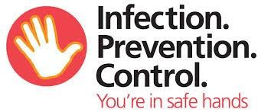

Monitoring and Audit Review Timescales for Care Homes

Monitoring arrangements

The Infection Prevention and Control (IPC) Policies used by the organisation should be subject to regular evaluation and monitoring of compliance to help reduce the risk of healthcare associated infection (HCAI).

Audit

The following key areas are associated with the greatest risk of HCAI and should, where applicable, be reviewed as indicated below using the IPC audit tools.

Infection Prevention and Control Audit Review Timescales
Key areas to be audited | Weekly | Monthly | Yearly
Infection Prevention and Control Audit Tool of compliance (Quality Assurance Matrix) |  | √
Aseptic Technique Competency Assessment |  |  | √
Decontamination of Equipment ( suggest IPS) |  | √
Environmental Cleanliness ( Suggest the IPS tool, contractual obligation) |  |  | √
Hand Hygiene (A rolling programme of audit should be undertaken, e.g. monthly audit. All staff should be assessed for hand hygiene technique on at least an annual basis).⃰ (Suggest  LCC tool) |  |  | √
Mattress⃰ (suggest LCC tool) |  | √
Pressure relieving cushions⃰⃰ (suggest LCC tool). |  | √
* The timescales above are a suggested guide. Frequency should be determined by local risk assessment. All audits should be undertaken on a regular basis.

- A number of audit tools have been produced by the IPC Team to assist in the monitoring of infection prevention and control practices, but these are not exhaustive and a local risk assessment should be undertaken to inform monitoring arrangements in each organisation.
- Completed audit tools or a copy should be retained in an accessible location for inspection.
- In the event of non-compliance, action plans should be drawn up locally, reviewed and monitored.

