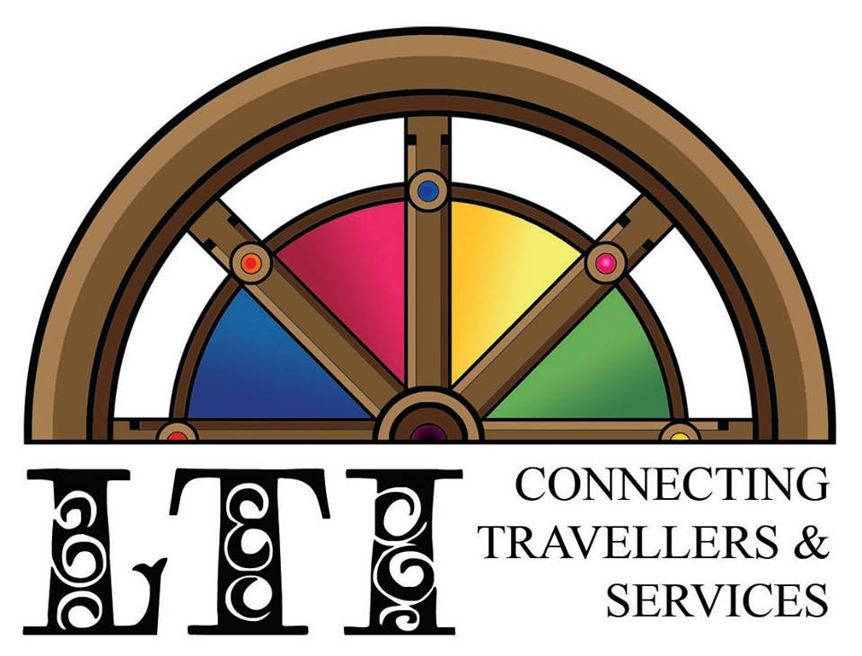

To whom it concerns:

Lincolnshire Traveller Initiative is often asked by service providers what is the best way to reach out to Traveller communities to make them aware of help, advice and services that can be offered to them. Below are links to two of the best resources that answer that question. They are clear, informative and importantly, they are the voice of Travellers themselves. They offer top tips on how to engage with the different communities. My top tip is, “find someone who knows the individual, family or group that you want to contact, is trusted by them and is willing to make an introduction.”

These resources can be shared with colleagues, students, trainees or anyone who is interested in engaging with Travellers in a positive and supportive way.

Paul Boucher

Director

Lincolnshire Traveller Initiative

<https://lttu.uk/External/GypsyRomaTraveller/Lesson1>

[https://lttu.uk/External/GypsyRomaTraveller/Lesson2](https://emea01.safelinks.protection.outlook.com/?url=https%3A%2F%2Flttu.uk%2FExternal%2FGypsyRomaTraveller%2FLesson2&data=05%7C02%7C%7C6d8fbbb56e014e031a7608dcb0181ed4%7C84df9e7fe9f640afb435aaaaaaaaaaaa%7C1%7C0%7C638578864844545690%7CUnknown%7CTWFpbGZsb3d8eyJWIjoiMC4wLjAwMDAiLCJQIjoiV2luMzIiLCJBTiI6Ik1haWwiLCJXVCI6Mn0%3D%7C0%7C%7C%7C&sdata=lqgY7nVTk8tpWTOIafsPyqTuz8r0jtDIzt8z64LfDeo%3D&reserved=0)

[https://lttu.uk/External/GypsyRomaTraveller/Lesson3](https://emea01.safelinks.protection.outlook.com/?url=https%3A%2F%2Flttu.uk%2FExternal%2FGypsyRomaTraveller%2FLesson3&data=05%7C02%7C%7C6d8fbbb56e014e031a7608dcb0181ed4%7C84df9e7fe9f640afb435aaaaaaaaaaaa%7C1%7C0%7C638578864844555339%7CUnknown%7CTWFpbGZsb3d8eyJWIjoiMC4wLjAwMDAiLCJQIjoiV2luMzIiLCJBTiI6Ik1haWwiLCJXVCI6Mn0%3D%7C0%7C%7C%7C&sdata=WsMeSU%2F3d0KYnjTTkTIQxTdwY%2B6Ww9bCxZ5D0MfBmtQ%3D&reserved=0)

[https://lttu.uk/External/GypsyRomaTraveller/Lesson4](https://emea01.safelinks.protection.outlook.com/?url=https%3A%2F%2Flttu.uk%2FExternal%2FGypsyRomaTraveller%2FLesson4%2F&data=05%7C02%7C%7C6d8fbbb56e014e031a7608dcb0181ed4%7C84df9e7fe9f640afb435aaaaaaaaaaaa%7C1%7C0%7C638578864844563120%7CUnknown%7CTWFpbGZsb3d8eyJWIjoiMC4wLjAwMDAiLCJQIjoiV2luMzIiLCJBTiI6Ik1haWwiLCJXVCI6Mn0%3D%7C0%7C%7C%7C&sdata=cSxnJV77thRuZo39Fx1BTmyG92sDeeIFOTnAZ1UUxIQ%3D&reserved=0)

* this is focused on Worcestershire and social work but can be distributed anywhere and is relevant to all human services professionals. An organisation can’t change the four modules’ content but could preface them with their own module or just a statement saying why these modules are relevant to the particular Traveller issues in their locality / service.

All we ask is some feedback on any impact on service delivery/ take-up

Peter



        Dr. Peter Unwin

        Principal Lecturer in Social Work

        Research and Knowledge Exchange Co-ordinator

        School of Allied Health and Community

        Binyon North 1010

        University of Worcester WR2 6AJ

[p.unwin@worc.ac.uk](mailto:p.unwin@worc.ac.uk)

        01905 855126

‘[How to tackle health inequalities in Gypsy, Roma and Traveller communities: A guide for health and care services](https://www.gypsy-traveller.org/wp-content/uploads/2020/11/SS00-Health-inequalities_FINAL.pdf)’ Friends, Families and Travellers.