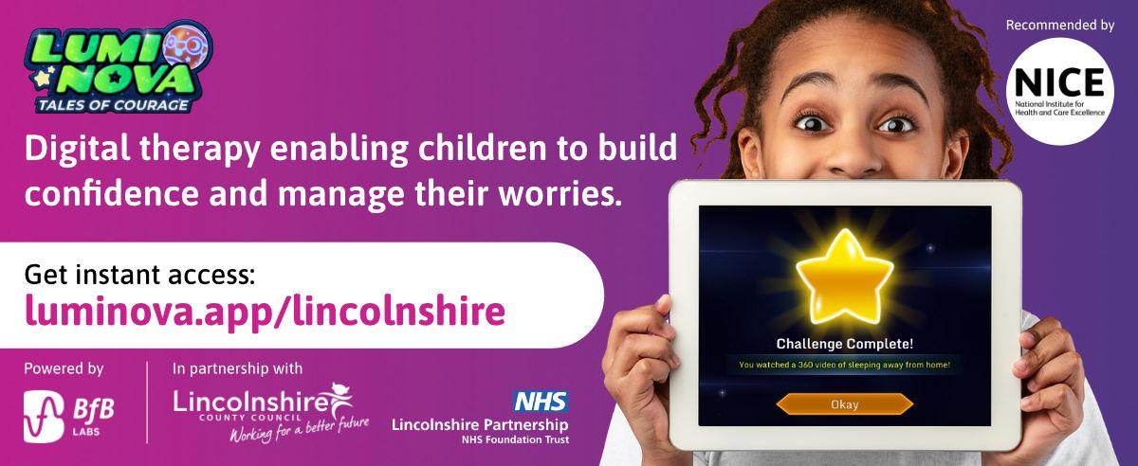

**Lumi Nova will be live in Lincolnshire from 8th January 2025!**

Lumi Nova: Tales of Courage is a digital therapeutic mobile game, which will be available to families as part of a pilot in Lincolnshire from **8th January 2025** to support children with fears, worries and anxiety.

Designed for children aged 7-12 years, Lumi Nova helps children to reflect on their feelings, build resilience, and learn lifelong skills to self-manage their worries in a fun intergalactic adventure.

Watch this short, animated video to learn more: [Lumi Nova Introduction Video](https://www.youtube.com/watch?v=mmgrU4zXU3M)

* **Learn more:** Join a [Lumi Nova Discovery](https://www.eventbrite.co.uk/e/lumi-nova-in-lincolnshire-discovery-session-45-mins-tickets-1074310143559?aff=ebdsoporgprofile) webinar (45 minutes) for professionals to learn more about the offer (multiple dates available)
* **Stay connected:** Subscribe to the [Lumi Nova Newsletter](https://bfblabs.eo.page/ssu-subscribe) and follow us on [Facebook](https://www.facebook.com/luminovaapp) and [Twitter](https://x.com/luminovaapp) for new resources and updates.

If you would like to order posters/leaflets or have any questions, please reach out to the Lumi Nova team at luminova@bfb-labs.com.