 |  |  | COSHH Risk Assessment
SUBSTANCE INFORMATION
Substance/material: |  |  |  |  |  |  |  |  | Trade name:
What is the substance used for?
(E.g. cleaning floors, toilets)
What hazardous ingredients/chemicals are used to form the substance?
Does the product have a Workplace Exposure Limit?
Does the product / MDS carry any of the following labels? (Highlight as appropriate)
 |  | Explosive |  | Flammable | Oxidising |  | Gas under pressure | Toxic |  |  | Health hazards |  |  | Corrosive | Serious health hazards  hazards |  | Dangerous for the environment
 |  |  |  | 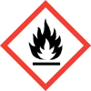 | 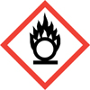 |  |  | 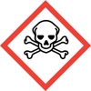 |  |  | 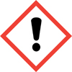 |  |  | 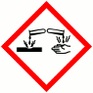 | 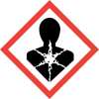 |  | 
Is the substance hazardous to health when? (Highlight as appropriate)
- In contact with skin? Yes/ No  - In contact with eyes? Yes/ No |  |  |  |  |  | - Breathed in? Yes/ No  - Swallowed? Yes/ No |  |  |  |  |  | - Other (Specify below)

USE OF SUBSTANCE
How should the substance be used?
(E.g. diluted in water, applied with a brush, sprayed, etc)
How much is used every week?
(State quantity in litres or kilos etc, as appropriate)
Who is exposed to the substance?
(E.g. those using it, service users, public etc)
Does the substance present additional risks to certain groups or individuals?
(E.g. young people, expectant mothers.)

CONTROL MEASURES
Can a less hazardous substance be used to do the same job?
(If you don’t know, please contact your supplier for further information.)
What controls are required for this substance, other than Personal Protective Equipment (PPE)?
(E.g. use well-ventilated areas, do not spray, brush application only)

Is any Personal Protective Equipment (PPE) required when using the substance?
PPE highlighted below is required when using this substance

 | - Eye protection? |  |  |  |  |  |  |  |  |  |  |  | - Gloves?
 | - Overalls/clothing? |  |  |  |  |  |  |  |  |  |  |  | - Mask/respirator?
 | - Other?

How should the substance be stored? (locked cupboard, away from other substances, etc)

First Aid & Fire Precautions
First aid: What actions should be taken if the substance is:
- Swallowed? |  |  | - In contact with eyes?
- In contact with skin? |  |  | Inhaled?
- Other? (Please specify.) None.
Fire precautions: The Extinguisher types highlighted below may be used.

WATER FOAM POWDER CARBON DIOXIDE (Co2)

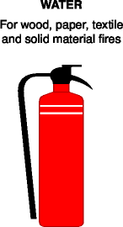 | 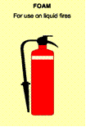 |  | 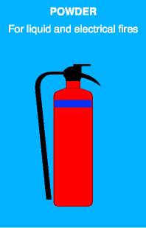 |  | 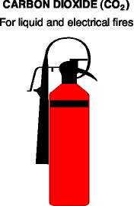

Chemical reactions: Is there any other substance that this substance must not meet?

Disposal: Are any special measures required to dispose of unused substance / container?

Health surveillance: Do staff using the substance require any health surveillance?

ASSESSMENT OF RISK

Are all the controls detailed above currently in place?
Are hazards adequately controlled once control measures in place?
Any additional information required? (if yes, specify)
Assessor(s) name: |  | Date: |  | Date for review:

The attached register details who has been briefed in the contents of this COSHH Assessment.

Note: A copy of the product Material Data Sheet must be attached to this assessment.

