Bed No.
Mattress/ cushion Type
Jan
Feb
Mar
April
May
June
July
Aug
Sept
Oct
Nov
Dec
Comments
Insert Date Audit Undertaken:
Example:
Pass or Fail
Staff initials
P JB
F AB
Feb Fail (soiled inner)

1
2
3
4
5
6
7
8
9
10
11
12
13
14
15
16
17
18
19
20

Bed No.
Mattress Type
Jan
Feb
Mar
April
May
June
July
Aug
Sept
Oct
Nov
Dec
Comments
Insert Date Audit Undertaken:
Example:
Pass or Fail
Staff initials
P JB
F AB
Feb Fail (soiled inner)

21
22
23
24
25
26
27
28
29
30
31
32
33
34
35
36
37
38
39
40

Don’t judge a mattress by its cover

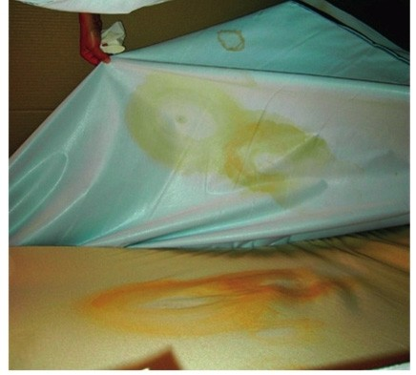
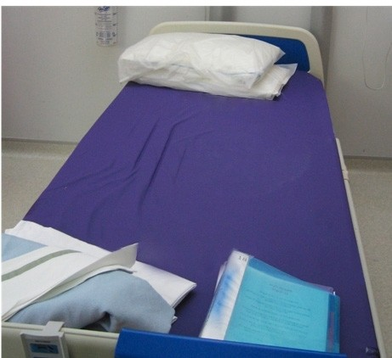
Calm surface

- Inspect the exterior surface of each mattress cover for signs of damage, such as holes or cuts.

- Remove the cover and inspect its inside surface and the mattress core for staining or contamination.

- Safely dispose of any covers showing signs of damage or staining

- Arrange for contaminated mattress cores to be cleaned and decontaminated in accordance with the manufacturer’s instructions or safely disposed of.

- Ensure that a frequent inspection regime is established for all mattresses.

What lies beneath

Do the user instructions for the mattress properly describe how to inspect, clean and decontaminate it? If not, tell us about it by reporting it as an adverse incident.

Report adverse incidents online www.mhra.gov.uk or on email aic@mhra.gsi.gov.uk
or telephone 020 7084 3080

Medicines and Healthcare Products Regulatory Agency, an executive agency of the Department of Health © Crown copyright 2013

