Phase 3 - Mapping Tool
Break down the overarching problem or issue into smaller, more manageable parts. Consider each of the 5 ‘Ps’ and identify the ways they interact with and contribute to the concern. Additional boxes should be added where needed under each Factor.

Name of child: |  | DoB:
Name of school:
Completed with: |  | Role:
Date of completion: |  | Year Group:

Presenting Factors:
List the presenting factors and how they manifest in the student’s behaviour or performance. What can we see that's happening with the child or young person? This might be things they do, or ways they behave, that show us something might not be quite right.
Factor 1: |  | How it manifests:
Factor 2: |  | How it manifests:
Factor 3: |  | How it manifests:

Predisposing Factors:
List the predisposing factors that make the student more susceptible to these issues. What things about the child or young person make them more likely to have these issues? It might be things that happened in the past, or personal characteristics.
Factor 1:
Factor 2:

Factor 3:

Precipitating factors:
Identify the specific incidents or changes that triggered the issues. What recent events or changes have set off these issues for the child or young person? It could be a big change at home, incidents of bullying or an argument with a friend.
Incident/change 1:
Incident/change 2:

Incident/change 3:

Perpetuating factors:
Identify ongoing situations, behaviours, or thought patterns that seem to be maintaining or exacerbating the issues. What things keep the problem going? This might be things the child or young person keeps doing, or ways they keep thinking, that don't help with the issues they are having.
Situation/Behaviour/Thought Pattern 1:

Situation/Behaviour/Thought Pattern 2:

Situation/Behaviour/Thought Pattern 3:

Protective factors:
Identify the student's strengths, supports, or positive influences that could help them cope with or overcome these issues. What things help the CYP deal with these issues? It could be their strengths, people who support them, or good things happening in their life.
Strength/Support/Positive Influence 1:

Strength/Support/Positive Influence 2:

Strength/Support/Positive Influence 3:

Problem Dimensions Summary:
Based on the above analysis, summarise the main dimensions of the problem, highlighting the interactions between different factors and aspects of the issue. Look at all the layers of information and then think about the main parts of the problem. Look at how these things work together to create the issue for the child or young person.

Helping me to understand and make changes
Triggers: what sets things off?

Past issues: what has happened to me?

What keeps things stuck?

Positives: what supports me?

Current issues: what is going on for me?

Goals:

Plans:

Next steps:

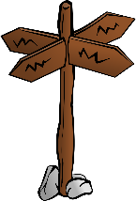

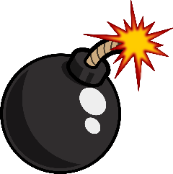
Plans: Thinking about your next steps to build your well-being.
Stuck: What keeps things stuck? What are the things that keep your difficulties going and make change difficult?
Positives: What are the positives in your life, including your strengths and support from people and things around you?
Current Issues: What are the key issues for you at the moment?
Triggers: What was happening when your current difficulties started?
Past Issues: What has happened in your past that may be important?

