**OPERATION KOMORAN: reporting crimes from MARAC**



**GUIDANCE**

The police understand the challenges partners face when reporting crimes about cases that will be discussed at MARAC. We have now created a pathway for you to report crimes that are **non-urgent**, so you can pass this information without the risk of us sending resources, which potentially ruins the relationship you have built with victims. This also means that we have the full picture to base our risk assessments on.

It must be noted that this should **only** be used for cases currently being heard at MARAC, not cases that were heard at previous MARAC meetings which are not now repeats.

When your report is completed, it comes straight through to the safeguarding hub and the DA Administrators will create the crime report and it will be a Detective Sergeant or Detective Inspector that reviews this within the hub.

You will be emailed with a crime reference number for your records.

We only work Monday – Friday 8-4pm. Therefore, any report made will not be viewed over the weekend, evenings, or bank holidays. It is imperative that you do **not** report crimes to us where there is a real and immediate risk to the victim, because it will not be picked up and the DA Admin team are not trained to fully assess the threat, harm and risk, which our force control room are trained to do.

Below is the guidance that allows you to report via this route to us providing you have fully read the guidance and are familiar with: -

* The victim does **not** want police involvement at the time of making this report *(they can change their mind at a later stage)*
* The victim is **not** in immediate risk
* **No other** person is in immediate risk
* If this is a rape or serious sexual offence that has happened in the last **10 days** you **must** report via 101, as this is in the forensic window (or if you feel there is an imminent threat then call 999)
* Any crime where a **child** has been assaulted has to be reported via 101 so that safeguarding can be completed.

Please ensure you are familiar with the questions on the Op Komoran link, to ensure you have all the information you require to complete the report. **If these criteria isn’t followed, then we may decide, following a risk assessment to attend.**

**LINK to report OP KOMORAN crimes**:

[Report | Lincolnshire Police (lincs.police.uk)](https://www.lincs.police.uk/ro/report/)

If you have any queries about the guidance, please email [DAADMIN@lincs.police.uk](mailto:DAADMIN@lincs.police.uk)

**Step-by-step guidance**

**STEP 1**

**\*Click on the link and you then select BOX ‘report domestic abuse’\***

[Report | Lincolnshire Police (lincs.police.uk)](https://www.lincs.police.uk/ro/report/)

**STEP 2**

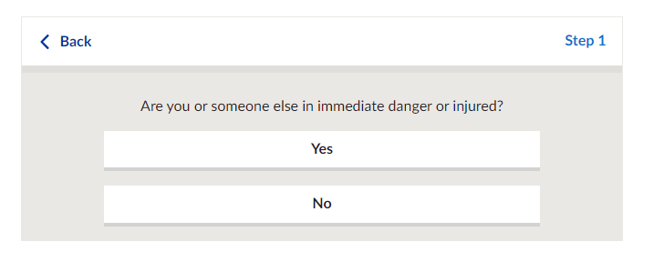

**\*IF SOMEONE IS THEN YOU SHOULD NOT USE THIS SERVICE\***

**STEP 3**

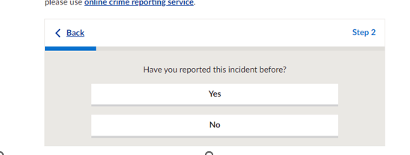

**\*\*PLEASE MAKE SURE YOU TICK ‘NO’ – OP KOMORAN REPORTS ARE ONLY NEW REPORTS\*\***

**STEP 4**

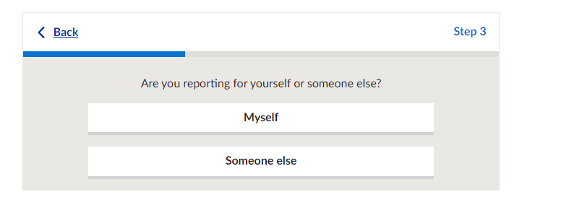

**\*\* SELECT ‘SOMEONE ELSE’\*\***

**STEP 5**

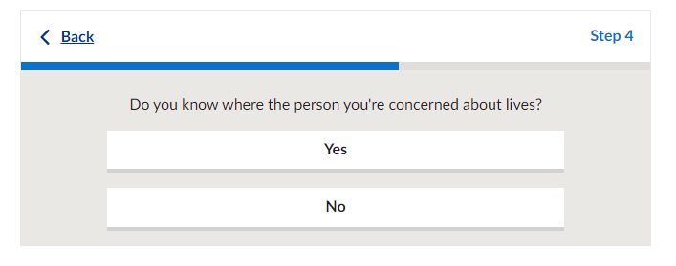

**\*\*YOU MUST SELECT YES. WE CAN NOT PROCEED UNLESS YOU KNOW THEIR ADDRESS\*\***

**STEP 6**

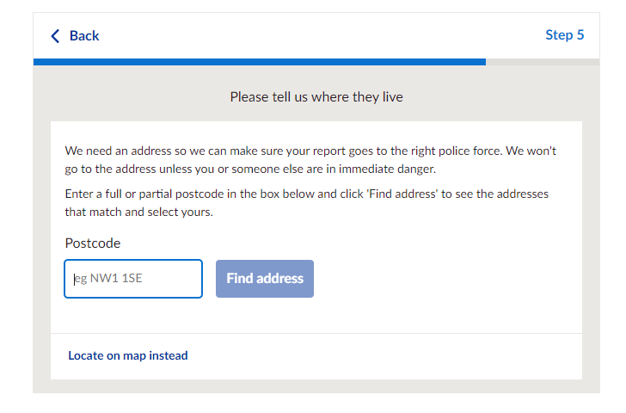

**\*TYPE IN THE VICTIMS POSTCODE AND THEN SELECT ADDRESS AND PRESS ‘START ON THE NEXT PAGE**

**STEP 7**

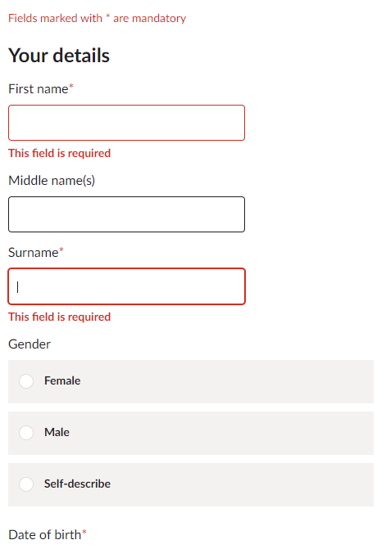

**\*COMPLETE YOUR DETAILS\***

**STEP 8**

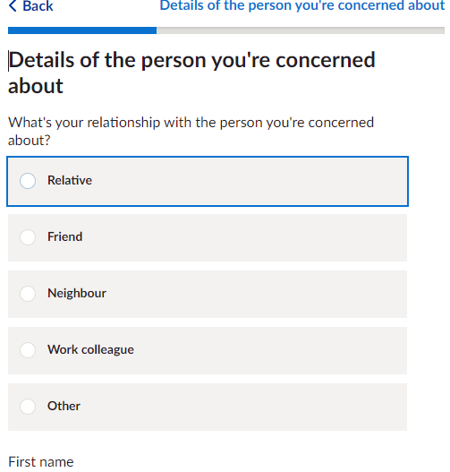

**\*YOU MUST SELECT ‘OTHER’ IN THE BOX PROVIDED WRITE ‘OP KOMORAN – AND YOUR AGENCY (LPFT / IDVA)\***

Once you have completed this, it comes directly into the safeguarding hub. The only people who have access to this email inbox are specially trained in domestic abuse and our force crime registrar. If you have reported something to via this route that does not meet the criteria then we will have to send to this to the FCR and it will be reported to your agency and during MARAC,.

Any queries contact us via our own DA inbox [DAADMIN@lincs.police.uk](mailto:DAADMIN@lincs.police.uk)

|  |
| --- |
| **Nick Waters**  **Inspector** |
| Lincolnshire Partnership Safeguarding Hub  Counter Terrorism Security Co-ordinator |

|  |  |  |
| --- | --- | --- |
|  |  | 07796 438698 |
|  | [nick.waters@lincs.police.uk](mailto:nick.waters@lincs.police.uk) |
|  | Grantham Police Station, Swingbridge Road, Grantham, NG31 7XT |
|  | [www.lincs.police.uk](https://gbr01.safelinks.protection.outlook.com/?url=http%3A%2F%2Fwww.lincs.police.uk%2F&data=05%7C02%7CLara.Iggulden%40lincolnshire.gov.uk%7Cc01e6b84ccb246a99cdf08dc9cb828eb%7Cb4e05b92f8ce46b59b2499ba5c11e5e9%7C0%7C0%7C638557561990872157%7CUnknown%7CTWFpbGZsb3d8eyJWIjoiMC4wLjAwMDAiLCJQIjoiV2luMzIiLCJBTiI6Ik1haWwiLCJXVCI6Mn0%3D%7C0%7C%7C%7C&sdata=NBlbjQ2duxY8Uy2AxzMfHADaogM5AaxoHueyISvza1I%3D&reserved=0) |