Education, Health and Care Hub Documentation

EHC SENCo’s Guide

Date: November 2023
Author: Jo Leonard
Version: v1.1
Commercial in confidence

Document control
Version | Changes | Author | Date
1.0 | Amendments and release | Jo Leonard | 24/11/2021
1.1 | Updated for EHC Hub version 9 | Alana Smith | 07/11/2023
Copyright
Ideas, solutions, suggestions, hints and procedures from this document are the intellectual property of Idox plc and thus protected by copyright. They may not be reproduced, transmitted to third parties or used in any form for commercial purposes without the express permission of Idox Group.

Contents

About this document 4
Introduction 5
Putting children, young people and their families at the heart of the EHC process 5
How to Register for an Account 7
App Authentication 9
SMS Authentication 10
Viewing your work trays 11
Searching for a Case 12
Viewing a Case File 14
Status of the Process 14
Details of the Case 15
Completing a Needs Assessment Request 17
Consent 18
Details of person requesting a EHCP Assessment 19
Child or young person’s details 20
Child or young person’s main contacts (family and involved professionals) 22
Details of the child or young person’s current education setting(s) 22
Setting 23
Details of previous setting(s) 25
Important information about the child or young person 25
Views of the child or young person and their parent, carer or guardian 25
Supporting Documents 27
Saving the request 28
Downloading the request 29
Deleting the request 29
Submitting the request 29
How to contribute to a request 30
Decision to Assess Pending 31
Assess Decision 32
How to contribute towards an EHC needs assessment 33
Requests for Advice 34
Documents 37
Submitting Advice 38
About (Child/young person name) 39
Parent Carer’s Views 40
Decision to Issue Plan Pending 42
Decision to Issue Plan 43
Viewing the Draft Plan 45
Downloading a Draft Plan 49
EHC Plan Consultations 49
Consultation for Education Settings 50
Response 52
Supporting Comments 52
Additional Information 52
Documents (Case Co-ordinator) 52
Documents (Education Setting) 52
Finalised and Issued EHCP 53
Viewing the Case Summary 54
Education, Health and Care Plan 54
Review not yet started 54
EHC Assessment and Planning Pathway 55
EHC Plan Review 55
Arranging the EHC Plan Review Meeting 56
EHC Plan Review Meeting Details 57
People invited to attend the EHC Plan Review meeting 57
Professionals and/or teams invited to attend 58
Case Co-ordinator(s) and/or Local Authority representative(s) invited to attend 60
Confirm and send invitations 61
Viewing who has confirmed attendance for the meeting 61
Confirming Attendance for the meeting 62
Sending Requests for Information 62
Responding to a request for information 63
Documents 66
Reopen a Request for Information 67
Closing a Request for Information 67
The Childs or Young Persons Views 68
The Parent, Carer or Guardian’s Views 69
Progress to Meeting 70
EHC Plan Review Meeting 70
EHC Plan Review Meeting Details 71
Record of people who were invited and attended 71
Other Attendees 71
Additional Meeting Information 71
Meeting Documents 72
Re-opening the Contribute Views stage 73
Progress to Draft Report 73
Draft Report Areas 73
Summary of EHC Plan annual review recommendations 75
Agreed Actions 76
Supporting Document 77
Submitting the Review Report 77
Downloading the Review Report 78
Reopening the Review Report 78
Review Decision 78
Keep the current EHC Plan as it is 79
Amend the EHC Plan 79
Cease to maintain the EHC Plan 79
Help Using Forms 81
Pick List Fields 81
Text Formatting 81
Entering an Address 81
Date Fields 82
Contact us 83

About this document
This document is a guide for persons with the SENCo role on how to use the EHC Hub.
In the context of this document, “the SENCo role” relates specifically to the level of access and permissions granted to an EHC Hub user account.
Depending on local practice, a person accessing the EHC Hub with the SENCo role may include those with a job title/duty of SENCo, Headteacher or other supporting person within an education setting that requires involvement with Education, Health and Care assessment, planning and review processes.
The local authority has control and responsibility for granting the SENCo role to relevant persons and for the intended education settings.
This document is intended as a basis for local authorities to use to produce their own version, specifically tailored for their local communities.
Local authorities may choose to add additional best practice information that reflects local policy/ process or divide the document up into several shorter documents that specifically focus on certain areas of the EHC Hub.

Introduction
Since the introduction of The Children & Families Act 2014 and the SEN Code of Practice (2014), local authorities across England have been implementing new processes and pathways to support children and young people with Special Educational Needs and / or Disabilities (SEND). In place of Statements and Learning Disability Assessments, local authorities have a duty to provide an Education, Health & Care Plan (EHCP) for children and young people aged up to 25 who need more support than is already available.
At the heart of the new legislation is a vision of collaborative working across Health, Education and Social Care and an engaging person-centred approach to the whole EHC pathway. However, the administrative processes currently in place to facilitate such an approach is a significant barrier that has left many local authorities struggling to sustain the volume of work, as well as to meet the statutory timeframes set by the Code (SEND Code of Practice 2014).
For many local authorities, the years since the introduction of the reforms has been a challenging period of significant change set against the backdrop of increased demand and ever-challenging budgets. A new way of working is needed, that not only supports local authorities to meet their statutory obligations more efficiently, but that achieves the SEND Code’s core principle of the child or young person being at the heart of everything we do.
Idox’s EHC Hub is an innovative digital platform for families, professionals and education settings to engage, contribute and collaborate on EHC assessments, plans and reviews. It provides an end-to-end solution for the two core statutory pathways: The twenty-week assessment and planning process and subsequently, the review of those EHC Plans. It puts the child or young person and their family at the heart of these processes and provides easy, secure access for all other case stakeholders to actively contribute and view information.

Putting children, young people and their families at the heart of the EHC process
For children, young people and their families, SENCos, education settings and professionals across education, health and social care, the Hub can be a one-stop digital resource for them to access and contribute information throughout their EHC journeys.
It can be accessed 24 hours a day on a smartphone, tablet or computer and is designed to be easy and intuitive to use without any need for formal training.
One of its most powerful features is the opportunity that it provides to truly capture the child or young person’s voice. The About Me and My Parent / Carer’s Views areas are unique multimedia spaces for uploading short video clips, photographs and scanned documents alongside written text to capture a dynamic narrative about their aspirations at the assessment stage, and later for Section A of the EHC Plan.
The EHC Hub offers:
- Online EHC assessment request pathway, including uploading/ sharing reports and or documents
- EHC case tracker with clear, contextual information advice and guidance as well as complete visibility of the statutory timeframes that relate to their case (review and assessment)
- Multimedia spaces to capture the child, young person & families views
- Secure 24/7 online access to all key information, documentation and reports
- Draft EHC plan consultation with ability to submit comments and feedback
- EHCP Review meeting information and invitations
- Ability to provide views/ feedback ahead of the EHC Review meeting
- Automated email alerts and notifications of case updates
- Access for advocates or independent support workers
- Access to multiple child/ Young person’s cases via the one login
- Download and save/ print all online case information
- Visibility of the Case Timeline to see all recent case activity

How to Register for an Account
An account on the EHC Hub will be created for you by an administrator and they will contact you by email to register this account. In order to access the Hub, you will need a username and password. There is also a second level of security (known as two factor authentication) which will involve the entering of a six-digit code provided to you either by an authentication app or a text message. See here for details on this. The username will be your email address.
The email will look like this:
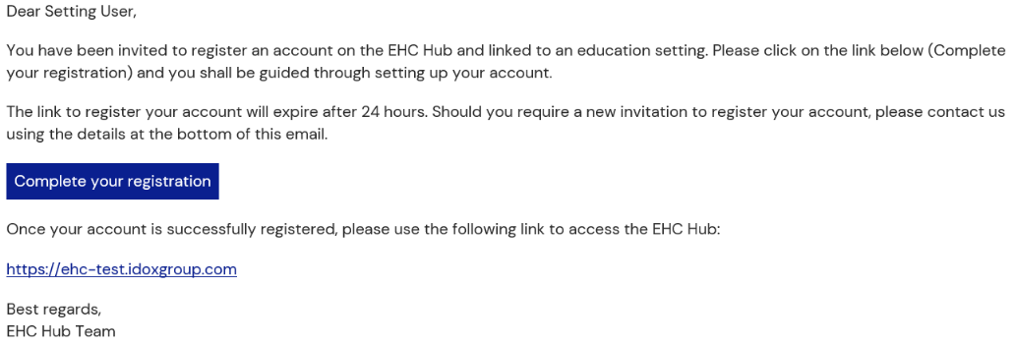
Click on the Complete your registration link in the email. The following page will appear:
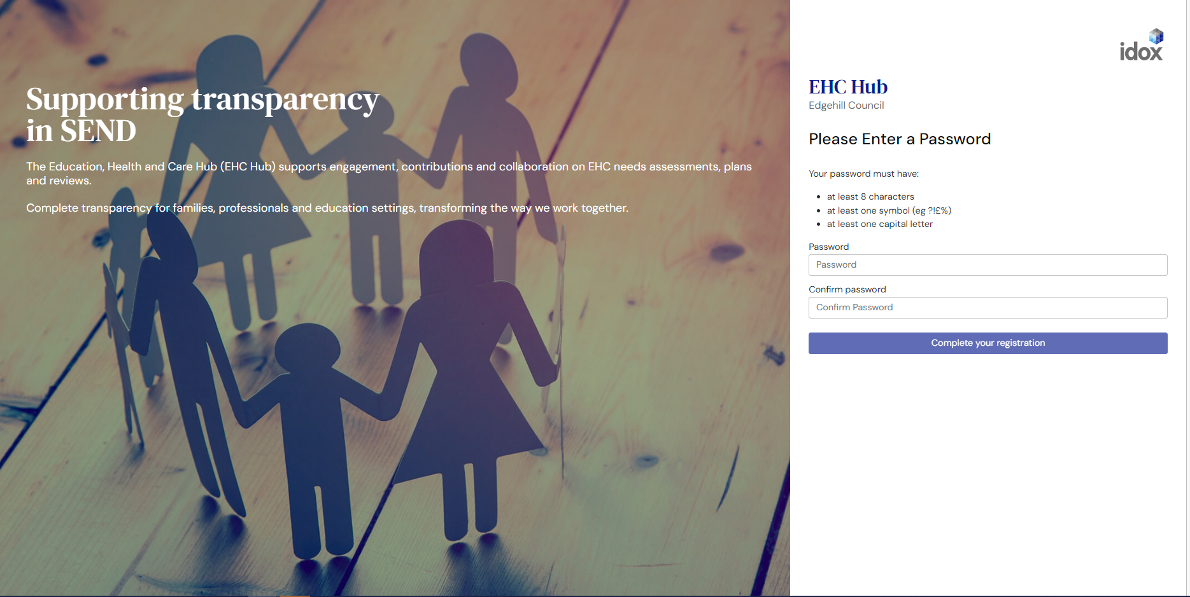
Enter a password for your EHC Hub account in the Choose your password field. Your password must have:
- At least 8 characters
- At least one symbol (eg ?!£%)
- At lease one capital letter

Enter the password again in the Confirm your password field. If the password entered does not match the criteria you will get a warning:

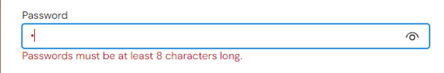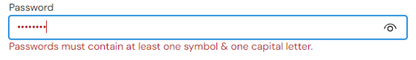

If the two passwords don’t match, you will get a warning message prompting you to type it again. You won’t be able to complete your registration unless the two passwords match:
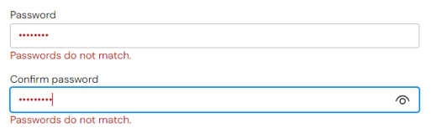

Click on Complete your registration.
You will then be asked to enter your username and password.
If there is a problem with your account, this message will appear in the top right-hand corner of the screen:
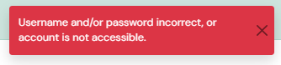
In this case, check you are entering the correct username (your registered email address) and password (just created). If problems persist, please contact your local authority. Contact details are included at the bottom of EHC Hub notification emails.
Once your username and password have been entered correctly, the following page will be displayed:
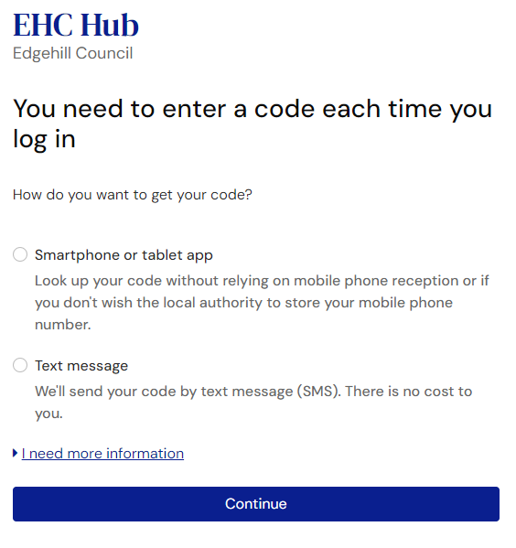
This is a second level of security to make sure only you can access the request details on the EHC Hub. This can be done with an authentication app on your smart phone, or using SMS text messages, whichever you prefer.
There is an expandable section on this page if you need more information:
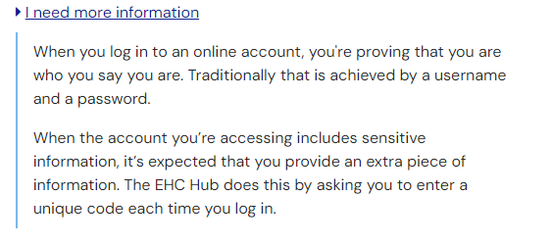
If you select an authentication app, this app will provide you with a 6-digit code to be entered. If you select Use SMS instead of an app, the 6-digit code will be sent to your mobile via a text message, and this can be entered on screen.

App Authentication
If you want to use an App authentication, click ‘Smartphone or tablet app’ then click ‘Continue’:
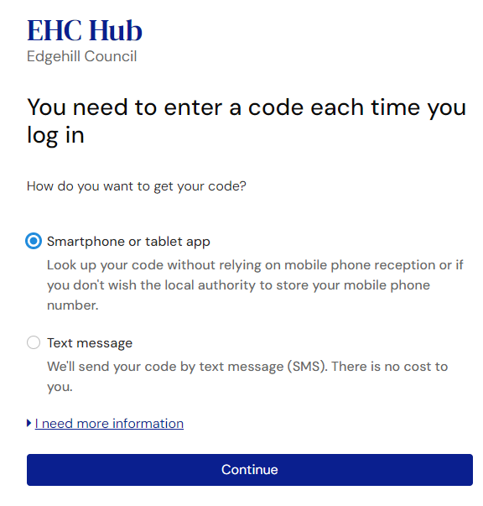
You will be given instructions on how to verify using the App authentication. This page will give you a ‘start again’ link. Which will allow you to go back to the previous screen and select the text message option instead:
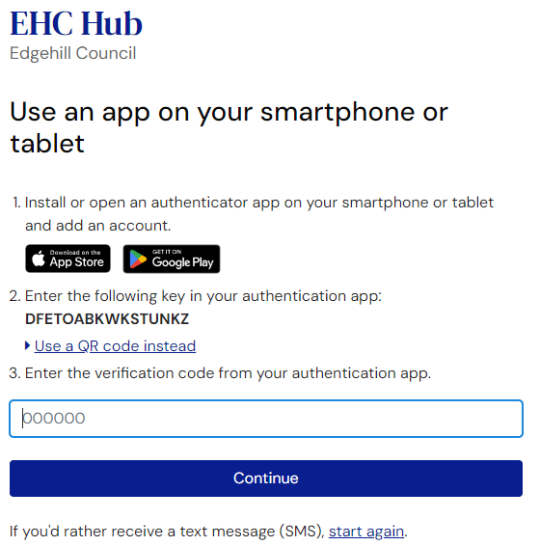
You can either enter the key displayed on the above screen directly into your Authentication App or you can also click ‘Use a QR code instead’, this will change the screen to show a QR code:
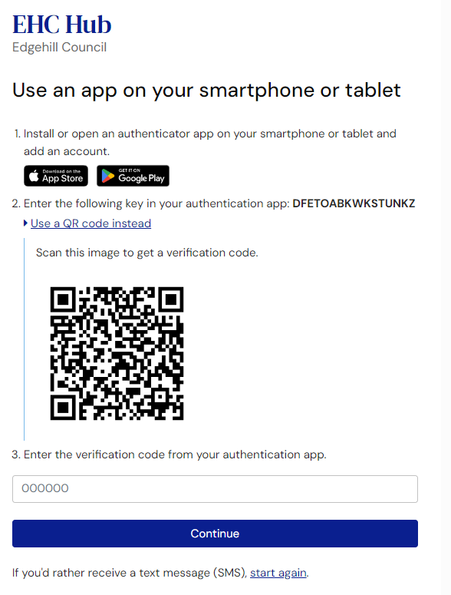

This will require you to turn your camera on your phone and use it to scan the QR code on the screen. You will automatically be directed to your authentication app and it will provide you with a six-digit code.
Enter this code into the field and click ‘Submit’. You will be taken to your ‘My cases in progress’ work tray:
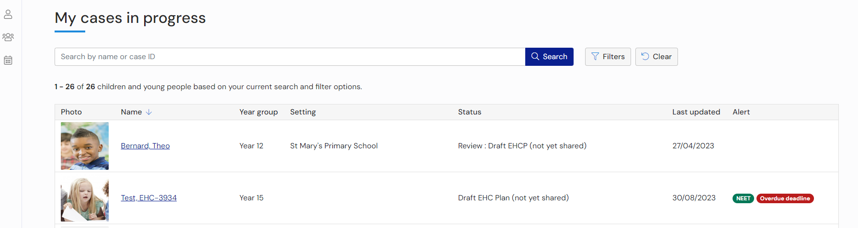

SMS Authentication
If you want to use SMS authentication, click on ‘Text message’ then click ‘Continue’:
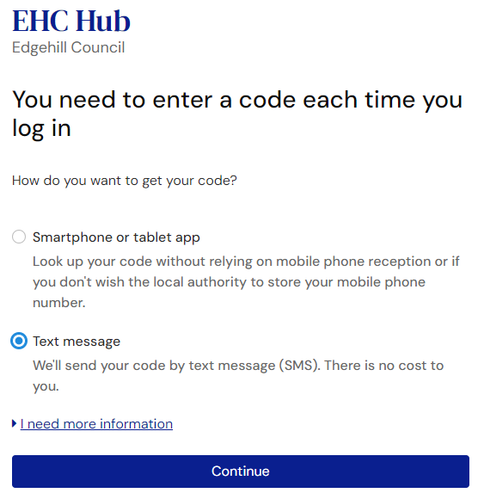
The following page will appear, it will give you a ‘start again’ link. Which will allow you to go back to the previous screen and select the authentication app option instead:
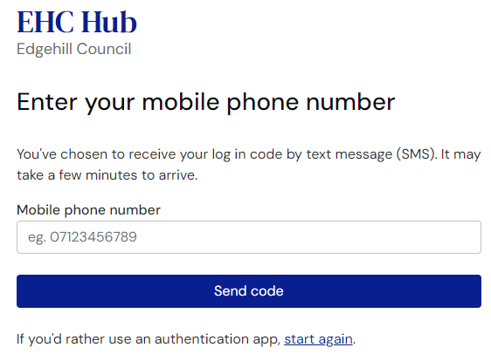
Enter the mobile number the text message with the code should be sent to and click on ‘Send code’. You will then see the following page, with a field to enter the code that was sent to the mobile phone number entered:
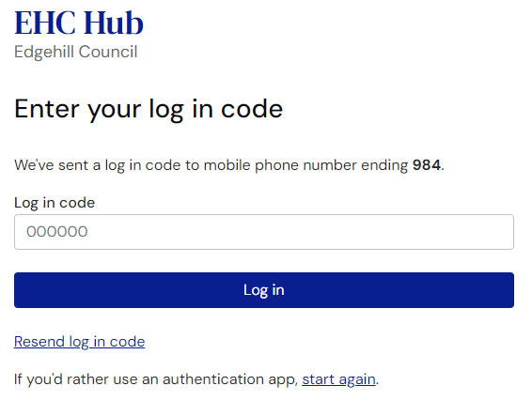
If you do not receive the code or the code times out, you can use the ‘Resend log in code’ and it will send you a new code via text message.
When you enter the code and click ‘Log in’. You will be take to your ‘My cases in progress’ work tray:
You have now successfully logged into the EHC Hub.

Viewing your work trays
When you log into the EHC Hub, you will be taken to the ‘My cases in progress’ work tray which will show a list of any cases currently assigned to you that are in progress:
There are 2 other work trays you will have access to as a SENCO, ‘My live cases’ and ‘Setting cases. ‘My live cases’ will show all cases currently assigned to you which are awaiting review and will have a status of ‘Review pending:
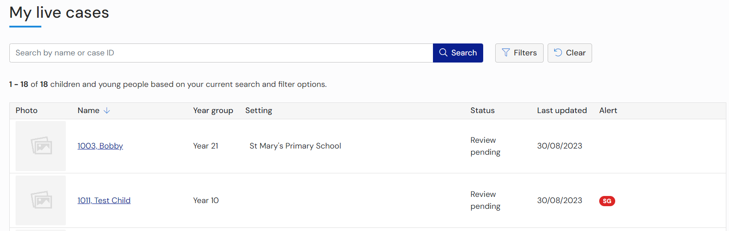
The ‘Setting cases’ work tray will allow show you all cases assigned to your Education Setting whether you are the named SENCO or not:
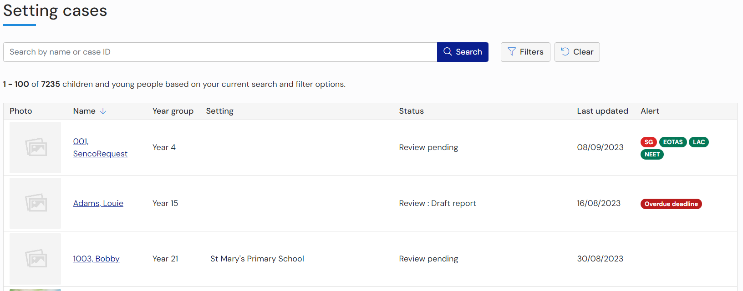
To view a case, click the Child/Young persons name. The case file will be displayed:

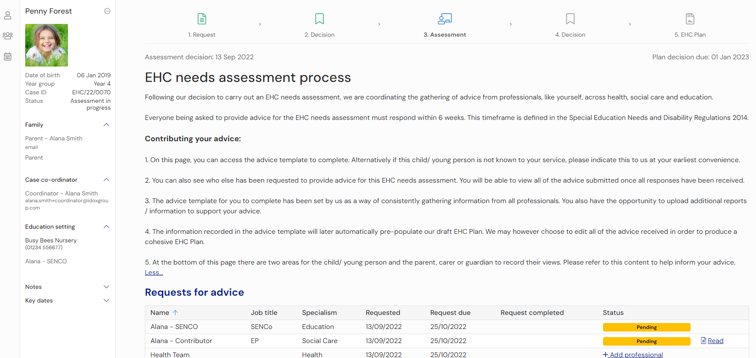

Searching for a Case
There are 3 work trays which you have access to and each one has a search bar and filters at the top of the screen, which you can uses to find specific cases:
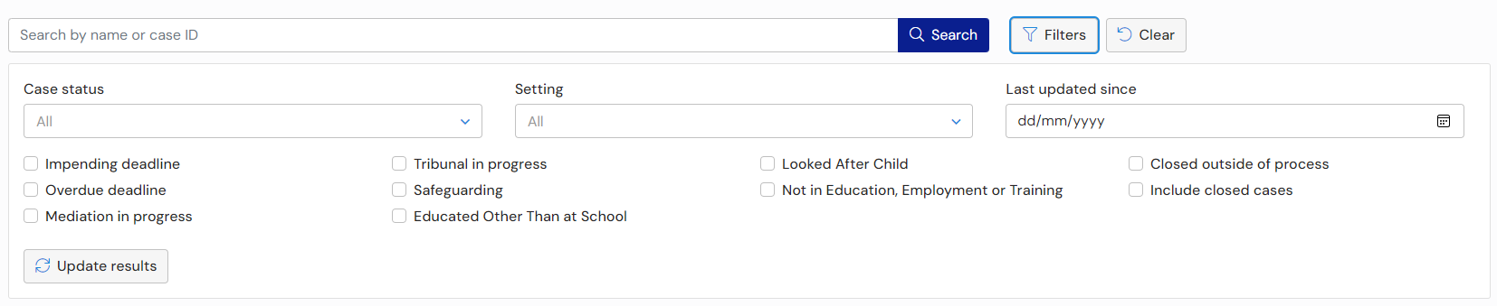

Using the search bar:
Start typing the name or the case ID into this field and the system will filter the list to display cases that match this criteria. For example, if you start typing “ha” in here, any case name that contain ha will be displayed.
Using the filters:
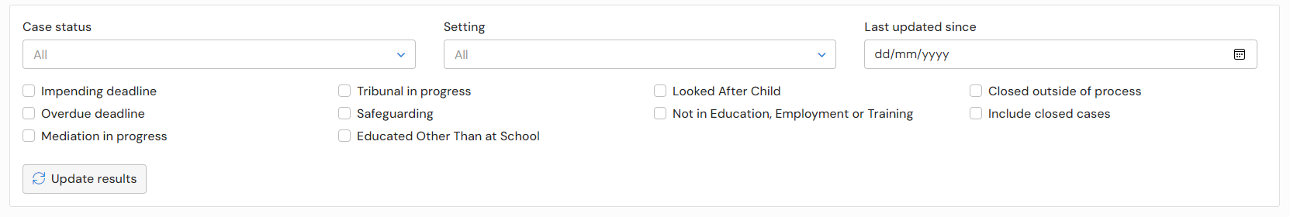
The display can be filtered by Case Status, Education setting and Last updated since.
Case Status – click ‘All’ in the Case status field and a box will be displayed showing all the statuses available:
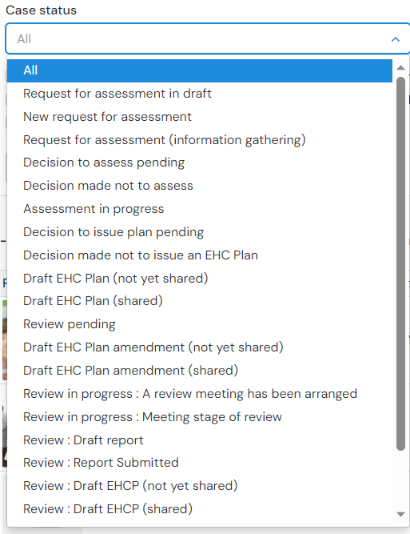

Click to select the required status
Education Setting – Click on All in the Education setting field to view the available education settings:
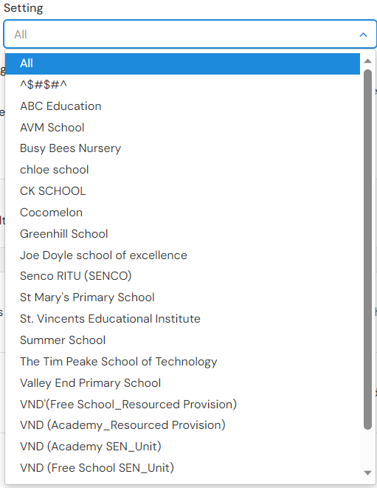
Click to select the required education setting
Last updated since – Type in the date required with a dash between the day, month and year. Alternatively, left click on the field and select the date from the calendar:
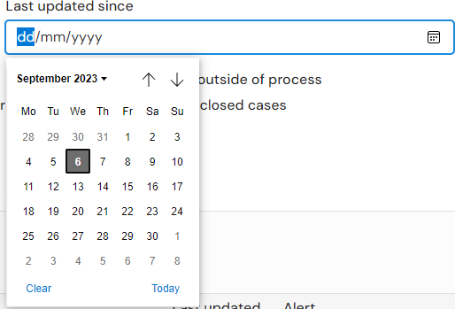
Navigate around the calendar using the arrows in the top right and left corners until the correct date is available. Left click on the date to select it
There are also 10 checkboxes for you to use:
- Impending Deadline
- Overdue Deadline
- Mediation in progress
- Tribunal in progress
- Safeguarding
- Educated Other Than at School
- Looked After Child
- Not in Education, Employment or Training
- Closed outside of Process
- Include closed cases
- Open education setting consultations (this is only visible in the ‘Setting cases’ work tray)
To clear any filters, click ‘Clear’ all filters button at the top of the filters.

Viewing a Case File
To view a case, click the child/young persons name. The case view will be visible:
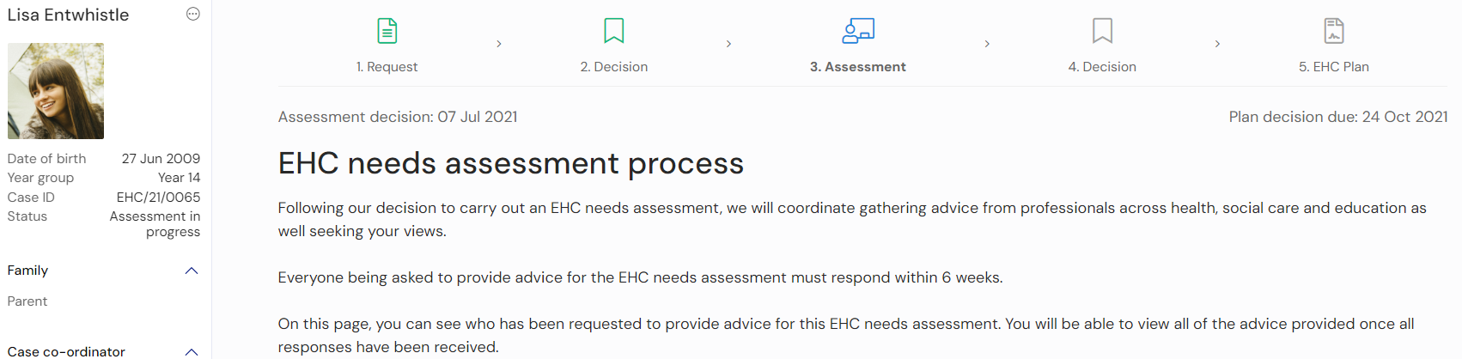

Status of the Process
The top of the screen will show what stage of the process the EHC plan is currently at.
Underneath this, key details relevant to the stage of the process will be displayed. For example, if the process is at the Consultation stage, the review meeting date and the date the consultation is to be completed by will be displayed along with a description of what is expected at this stage:
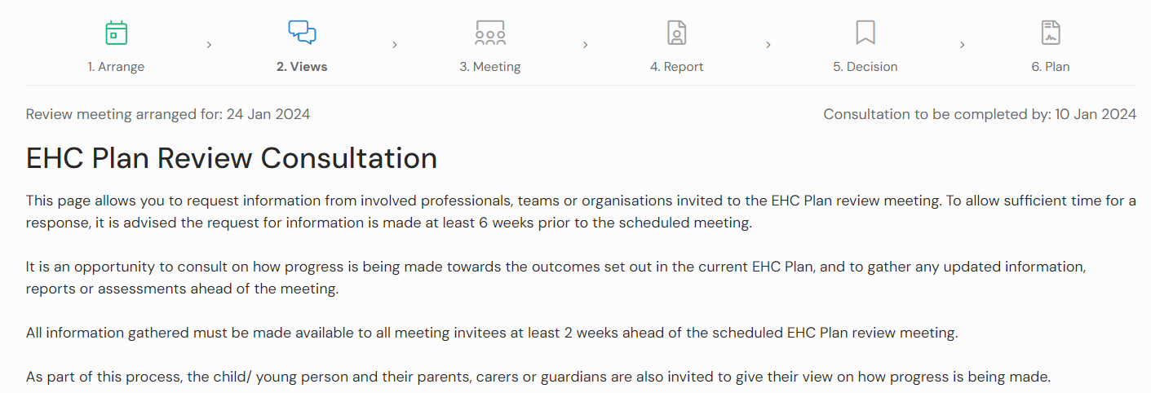

Details of the Case
The left-hand side of the screen can be used to access different parts of the case record.
The top section shows the Child/Young persons name, DoB, Year group, Case ID and current status of the process as well as a photo if uploaded by a parent/carer/guardian or the case co-ordinator:
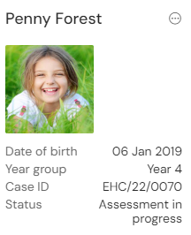
When you click the 3 dots in the top right and select ‘View details’, you will be given more information about the child record:
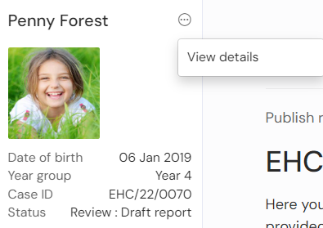
You will then see the following information:
- Child or young person’s details
- Child or young person’s main contacts (family and involved professionals)
- Current Education Setting
- Previous Education Setting
This is what the screen will look like:
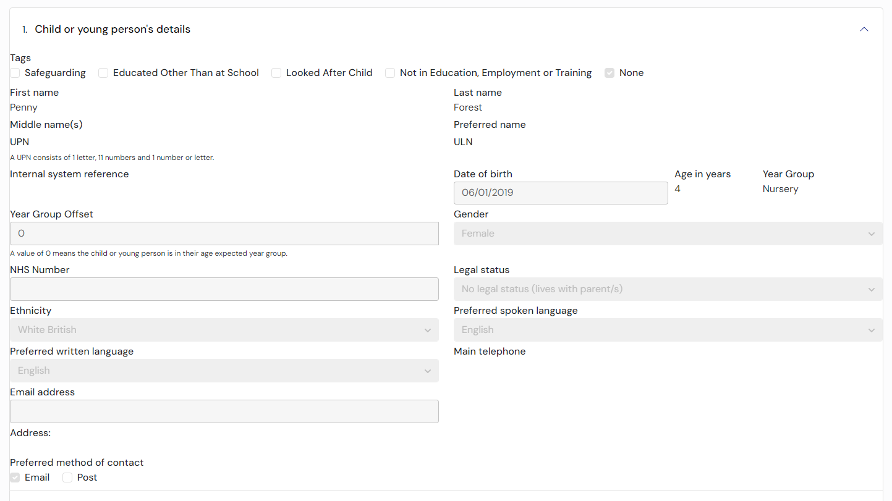
Scroll down to the bottom of the screen and click ‘Cancel’ to go back to the case view.
Below the child details, there are other sections for Family, Case Co-ordinator, Education Setting, Notes & Timeline and Key Dates:
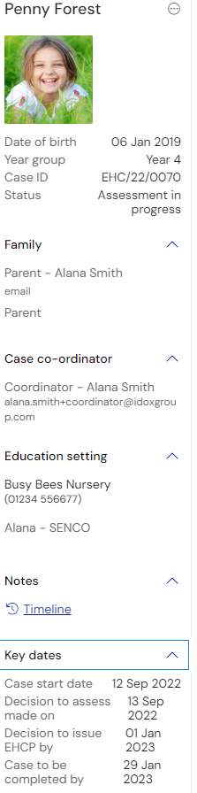
You can expand or collapse each section by clicking the section heading or the arrow at the end of each section header:
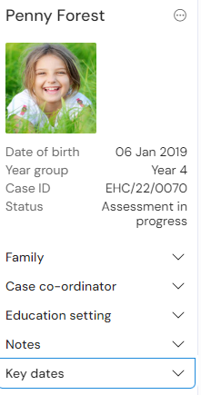
Family – This will show the details of any parent, carer, guardian, the young person or advocate who has access to the case
Case co-ordinator – This will show the case co-ordinator responsible for overseeing the process
Education Setting – This will show the details of the education setting which has access to the case
Notes – This is where you can view the case timeline. Click on View details to see this information:
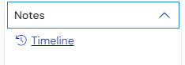
Key Dates – this will display the key dates in the process, based on the statutory date requirements. For example, it could show the start date of the case, when the decision to assess needs to be made and when the case needs to be completed:
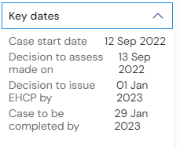

Completing a Needs Assessment Request
To make a new request, click on the Plus icon on the left hand of the screen:
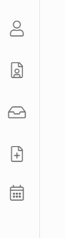
The following sections contain details on how to complete the different sections of the needs assessment request if you are the SENCo making the request. At this stage your Request for Assessment is in draft, which means no one (besides yourself) will be able to view this request. You can add to the request and save the changes, you do not need to submit it immediately. If you wish to continue working on your request you will be able to locate this within your ‘My cases in progress’ work tray, the request will have a status of ‘Request for assessment in draft’.
The following sections can be completed:
- Consent
- Details of person requesting an EHCP Assessment
- Child or young person’s details
- Child or young person’s main contacts (family and involved professionals)
- Details of the child or young person’s current education setting(s)
- Details of previous setting(s)
- Important information about the child or young person
- Views of the child or young person and their parent, carer or guardian
- Identified special educational needs (SEN)
- Supporting Documents
There are certain fields that are required and that must be completed in order for the request to be sent, these will be marked with a red asterisk.

Consent
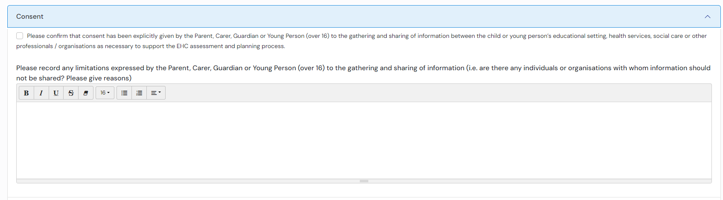
Click in the tick box to confirm that the Parent, Carer, Guardian or Young Person (over 16) has given consent to the gathering and sharing of information.
Click in the text box to record any limitations expressed by the Parent, Carer, Guardian or Young Person (over 16). Click here for more information on using text fields.

Details of person requesting a EHCP Assessment
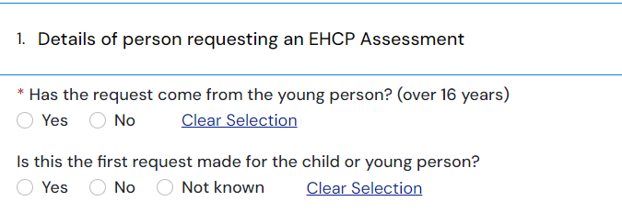
A SENCo completing the request should click “No”. The following extra fields will be displayed for the requester’s details:
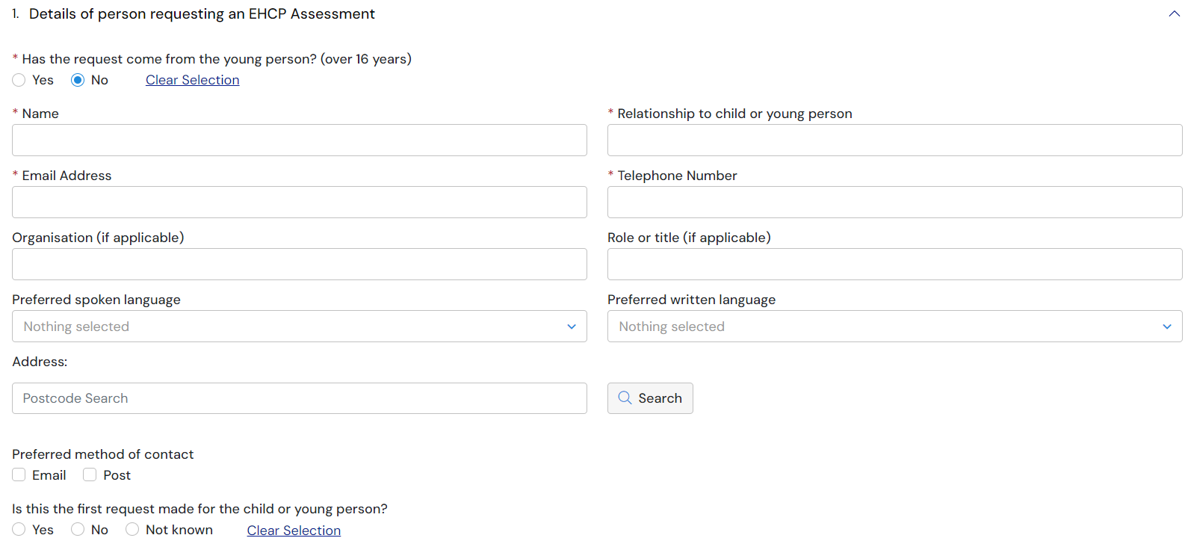
Name – Enter your name.
Relationship to child or young person – Enter the nature of the relationship between yourself and the young person
Email Address – Enter your contact email address if you are the person making the request. When the request has been completed and sent, a confirmation email will be sent to this email address to show that an assessment request has been sent.
Telephone Number – Enter your contact telephone number if you are the person making the request for the assessment.
Organisation – If you are making the request for this young person on behalf of an organisation, enter the organisation name here.
Role or Title – Enter your job role or title in the organisation
Preferred spoken language – click here for more information on using pick list fields:
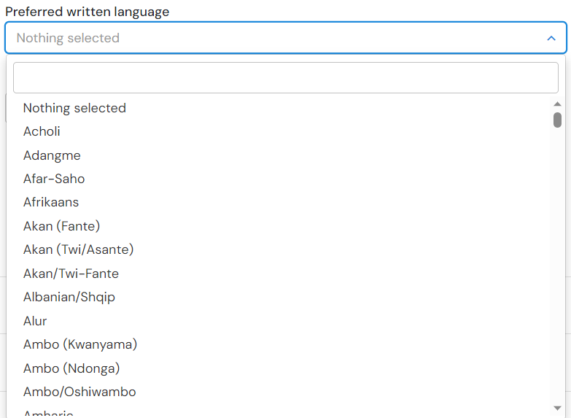
Preferred written language – click here for more information on using pick list fields .
Address – click here for more information on using address fields
Preferred method of contact – select if you would prefer to be contacted by email or post
Is the first request made for the child or young person – select Yes, No or Not known as applicable. If No is selected, enter the date a previous request was made, if known.

Child or young person’s details
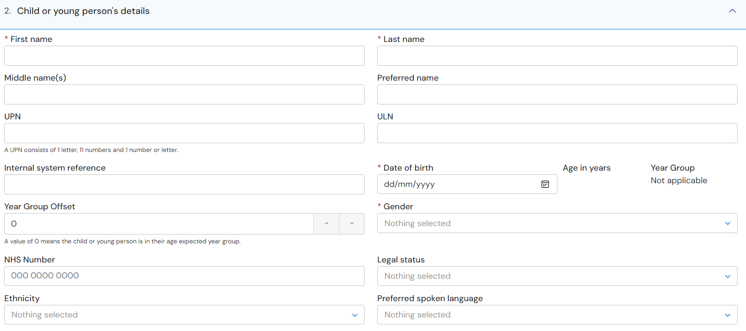
First name – enter the first name of the child or young person the request for an assessment is for.
Last name – enter the last name of the child or young person the request for an assessment is for.
Middle name(s) – enter the middle name(s) of the child or young person the request for an assessment is for.
Preferred name – enter the preferred name of the child or young person the request for an assessment is for.
UPN – enter the UPN if known. Otherwise, leave blank.
Internal system reference – local authority office use only. This should be left blank.
Date of Birth – Type in the date of birth, with a dash between the day, month and year. Click here for more information about using date fields.:
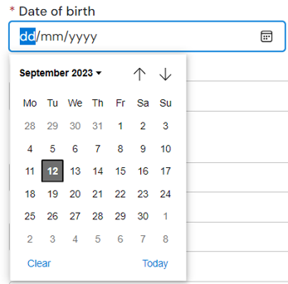
Once the date has been selected, the age and year group will be automatically calculated:
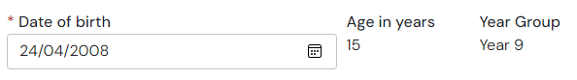
Year Group Offset – if the child or young person is not in their age expected year group, use this field to apply a correction; e.g. a child or young person in the year group below their age expectation would require an offset of “-1”.
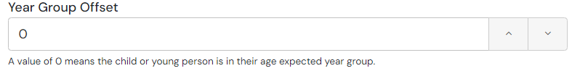
Click on the up or down arrow to change the year group offset.
Gender – Click here for more information on how to use pick list fields:
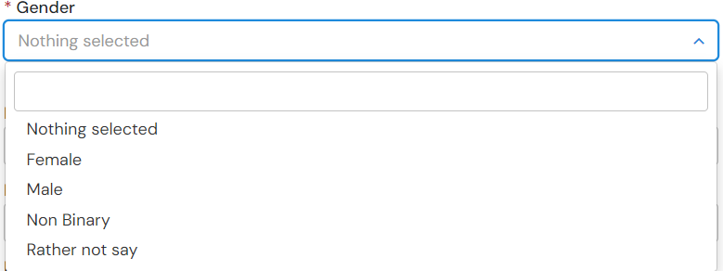
NHS Number – Enter the NHS Number of the child or young person, if known
Legal Status – Click here for more information on how to use pick list fields:
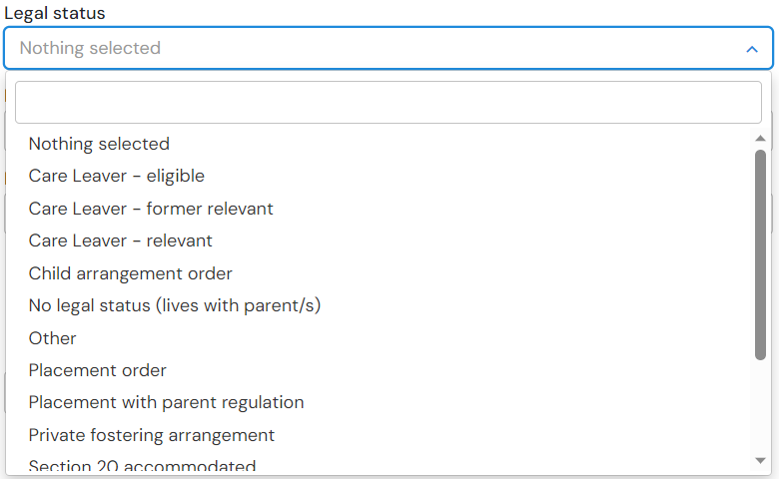
Ethnicity – Click here for more information on how to use pick list fields:
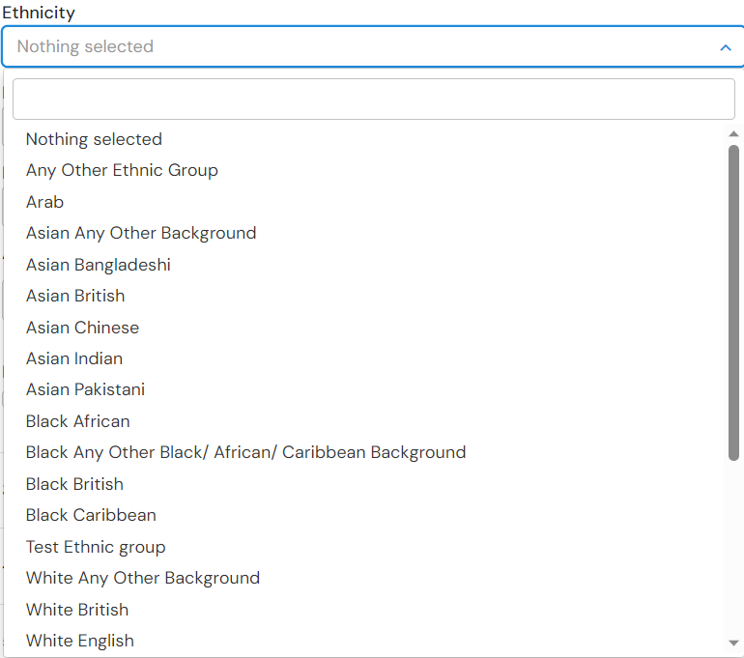
Preferred spoken language – Click here for more information on how to use pick list fields:
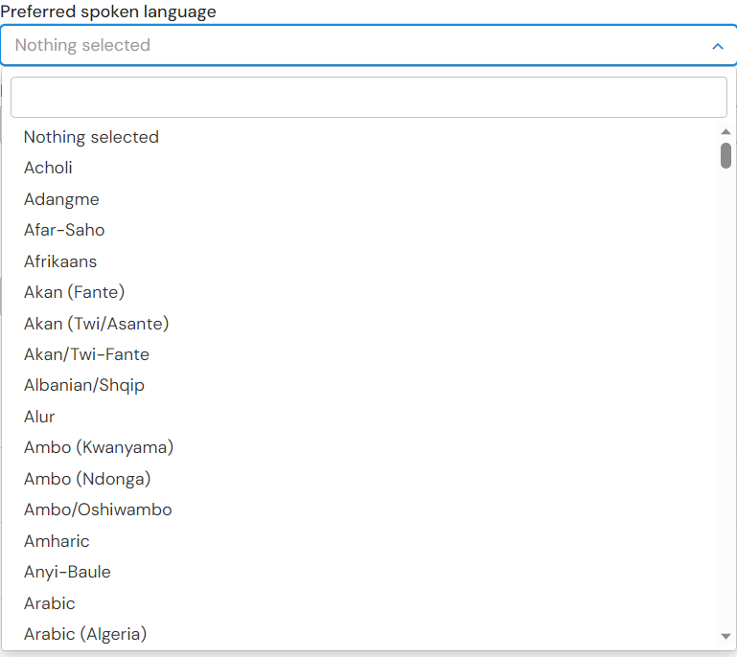
Preferred written language – This will automatically default to the preferred spoken language but can be amended if not correct. Click here for more information on how to use pick list fields
Main telephone – enter the main telephone number for this child or young person.
Email address – enter the email address of the child or young person. This is NOT the email address any confirmation emails or requests for registration will be sent to and is just for information.
Address – See here for more information on how to use address fields
Preferred method of contact – select if the young person would prefer to be contacted by email or post, if appropriate.

Child or young person’s main contacts (family and involved professionals)
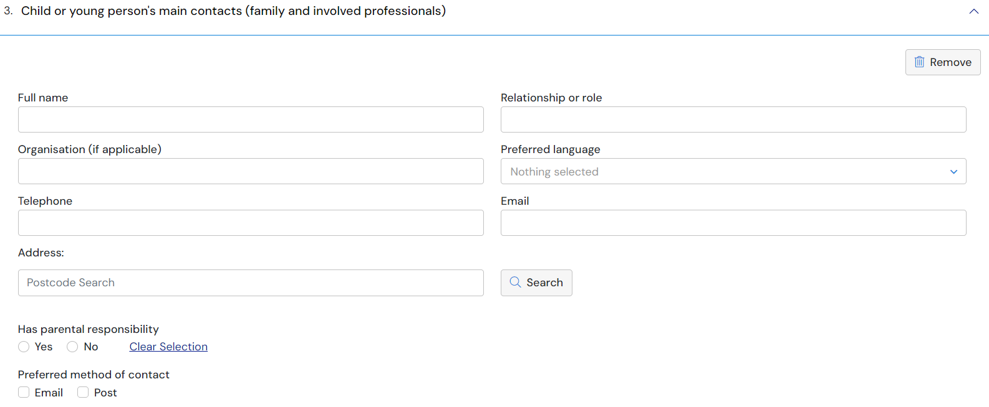
This section is for details of any contacts for the child or young person the request for an assessment is being made for. All family and involved professionals relevant to the request should be included.
Full name – enter the name of the Full Name of the contact e.g. John Smith
Relationship or role – enter the relationship between or the role of the contact to the child or young person the request for an assessment is being made for. E.g. Father
Organisation (if applicable) – if this contact is part of an organisation (as opposed to a family member), enter the name of the organisation here
Preferred Language – Click here for information on how to use pick list fields
Address – Enter the details of the contact for the child or young person. See here for more information on how to use address fields.
Has parental responsibility – select yes or no if this main contact has parental responsibility
Preferred method of contact – select the preferred method of contact for the child or young person’s contact.
It is possible to add more than one contact to the assessment. To add further contacts to the request, click on the Add button in the bottom right-hand corner and complete the fields as above. This can be done as many times as required.
To remove a contact, click on Remove in the top right-hand corner of the section:
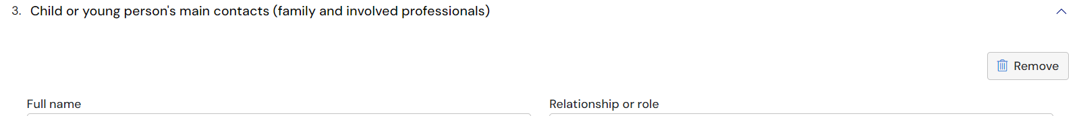

Details of the child or young person’s current education setting(s)
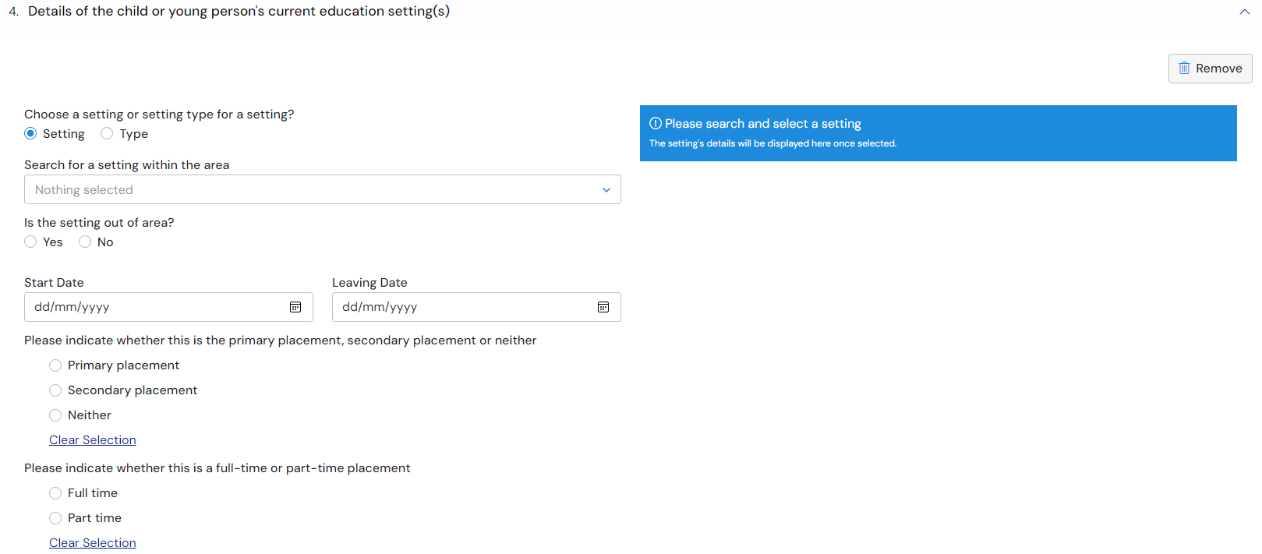
It is possible to add an educational setting either based on the setting itself (e.g. the actual name of the education setting) or based on the type of setting (e.g. Mainstream school, Special school: Non-maintained etc). The details available to be completed will be based on if Setting or Type is selected.
Setting
If Setting is selected, search for a setting within the dropdown list – Click here for more information on using Pick Lists:
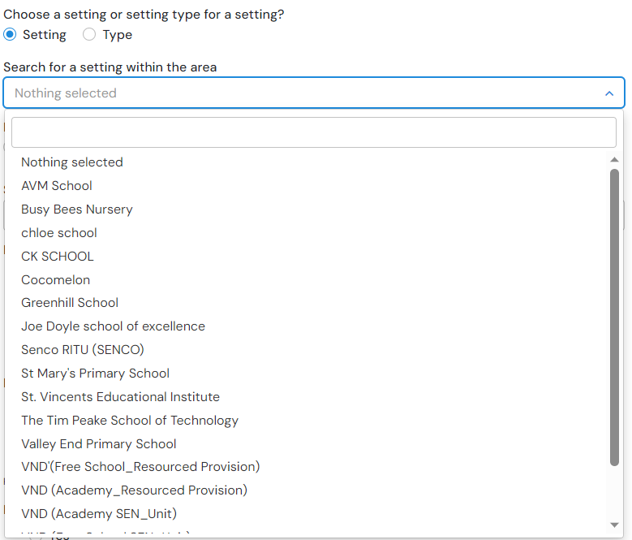
If the setting is not on the list, click on Nothing selected and click on Yes to the next question, Is the setting out of area. The setting can then be added manually in the fields on the right:
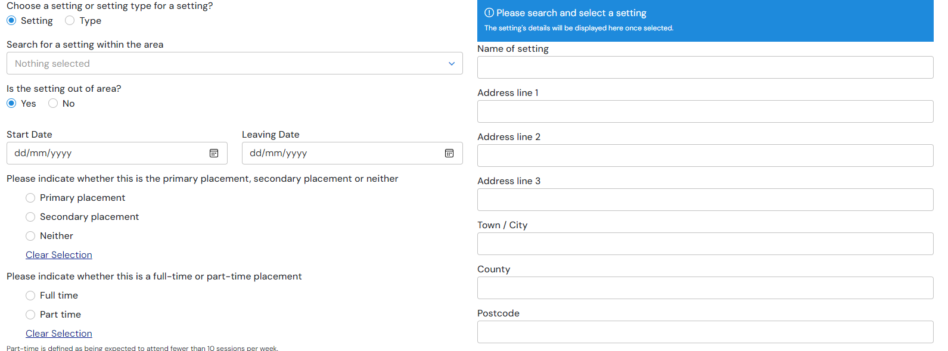
Start Date – Type in the date the child or young person started at the educational setting. Click here for more information on using date fields:
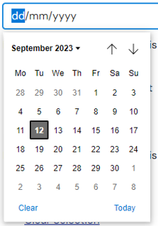
Leaving Date – if known, enter the date the child or young person left or will leave the education setting
Reason for leaving – Enter a reason for leaving. Click here for more information on using free text fields:
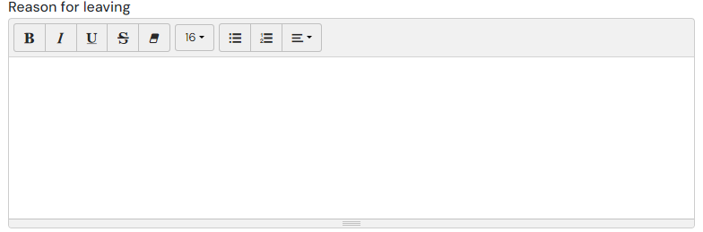
Percentage attendance of child or young person in the last year and any comments on this – Click here for more information on using free text fields:
Additional Details - Click here for more information on using free text fields:
Type
If type is selected, the screen will look like this:
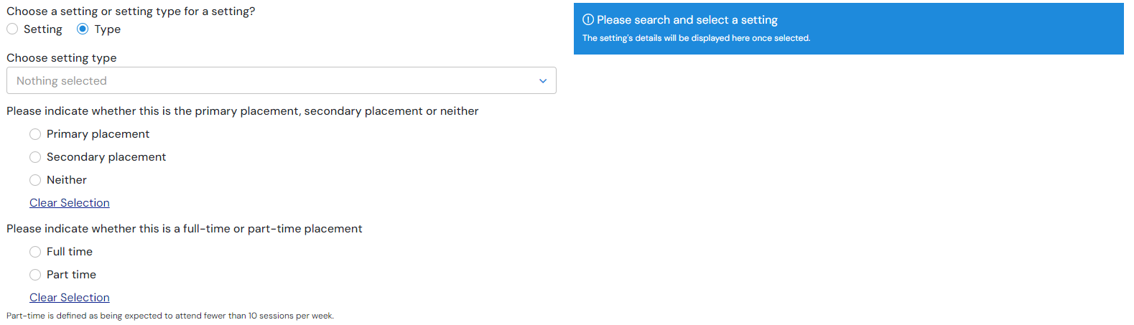
Choosing setting type - Click here for more information on how to use pick list fields :
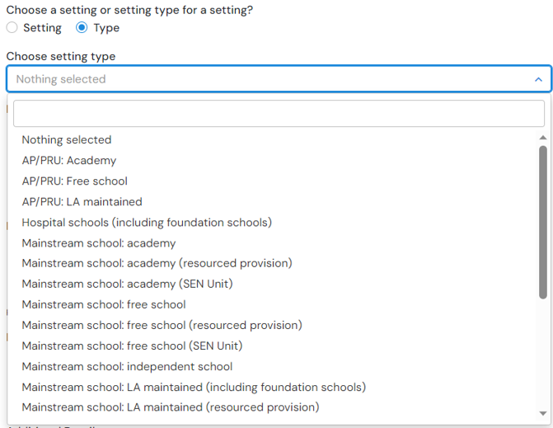
Left click on the required option to select it.
Additional details – click into the field to enter information. Click here for more information on using free text fields
Multiple education settings can be added. To add further education settings to the request, click on the Add button in the bottom right-hand corner and complete the fields as above. This can be done as many times as required.
To remove an education setting, click on Remove in the top right-hand corner of the section.

Details of previous setting(s)
If the child or young person has attended any other education settings in the last five years, click on Yes and enter the details as described above.

Important information about the child or young person
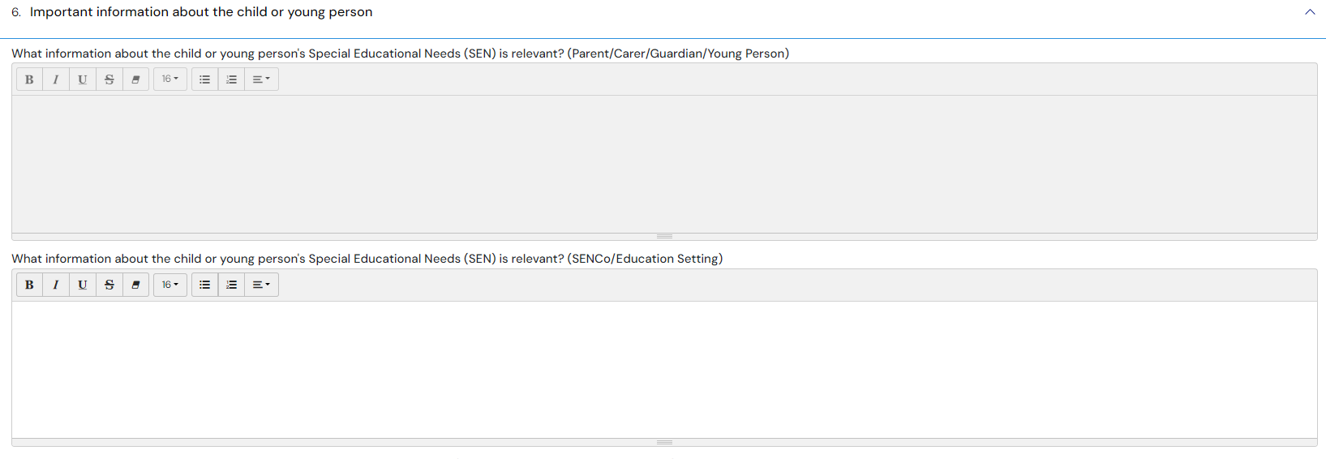
The section is used to enter historical information relevant to the request. You will notices that the boxes (questions) are duplicated, this is so that your comments and the parent/carer/guardian/young person comments are kept separate.
The parent/carer/guardian/young person boxes will be greyed out to you, and your boxes will be greyed out when the parent/carer/guardian/young person log in.
What information about the child or young person's Special Educational Needs (SEN) is relevant? (SENCos/Education Setting) – Click here for more information on using free text fields.
What information about the child or young person's health needs is relevant? (SENCos/Education Setting) – Click here for more information on using free text fields.
What information about the child or young person's social care needs is relevant? (SENCos/Education Setting) – Click here for more information on using free text fields.

Views of the child or young person and their parent, carer or guardian
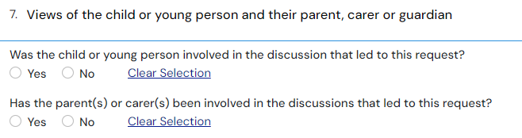
Was the child or young person involved in the discussion that led to this request– click on Yes or No
If Yes is selected, the following fields will be displayed, A Views and opinions of the child or young person:
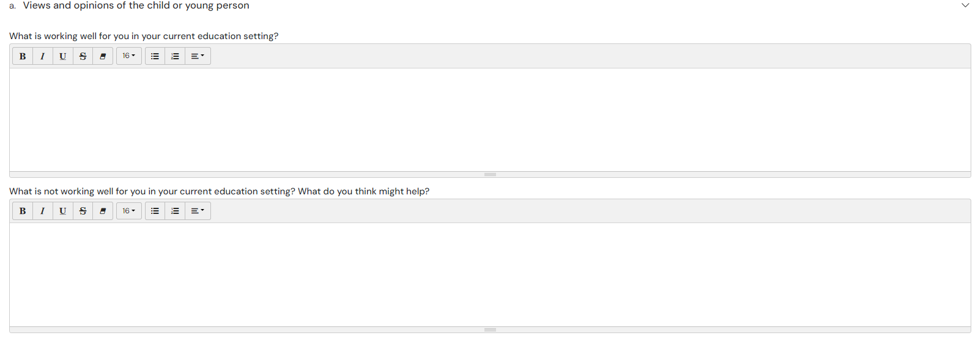
What is working well for you in your current education setting? – Click here for more information on using free text fields.
What is not working well for you in your current education setting? What do you think might help – Click here for more information on using free text fields.
If No is selected, the following field will be displayed:
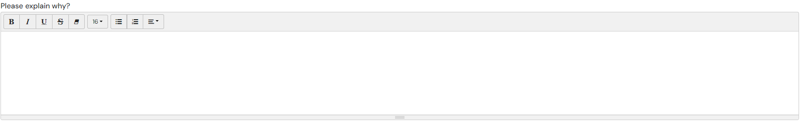
Please explain why – Click here for more information on using free text fields.
Has the parent(s) or carer(s) been involved in the discussions that led to this request – left click on Yes or No.
If Yes is selected, the following fields will be displayed, b Views and opinions of the parent(s) or carer(s):
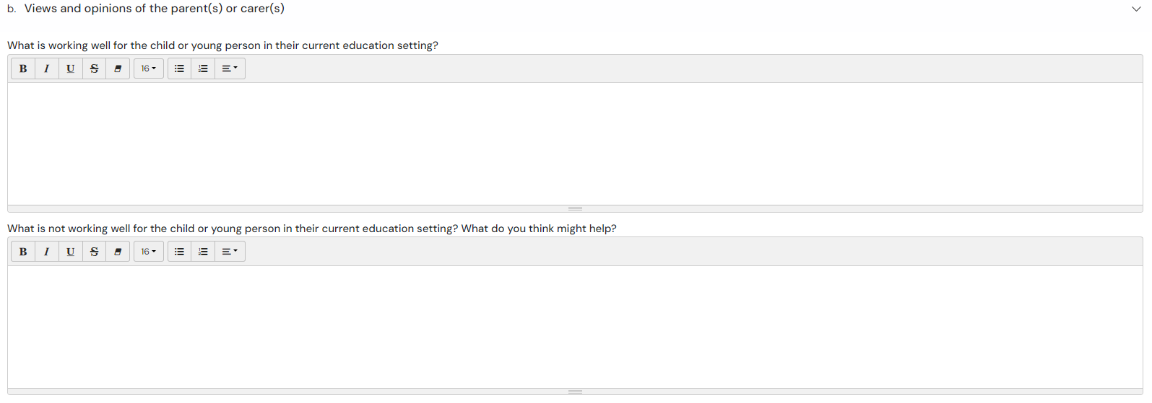
What is working well for the child or young person in their current education setting? – Click here for more information on using free text fields.
What is not working well for the child or young person in their current education setting? What do you think might help? - Click here for more information on using free text fields:
If No is selected, the following field will be displayed:
Please explain why – Click here for more information on using free text fields
Identified special education needs (SEN)
There are four sections to this
- Communication and interaction
- Cognition and learning
- Social, emotional and mental health
- Sensory and/or physical needs
Each area of need has the same layout. Firstly, you will be asked if this is an area of need:
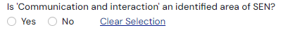
Click on Yes or no as applicable.
If Yes is selected, more free text fields will be displayed to be completed with the appropriate information:
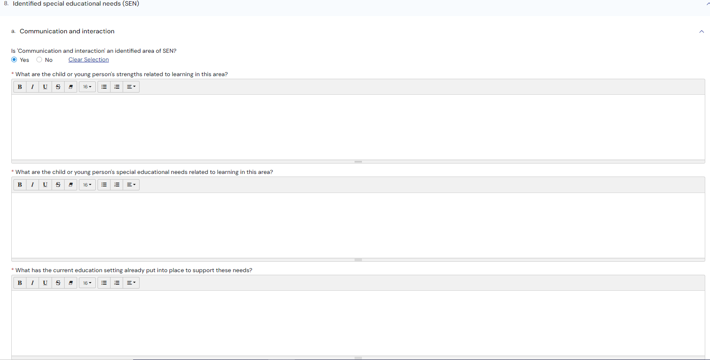
Are there any anticipated outcomes for the child or young person in this area – if you select yes additional boxes will appear:

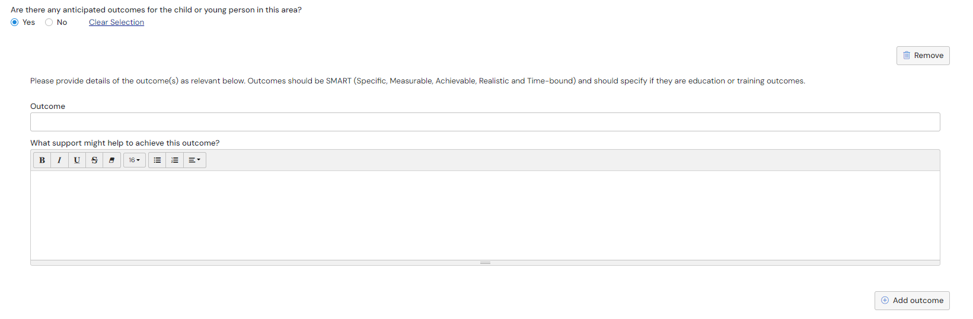
You can add multiple outcomes by clicking ‘Add outcome’.
If the local authority make a decision to assess then any details you have entered within this section will automatically carry over to you advice request.

Supporting Documents
Any addition information to support the request can be uploaded here. Examples of supporting documents are listed on the page:
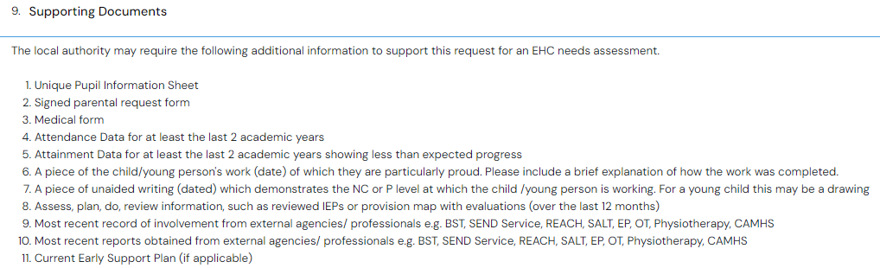
If you want to add any supporting documents, click ‘Add Files’:
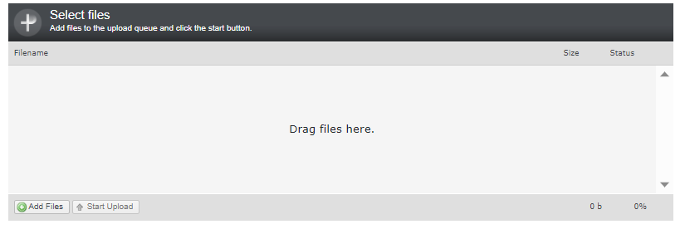
You will then need to navigate to the file wherever it is saved on your PC:
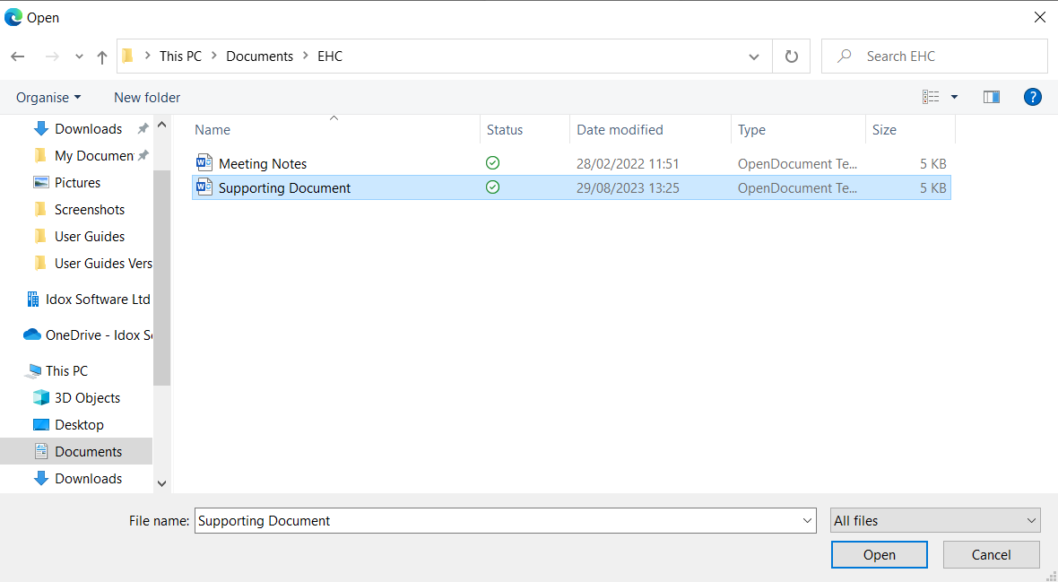
Click ‘Open’ and the file will be uploaded. The uploaded file will be displayed: 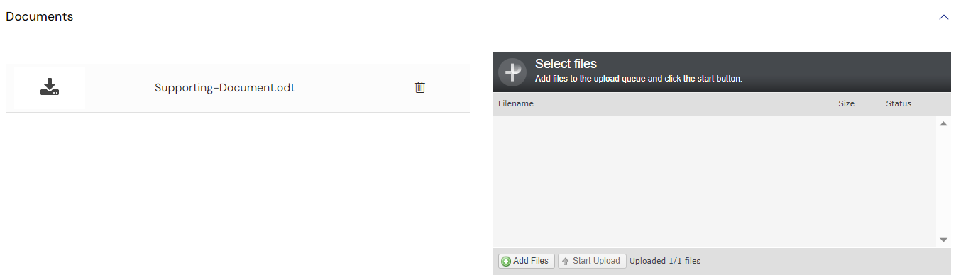

Saving the request
The request can be saved at any time by clicking ‘Save’ button at the top of the screen. These options will remain available as you scroll down the sections of the request.
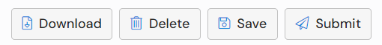

Downloading the request
The information entered into the request can be downloaded as a PDF at any time. Click ‘Download’ to download the file:

Deleting the request
To delete the draft request, click ‘Delete’ at the top of the form:

Submitting the request
When all the required information has been entered, you will need to click ‘Submit’ at the top of the page:
There are certain fields that are required and that must be completed in order for the request to be sent. These are indicated with a red asterisk:
If information has not be entered into a required field, when the ‘Submit’ button is clicked, the section header containing the required information will turn red and the field to be completed will be shown with a message saying “This is required”. If any mandatory fields have not been completed, these will be highlighted with a red box:
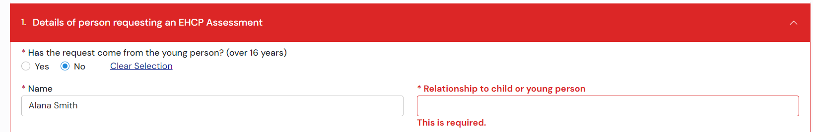
Complete the fields and then click ‘Submit’. When the request has been submitted, a message will appear to confirm this:

You will also receive an email notification:
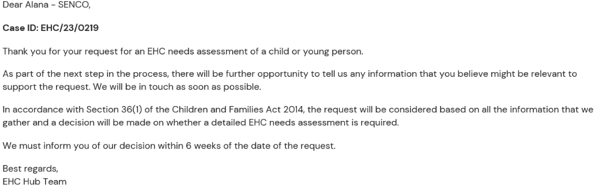
Once the request has been submitted, it will be sent to the local authority.
This case will not appear in your list of cases until you have been allocated as SENCo by the local authority.
Once you have been allocated as the SENCO on this case you will receive another email notification, similar to this:
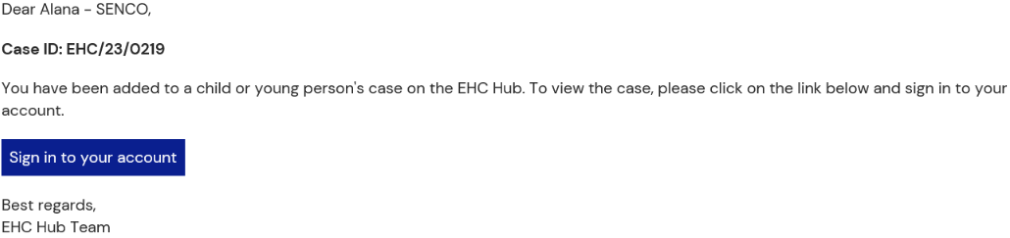
The case will appear in your ‘My cases in progress’ work tray with a status of ‘Request for assessment (information gathering):
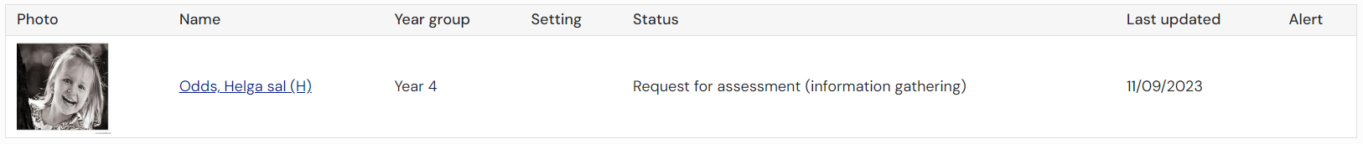

How to contribute to a request
When you sign into the EHC Hub, the request will appear in your cases in progress list with a status of Request for assessment (information gathering):
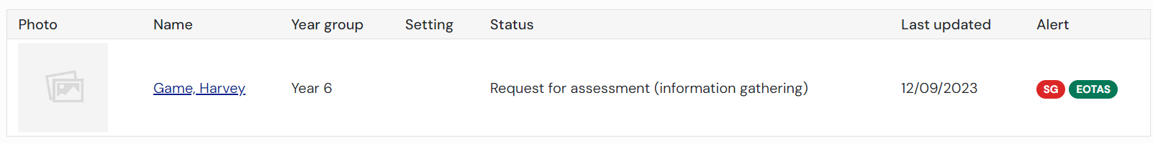
Some of the information can be amended or added to here by you, but some information can only be amended by the case co-ordinator.
If you want to change information in an area that can only be amended by the case co-ordinator, you should email the case co-ordinator with the request.
The details of the case co-ordinator, including their email address are displayed on the left-hand side of the screen:
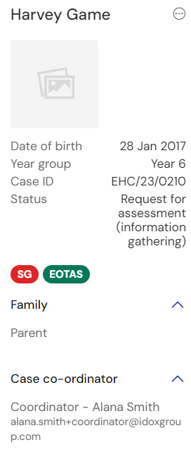
If you do make any changes, you will need to click ‘Save’ to save those changes.
Enter the correct information and click on save changes at the top of the screen:
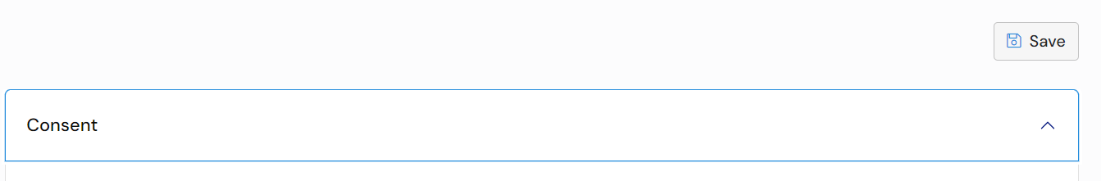
When you click ‘Save’, the information will update and the following message will appear:
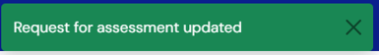
Once all of the information for the decision on the assessment has been gathered, the case co-ordinator will progress the case to the next stage.

Decision to Assess Pending
When the case co-ordinator progresses the case on to make a decision, the case status will update from ‘Request for assessment (information gathering)’ to ‘Decision to assess pending’:
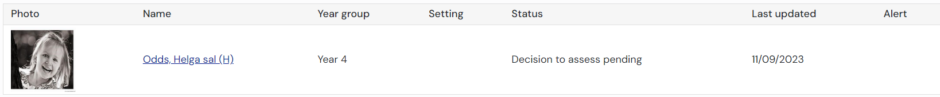
When the case is viewed, it will look like this:
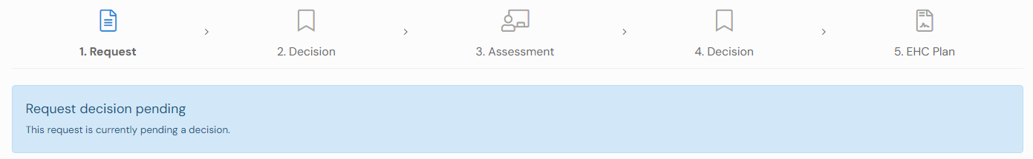
As a decision is pending the ability to edit the request for assessment is removed.

Assess Decision
When the decision has been made to assess the child or young person or not, you will receive an email telling you this and asking you to access the hub to view the details. The email will look something like this:
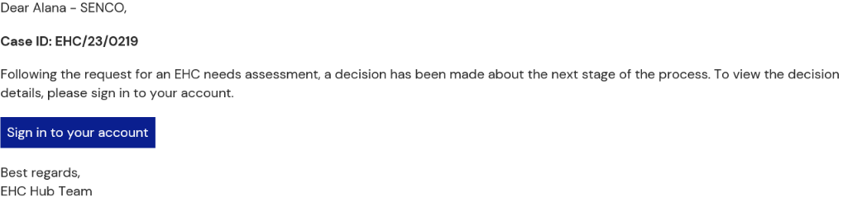
When you sign into the Hub, the case status will look like this:
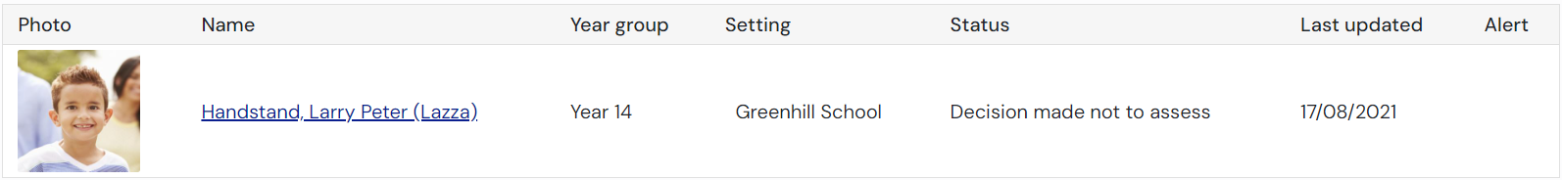
Or
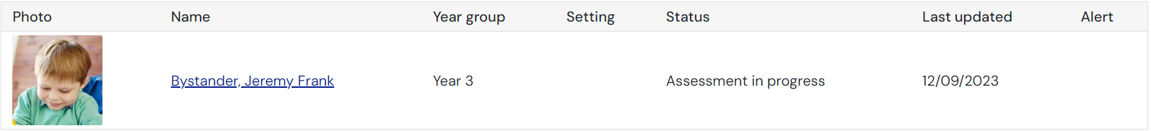
If the decision was made not to proceed with an assessment, the case file will not be displayed in your ‘My cases in progress’ work tray as this case is no longer in progress. To view the information select Include closed cases tick in the filter bar on the left hand side:
You will be able to view the decision reason and download the decision letter by clicking on the child/young person name. This is what the view will look like:
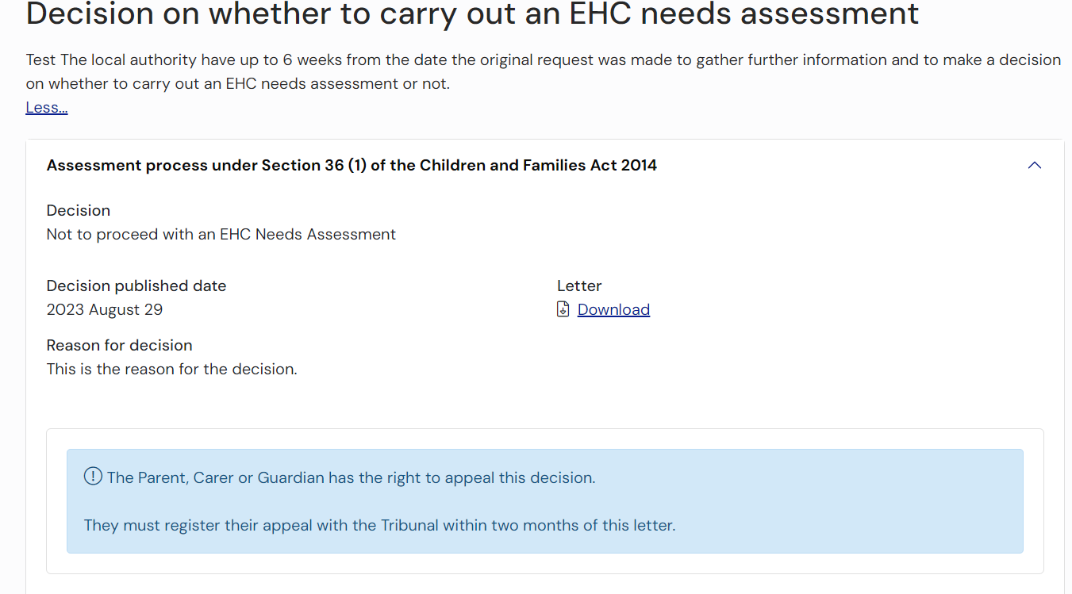
If the Local Authority originally say ‘no’ assessing the child/young person, they can change their decision by recording a second decision. You will be notified by email and the decision screen will show the second decision at the top and the previous decision at the bottom, it will look like this:
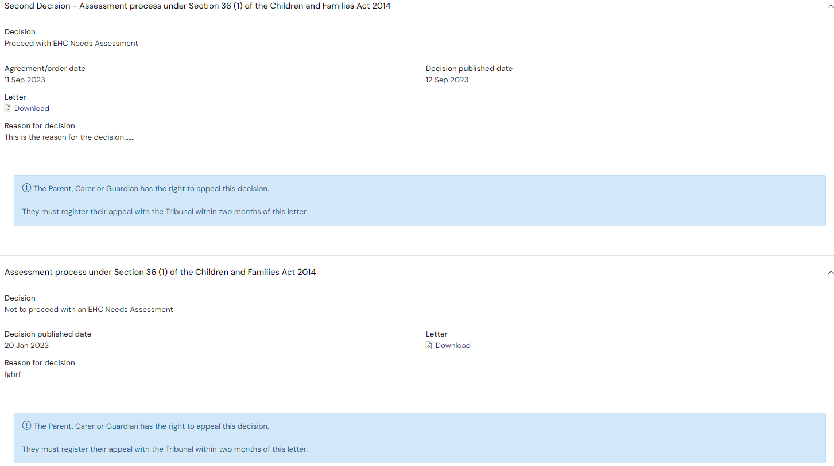
If the decision was to assess the child/young person, the status will update to ‘Assessment in progress’ and you will be taken to the ‘Assessment’ stage of the case. You will be able to click back to the decision if you wish to view the reason or download the decision letter:
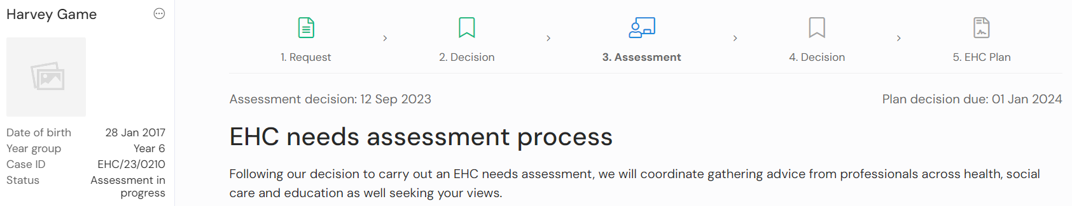

How to contribute towards an EHC needs assessment
If you have been requested to provide advice, you will receive an email to inform you of the request. The email will look similar to this:
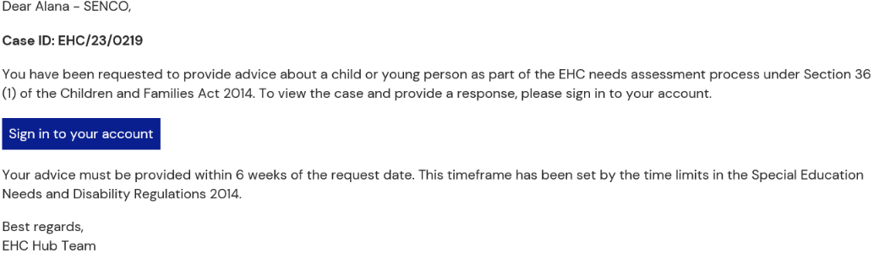
When you log into the hub, the case will be displayed in your My cases work tray and can be found by using the case reference included in the notification email.
Click here for more information on viewing the My cases in progress work tray.
When you click on the case file, the case will open to the “Assessment” stage:
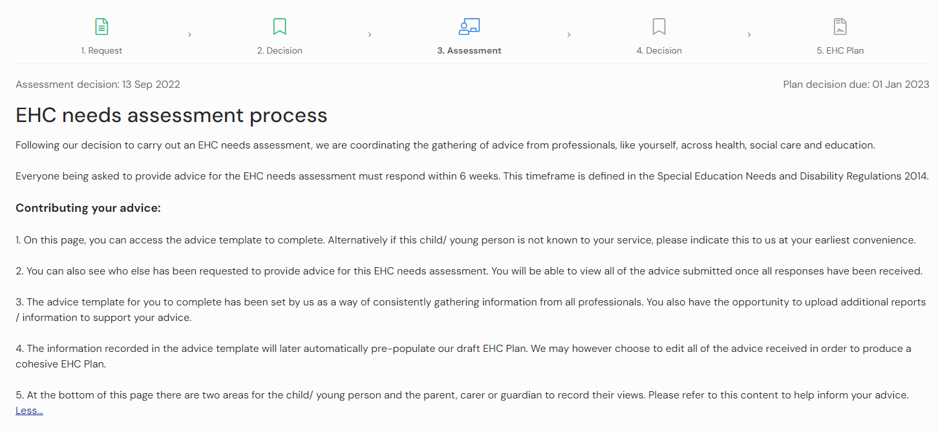
You will see some information at the top of the page to assist you with providing your advice.
If you scroll down the page you will see your advice request.
If this child/ young person is not known to your service, this can be indicated on the advice template.
The assessment page provides access to complete your response and will also see who else has been asked to provide advice. You will be able to view all responses once your (or your team’s) response has been submitted.
The advice template for you to complete has been set by the hub as a way of consistently gathering information from all professionals. You can also upload additional documents to support your advice.
The information submitted in the advice template will later pre-populate onto the draft EHC Plan should the local authority decide to issue one. They may however choose to edit all the advice received in order to produce a cohesive EHC Plan. Any changes made while drafting an EHC Plan will not change your original submission of advice at the assessment stage.
At the bottom of this page there are two areas for the child/ young person and the parent, carer or guardian to record their views.

Requests for Advice
If you have been requested to provide advice, your name will be displayed in the list below:
The date of the request and the date your response is due will be displayed, as well as the status of the request for advice.
To enter your advice, click ‘Edit’.
You will need to specify if you are providing information on behalf of someone else or not; “Yes” or “No”.
If you are providing advice on behalf of someone else, you will need to enter their name and job title/role. If you are not providing advice on behalf of someone else, these details will be added for you from your user profile.
Indicate if information will be being provided, and the reason for this answer (Details). To select your answer, click on the appropriate radio button:
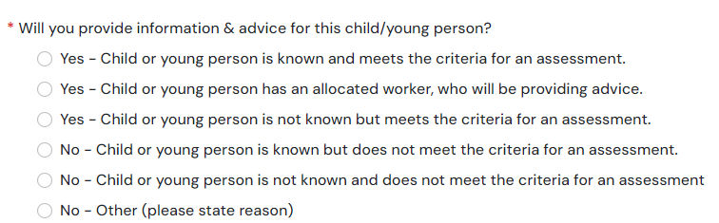
If your response is part of a request for advice made to a team, this part may not appear to you or has already been completed by your manager.
Below this, there are free text fields for you to provide background details.
The first section has 5 fields to be completed:
- When did the child or young person first come into contact with your organisation? (This field is mandatory and must be completed before the advice can be submitted)
- Details of any discussion held between the child or young person and your organisation (if relevant)
- Details of any discussion held between the parent(s) or carer(s) and your organisation (if relevant)
- What has your organisation put in place already to support the child or young person’s needs? (This field is mandatory and must be completed before the advice can be submitted)
- What has been the effect of any support or strategies already put in place by your organisation? (This field is mandatory and must be completed before the advice can be submitted)
Below that, there are 6 more sections, one for each area of need. If you submitted the ‘Request for Assessment’ this section will be prefilled with the details you entered for each area of need on the request for (a green tick will appear beside the areas where information is already there). If you did not submit the ‘Request for Assessment’ or didn’t add any details in the areas of need, these will be blank and you will need to complete them.
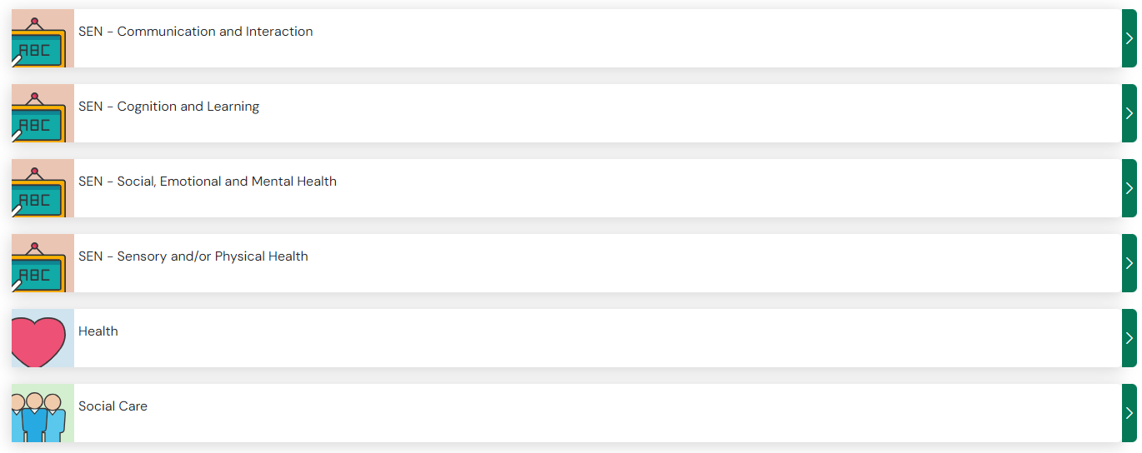

Only complete sections which are relevant to your assessment of the child or young person’s Special Educational Needs – leaving any advice area empty indicates to the local authority that you have not identified it as an area of need.
There are certain fields that are mandatory. These fields will be indicated with a red asterix. You will not be able to submit your advice unless these fields have been completed.
Click the green arrow beside the area of need you would like it edit, each section has the same layout and structure.
Strengths and Needs
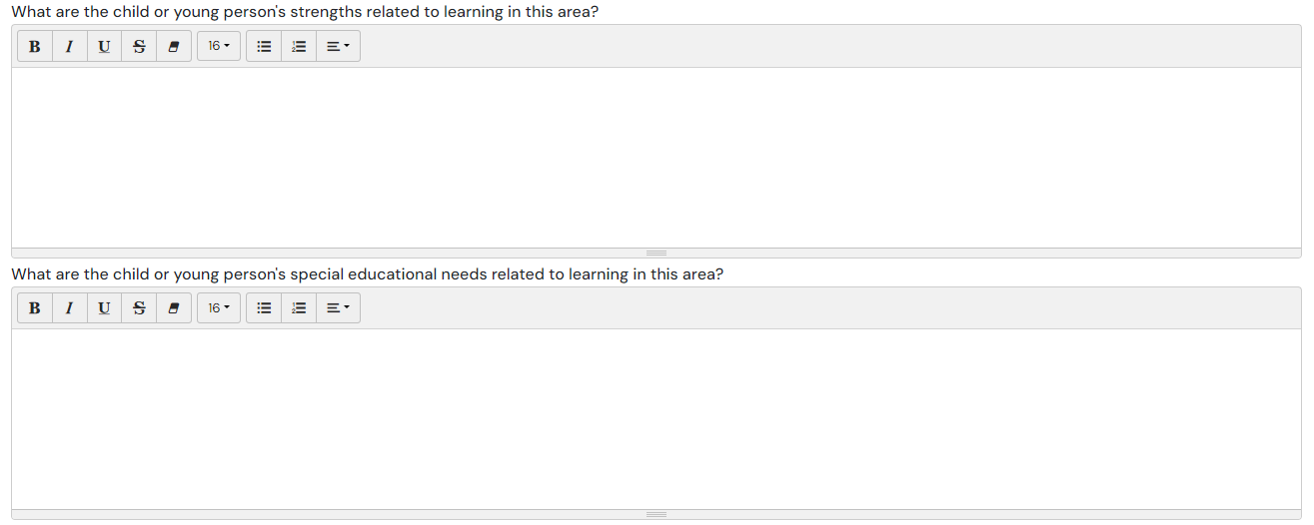

Outcomes, Steps and Provisions
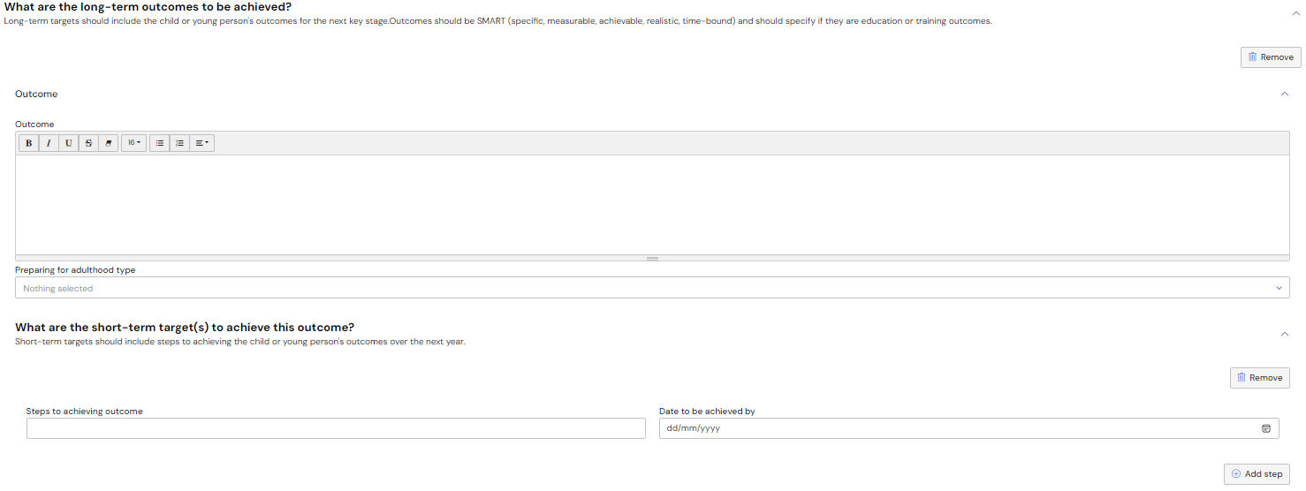
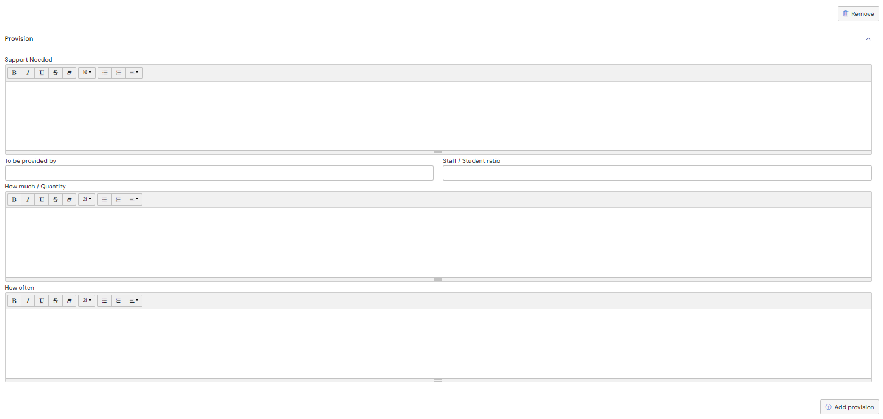
If you want to add more steps, click ‘Add step’.
If you want to add more outcomes, click ‘Add outcome’.
Outcome - Enter the details of the outcome in the text field.
Preparing for adulthood type – Select the relevant type(s) from the pick list. Click here for more information on using pick list fields
Steps – to add a step, click ‘Add step’. Enter the step to achieving outcome and the date to be achieved by
Provision – Click ‘Add provision’ button.
There is no limit to the number of Outcomes, Steps or Provision that can be added.
Click ‘Save’ at the top of the page to save the information you have entered.
Click the X button when you are finished with the section, this will take you back to your advice request home page and you can select another area of need to edit:
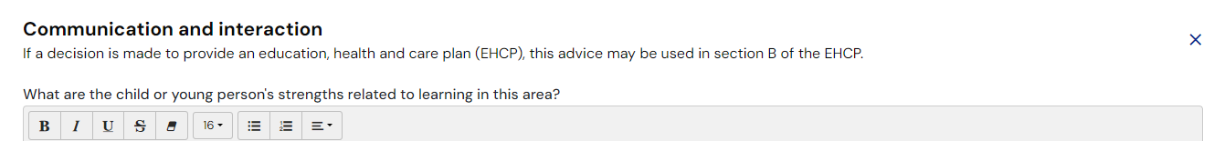

Documents
Any additional information to support the advice can be uploaded here:
If you want to add any documents, click ‘Add Files’:
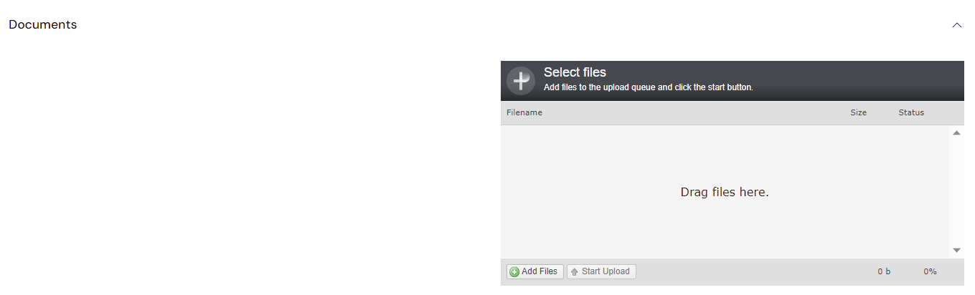
You will then need to navigate to the file wherever it is saved on your PC:
Click ‘Open’ and the file will be uploaded. The uploaded file will be displayed:

At the top of the screen, there are four options:
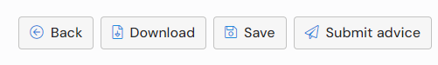
Back - This will return you to the assessment page (please make sure changes are saved before returning to the assessment page – a warning message will be displayed if there are unsaved changes):
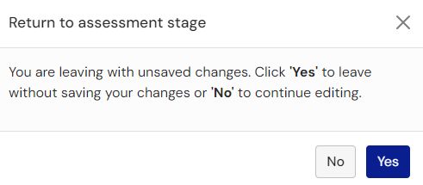

Download – it is possible to download a copy of your response as a PDF document. When you click on download, the file can be saved to your device
Save – allows you to save any information you’ve entered
Submit advice – click this when you have entered all your advice and are ready for this to be made available to view

Submitting Advice
When you are ready to submit your advice, click ‘Submit’.
You will be asked to confirm you wish to submit the advice – once submitted, your response cannot be changed:
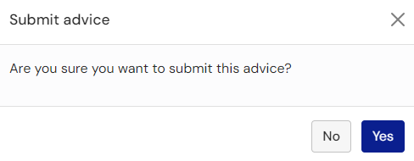
When you click on yes, you will be taken to the Assessment page and the display of the Requests for advice will be updated and will change the status from ‘Pending’ to ‘Completed’:
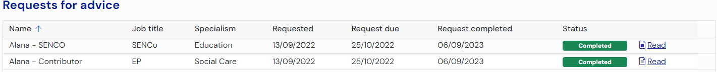
Having submitted advice towards the assessment, you will able to read all other professional advice that has been submitted. Click ‘Read’ beside advice you wish to view, you will also be able to download any submitted advice.
If there is an error in your submission, and the case remains at the assessment stage, it is possible for the case co-ordinator to re-open your response. However, please note that the request completed date will reflect the date of re-submission (if it is different to the date on which you originally submitted your response).

About (Child/young person name)
The section is all about the child or young person. If it is possible, the information should be completed by the child or young person the assessment is for. If the child/young person cannot complete this independently, this section can be completed by yourself on their behalf, it is important that this indicated in each section. If the local authority decides to issue a EHC Plan after the assessment is complete, content from these sections will be included in the plan.
There are 8 sections to can be completed:
- Things that are important to me
- Things that are working well at home and school
- Other information I think is important to know about me
- Important things to know about my past
- Things that I enjoy doing
- How to communicate with me
- My hopes, dreams and aspirations for the future
- Things I would like to change at home and school
Click ‘Open’ on each section to view or enter information:
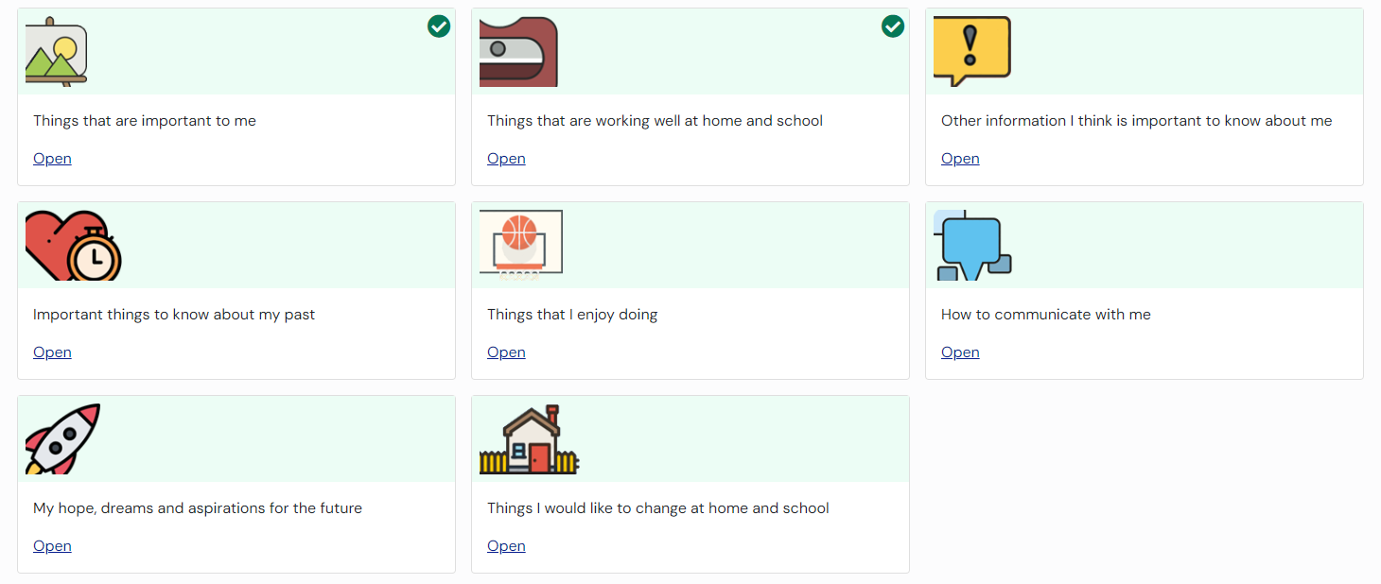
When you click ‘Open’ on one of the options, a page will be displayed allowing information to be typed in:
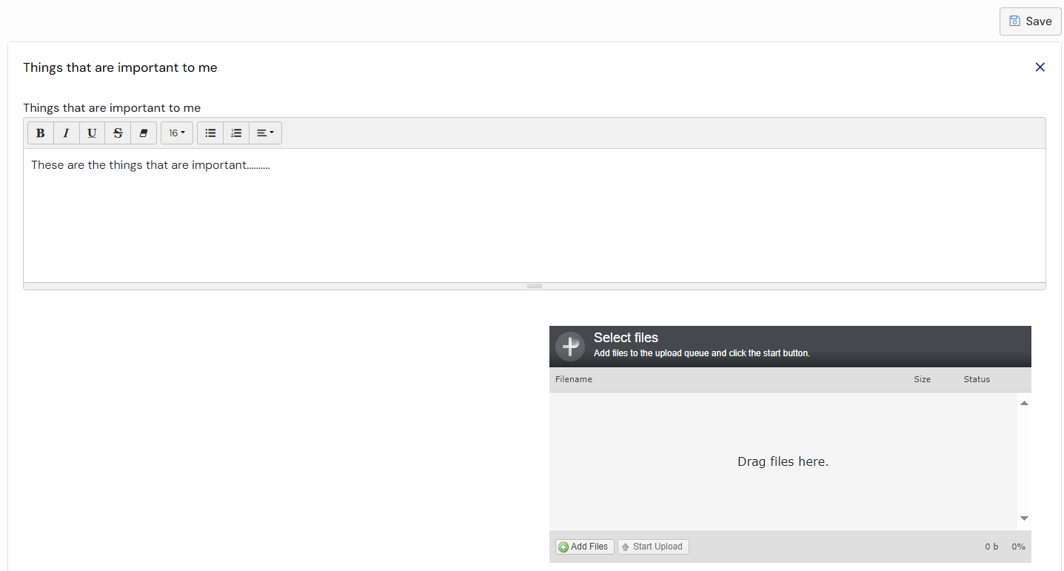
Click here for more information on using free text fields:
There is a section to add files. These could be files like documents, photos or short video clips. Click on the ‘Add Files’ button and navigate to the file wherever you have it saved on your device:
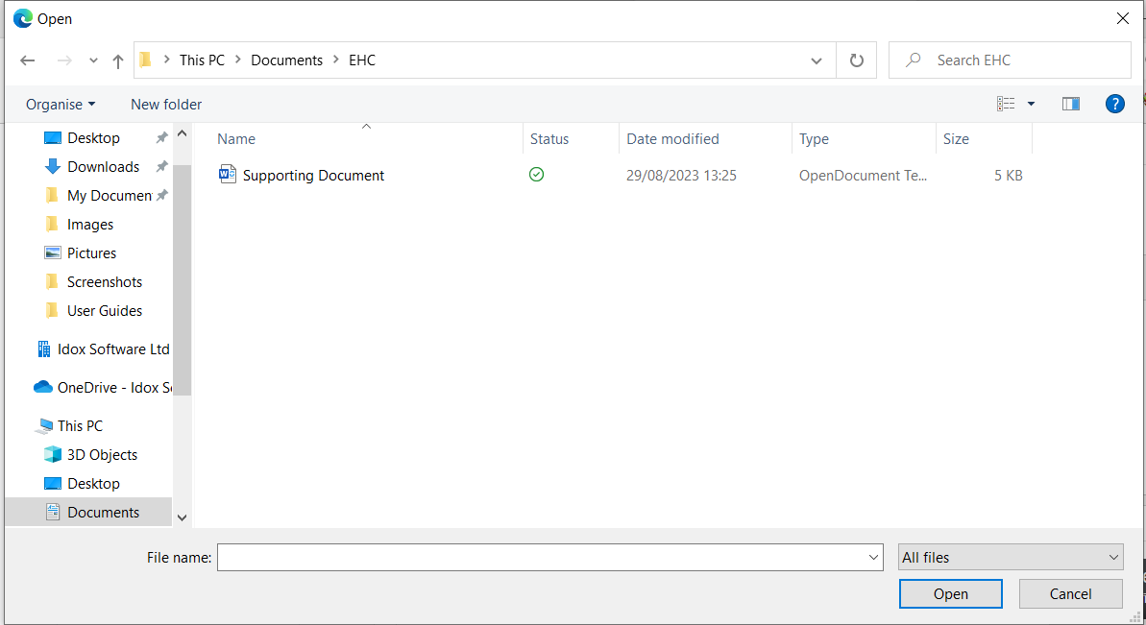
Click on Open and the file will be uploaded. The uploaded file will be displayed:
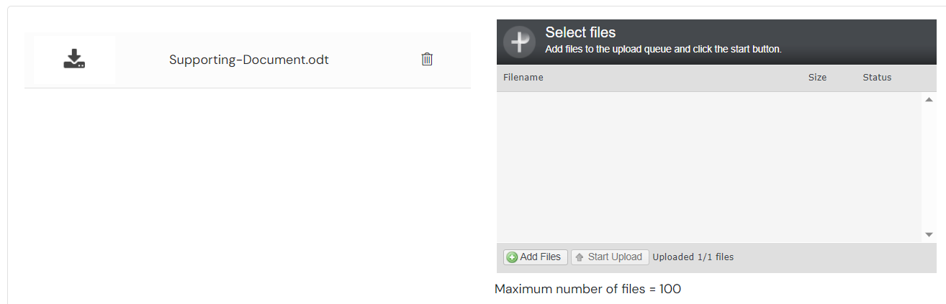
When you have completed the information, you need to save it before moving on to the next section. Click ‘Save’ to save the information:
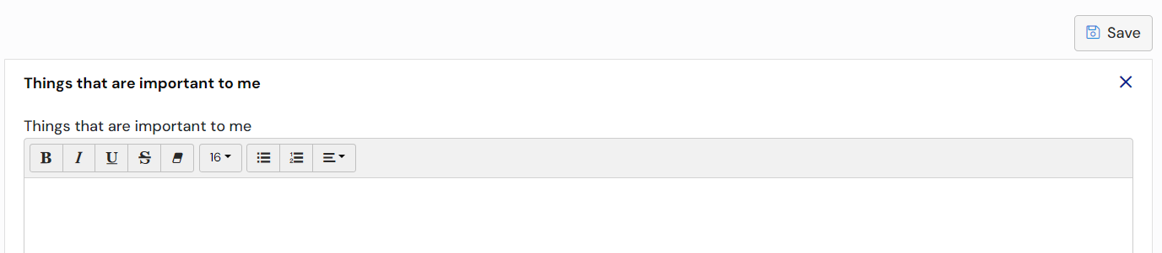
Once you have completed the information and saved it, click the X button in the top right corner and you will be taken back to the main page to choose which section you want to complete next:
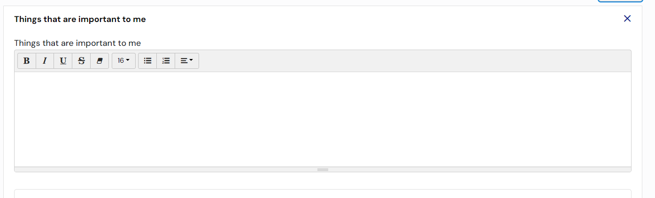

Parent Carer’s Views
This section is for the Parent or Carer of the child or young person to give their views. If it is possible, the information should be completed by the child or young person the assessment is for. If the Parent, Carer or Guardian is unable to complete this independently, this section can be completed by yourself on their behalf, it is important that this indicated in each section. If the local authority decides to issue a EHC Plan after the assessment is complete, content from these sections will be included in the plan.
There are 5 sections to that can be completed:
- Important things to know about our family history
- Things that are working well at home and school
- Things that are not working well and we would like to change
- Our hopes and aspirations for the future
- Other information we think is important
If a section already has information entered, you will see a green tick in the corner of the section.
Click ‘Open’ on each section to view or enter information:
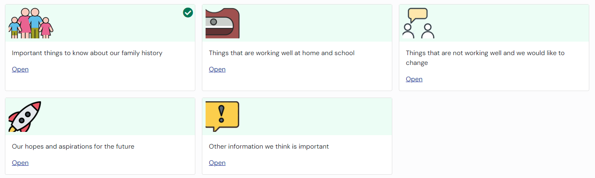
When you click ‘Open’, a page will be displayed allowing information to be typed in:

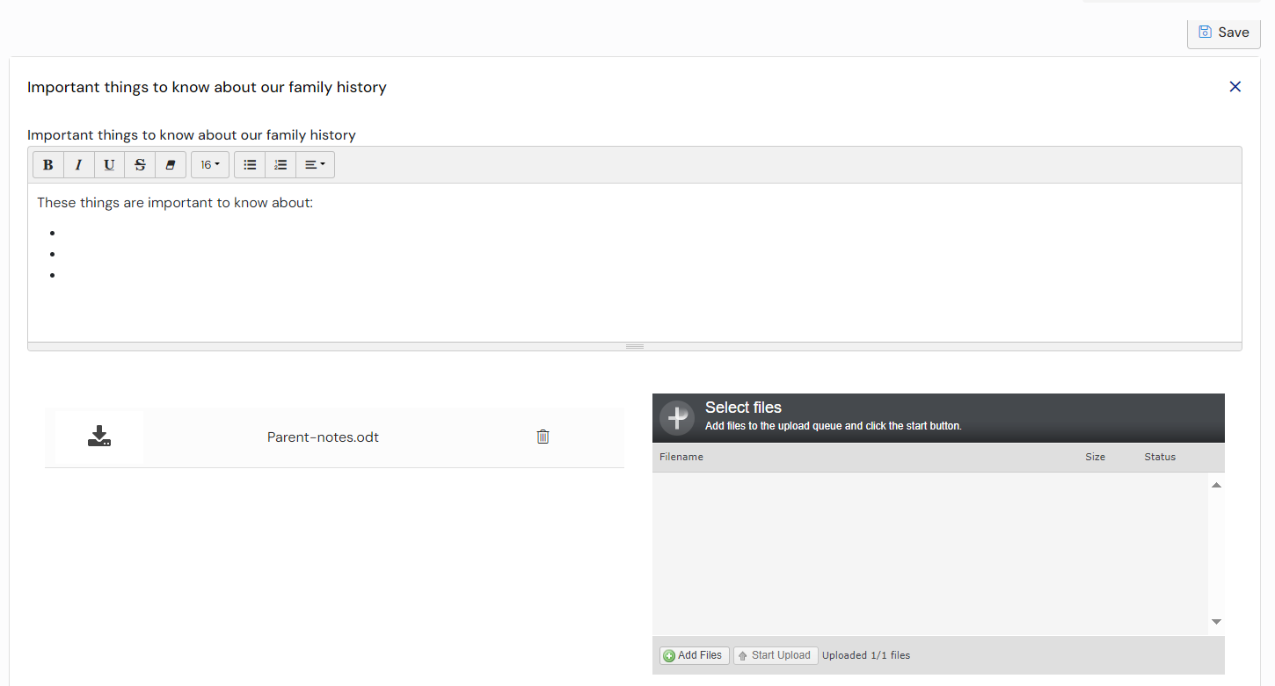
Click here for more information on using free text fields.
There is a section to add files. These could be files like documents, photos or short video clips. Click on the ‘Add Files’ button:
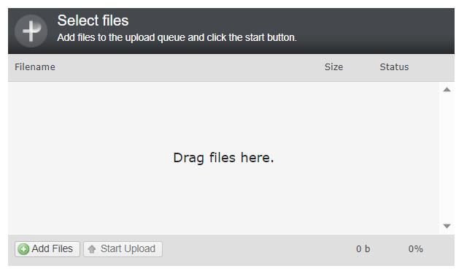
You will then need to navigate to the file wherever you have it saved on your Device:
Click ‘Open’ and the file will be uploaded. The uploaded file will be displayed:
When you have completed the information, you need to save it before moving on to the next section. Click ‘Save’ to save the information:
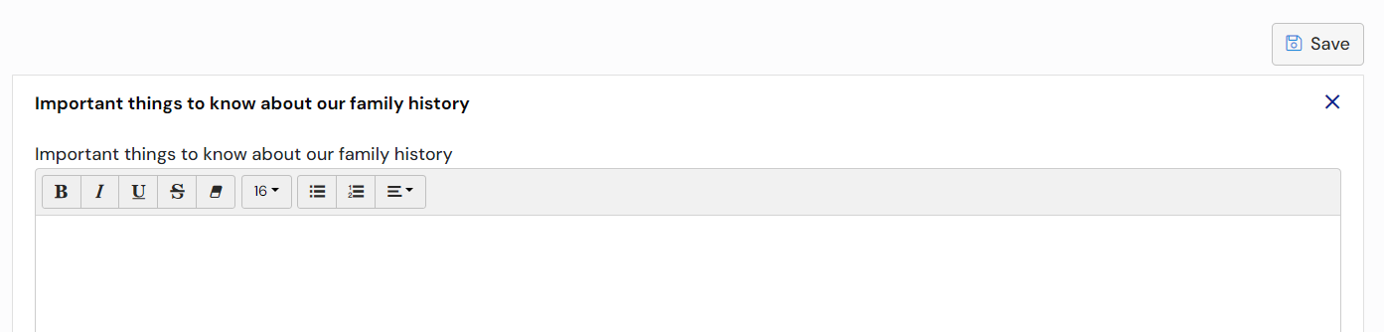
Once you have completed the information and saved it, click the X button in the top right corner and you will be taken back to the main page to choose which section you want to complete next:
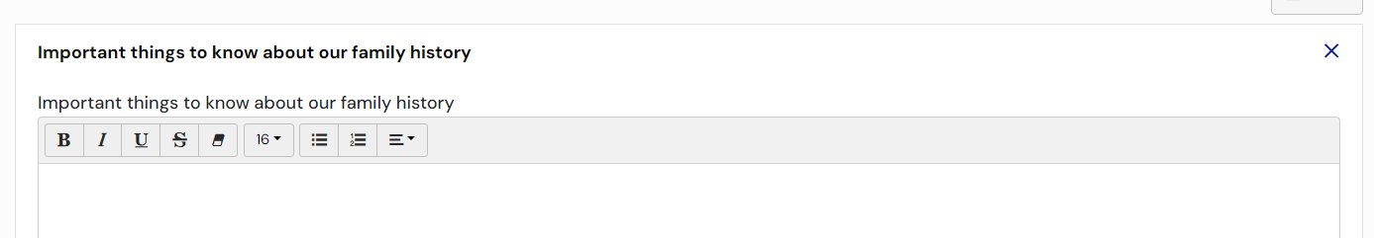

Decision to Issue Plan Pending
Once the case co-ordinator has indicated that the case is ready to progress to the decision, this change in status will be reflected in the display of the case in the My cases in progress:
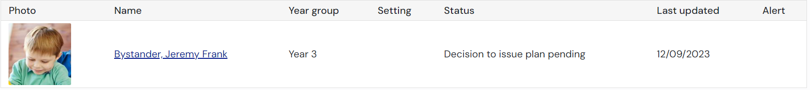
You will be notified when the local authority have made a decision.

Decision to Issue Plan
When the decision has been made to issue a plan or not, you will receive an email telling you that there is new information on the Hub for you to view. The email will look something like this:
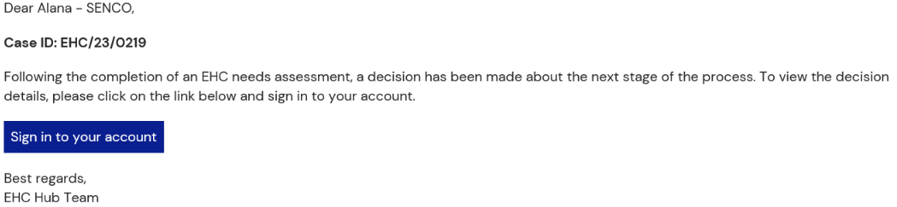
You will need to sign into the Hub to view the result of the decision.
If a decision has been made to issue an EHC Plan, a draft plan will be published as soon as possible. You will be asked to comment on this draft plan within 15 calendar days and when these comments have been submitted, the draft plan can be updated before a final plan is made.
When you log in to the Hub, the status will show like this:
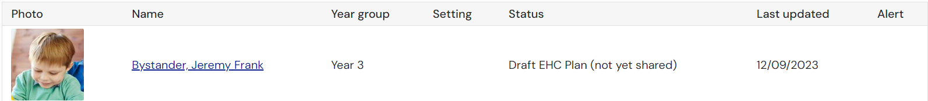
Or
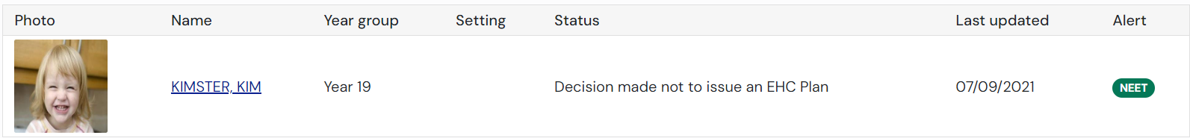
When a decision has been made on whether to issue a plan or not, the following information will be displayed detailing the decision details:
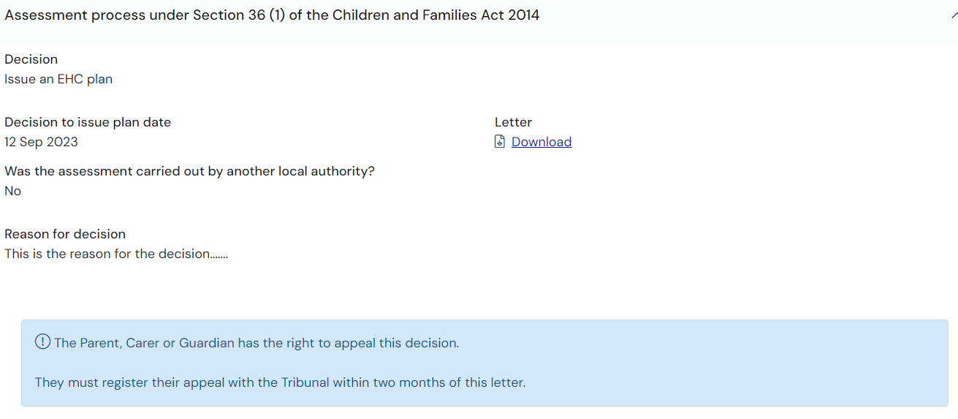
OR
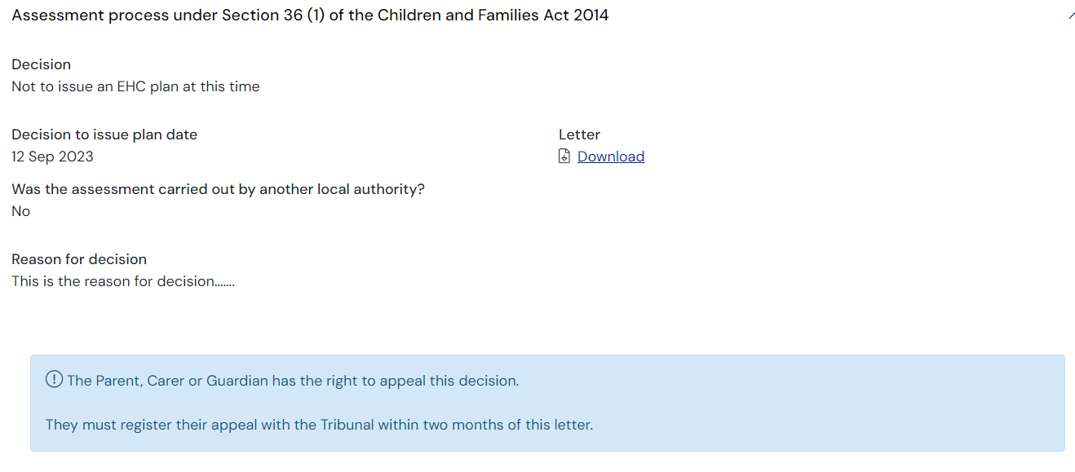
This will include the reason for the decision and a letter that can be downloaded with more information about the decision. To view this letter, click ‘Download’.
If the Local Authority originally say ‘no’ to issuing a plan, they can change their decision by recording a second decision. You will be notified by email and the decision screen will show the second decision at the top and the previous decision at the bottom, it will look like this:
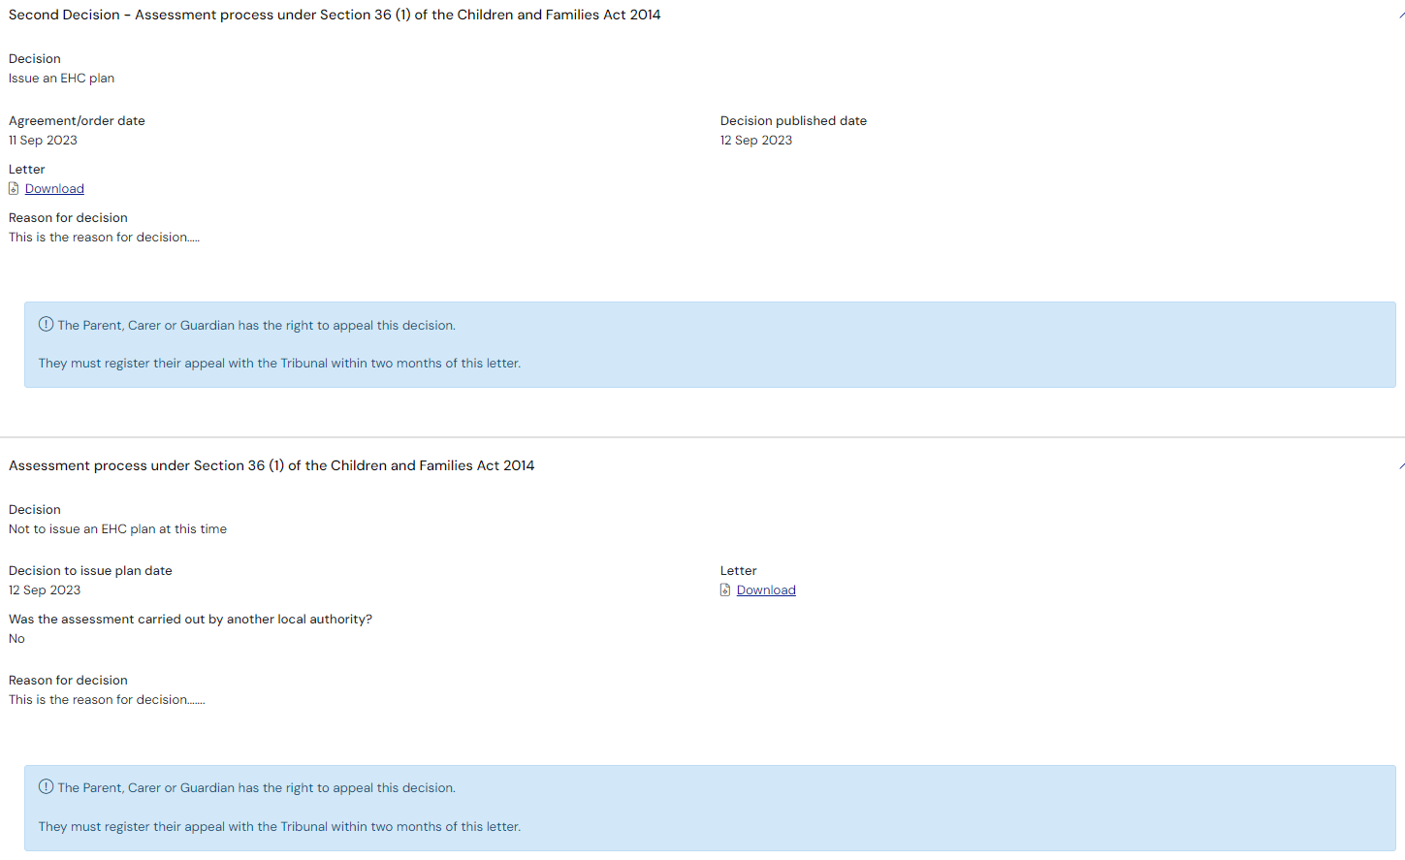
If the decision has been made to issue a plan, the status will show that the case have progressed to the EHC Plan stage:
To view details and download the letter about the decision, click on Decision at the top of the screen.
Click ‘EHC Plan’ at the top of the screen. The main screen will show some information about the next part of the process:
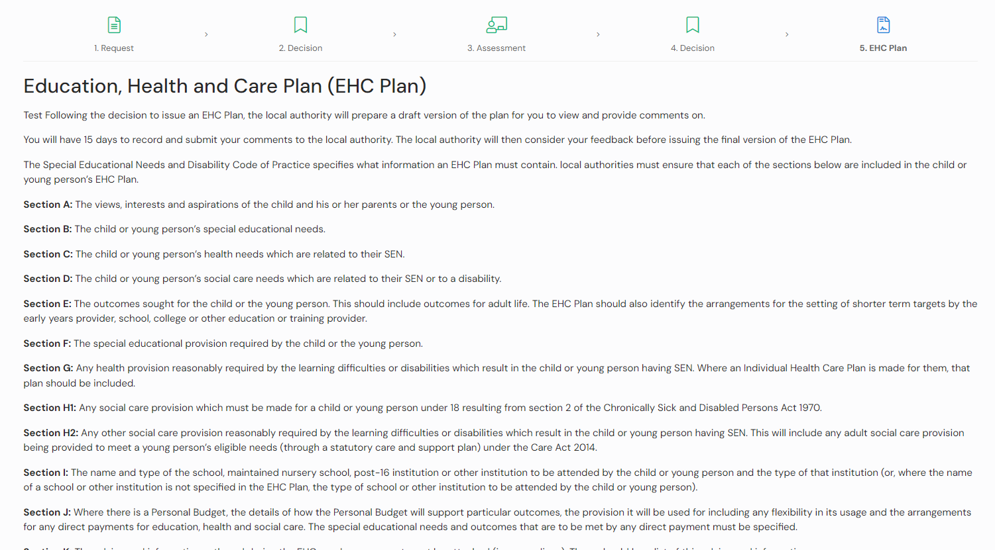
This details what information the plan must contain.
Underneath, it will show if the plan is in draft (not yet shared). If it is still being drafted, this will be displayed:
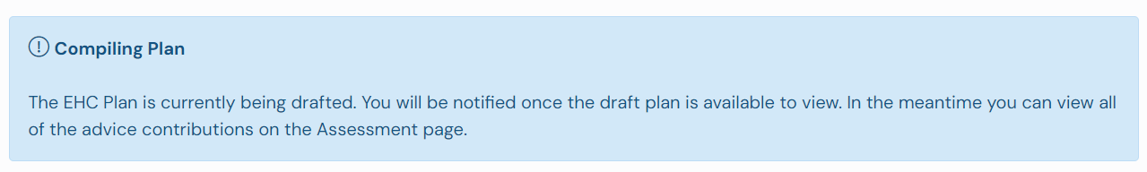
If you haven’t already read the advice contributions that might go into the plan, click Assessment at the top of the screen to view the Assessment page:
At the bottom of this screen there is the Requests for Advice section:
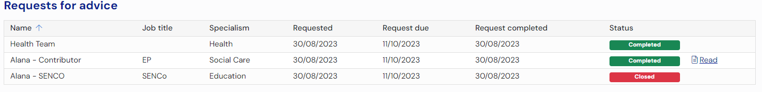

Viewing the Draft Plan
Once the draft plan has been created, it will be shared by the case co-ordinator and you will receive an email to this effect:
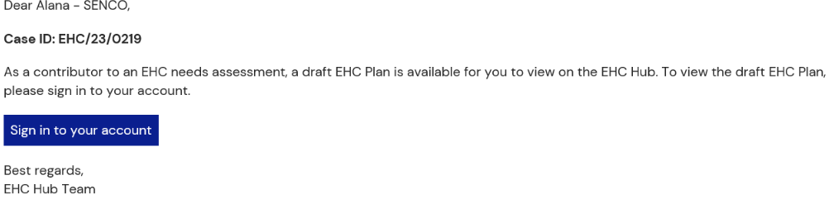
The status of the case file will change to ‘Draft EHC Plan (shared)’.
If the draft plan is ready to be viewed, the screen underneath the information section will look like this, showing when the Draft was shared:
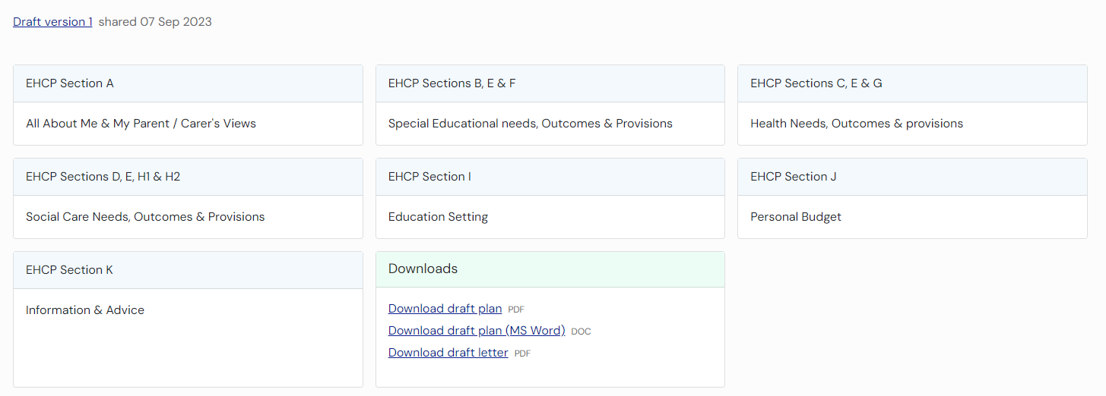
Each of the sections make up part of the Plan. To view more information on each section, left click on that section. Here is a summary of each plan section:
EHCP Section A – click ‘Open’ on this to display the information entered by the Parent/Carer and /or young person.
This has three parts:
- About
- Parent/Carer’s Views
- Local authority background information
EHCP Sections B, E and F – click ‘Open’ on this to display information about Special Educational needs, Outcomes and Provisions.
EHCP Sections C, E and G – click ‘Open’ on this to display information about Health Needs, Outcomes and Provisions which relate to the special educational needs of the child or young person.
EHCP Sections D,E,H1 and H2 – click ‘Open’ on this to display information about Social Care Needs, Outcomes and Provisions which relate to the special educational needs of the child or young person.
EHCP Section I – click Open’ on this to display information about the Education Setting. This information may not populated at this draft plan stage. The settings will be recorded in the Final EHC Plan.
EHCP Section J – click ‘Open’ on this to display any information about the personal budget. This has two parts:
- Personal Budget
- Annual Cost of Support
Section K – click ‘Open’ on this to display any information and advice provided by professionals during the assessment process
This has 2 parts
- Monitoring and review
- Progress towards outcomes specified in this plan will be monitored by
It also has a section on Advice Contributions. To view any advice contributions that have been made, click ‘View’:
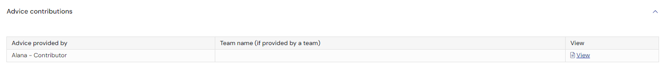
You will then be able to view the information. See here for more details on this. When you have finished looking at this information, click ‘Close’:
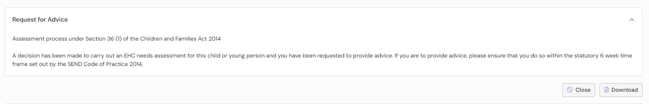
Left click on Plan at the top of the screen to return to the draft plan:

Some sections may have multiple areas to view, for example Section B, E & F could have outcomes, provisions, etc.
Some sections may have multiple areas to view, for example Section B, E & F could have outcomes, provisions, etc.
When you click ‘Open’ for Section B, E & F, the following screen will show and you will be able to expand the 4 SEN areas:

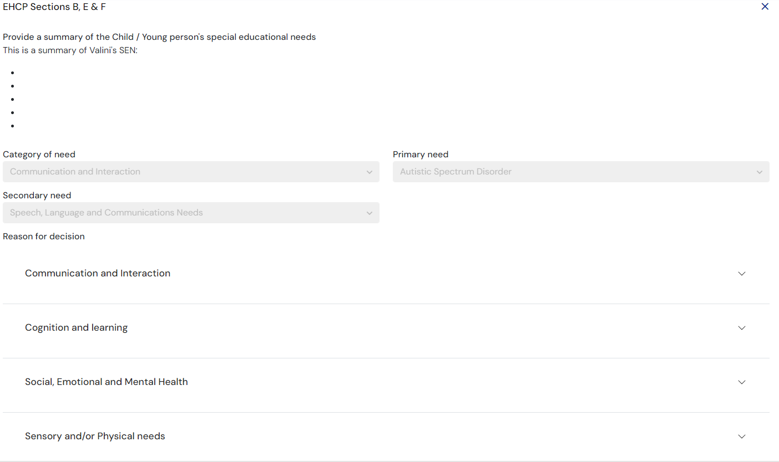
When you expand a SEN area, you will be able to view any information that has been entered.
Strengths, needs & outcomes:
There could be more then one outcome, you will need to scroll down to see if anymore outcomes have been added.
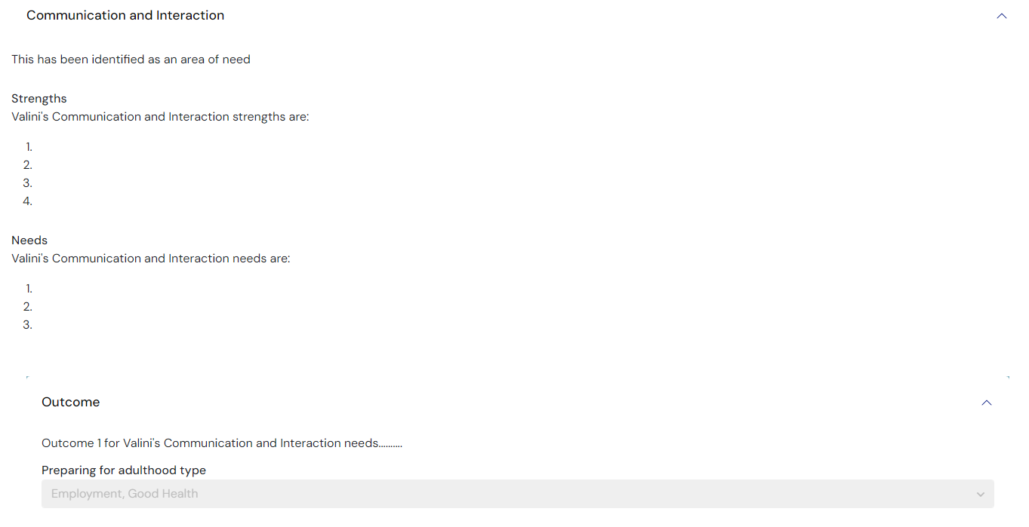
Steps to achieve outcomes:

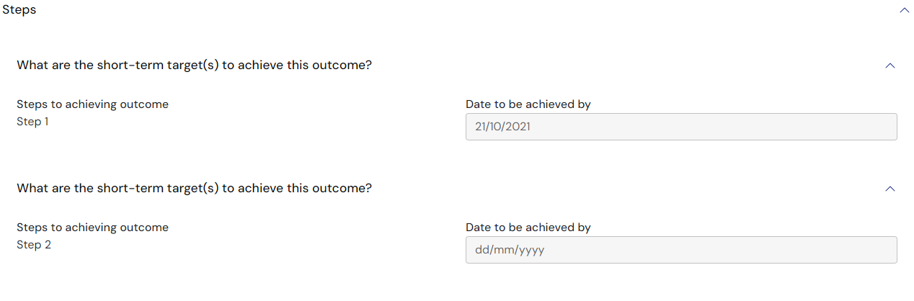
Provisions:
There could be more than one provision added for each outcome, these will be listed one after the other.

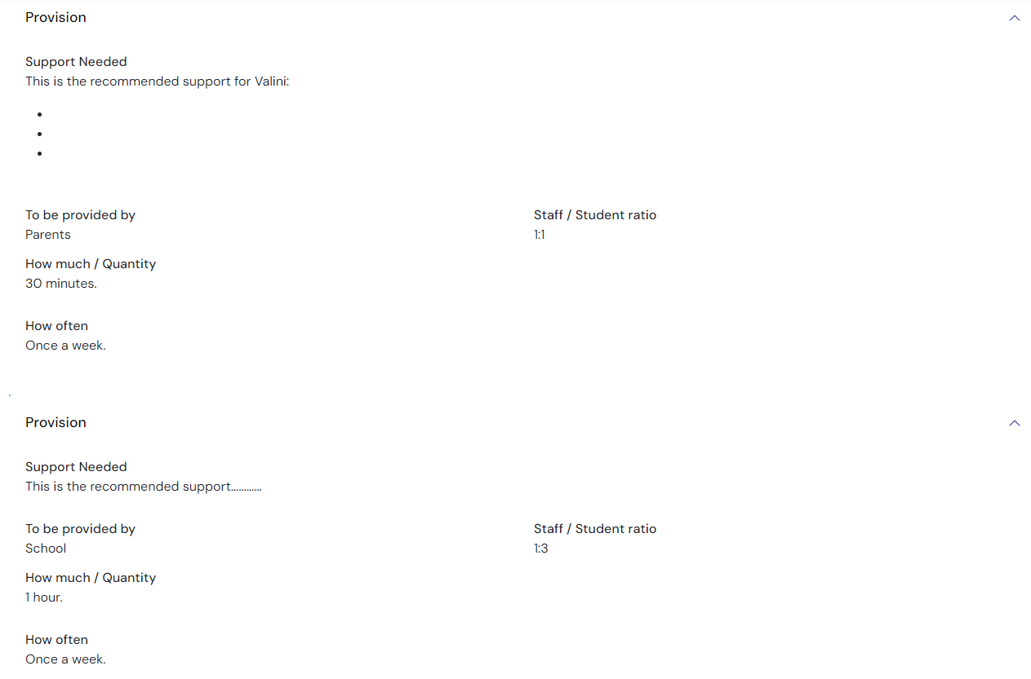
If a section is not applicable (for example, the child or young person does not have extra Health Needs) it will look like this:
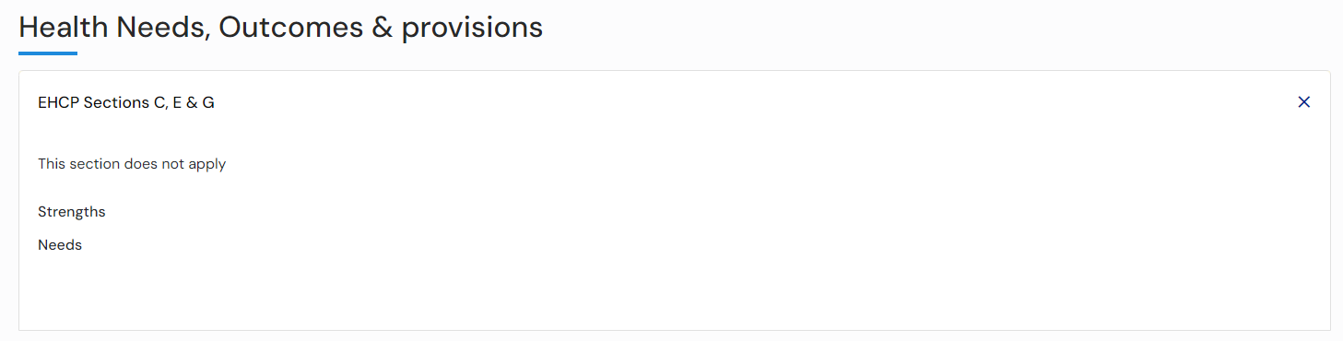
It is important to scroll up and down the screen to make sure you can see all the information that has been added to the plan. Left click on the scroll bar on the right-hand side of the screen to move up and down on the screen.
Click on the X to return to the main screen:
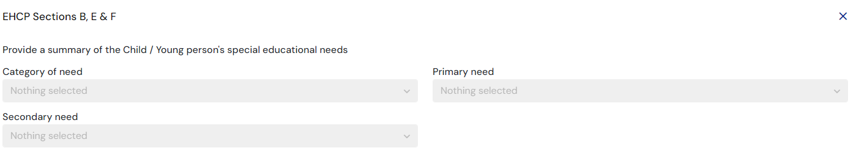

Downloading a Draft Plan
If you wish to download the draft plan as a PDF file. Click ‘Download Draft Plan’:
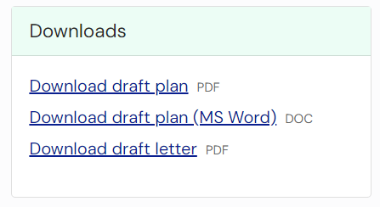
The downloaded plan file will appear on your screen:
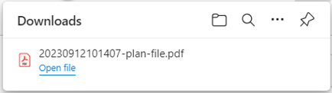
Click ‘Open file to view the contents of the PDF file. This can be saved to your own device, if required.

EHC Plan Consultations
Parents/Guardians/Carers
At the bottom of the plan, there will be list of the Parent/Guardians/Carers or young people that can comment on this draft plan:
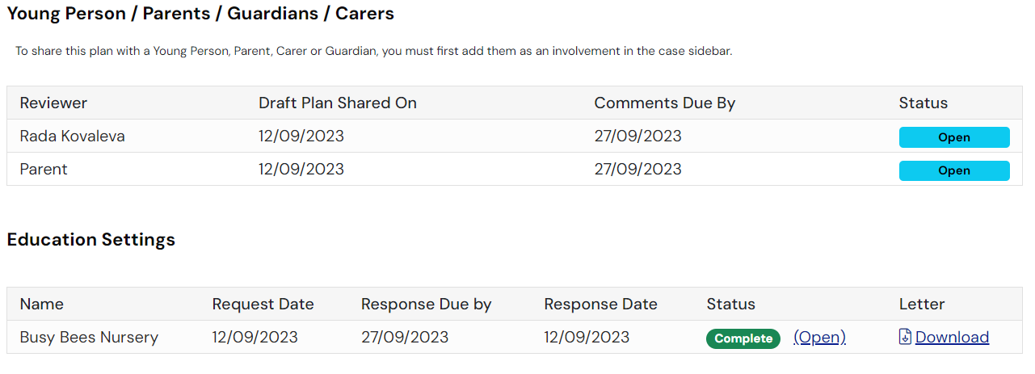
It will list all Parent/Guardians/Carers or young people who have been asked to review the plan, when the draft plan was shared with them and when they need to comment by. It will also have the status of the comments process. If this says Open, then that person is still in the process of adding comments. Once the comments have been entered, the status will change to show completed:
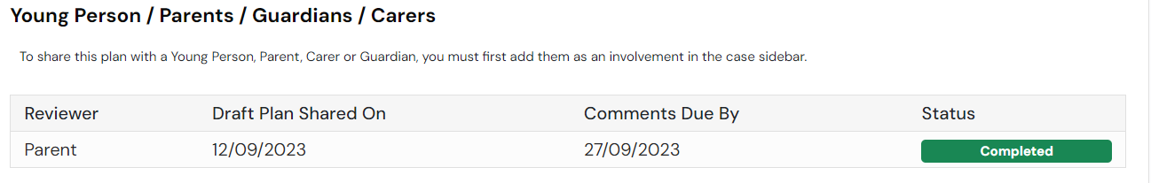
If a parent/carer/guardian or young person left comments, there will be a speech bubble beside the section of the plan they left comments in and you will be able to view the comments:

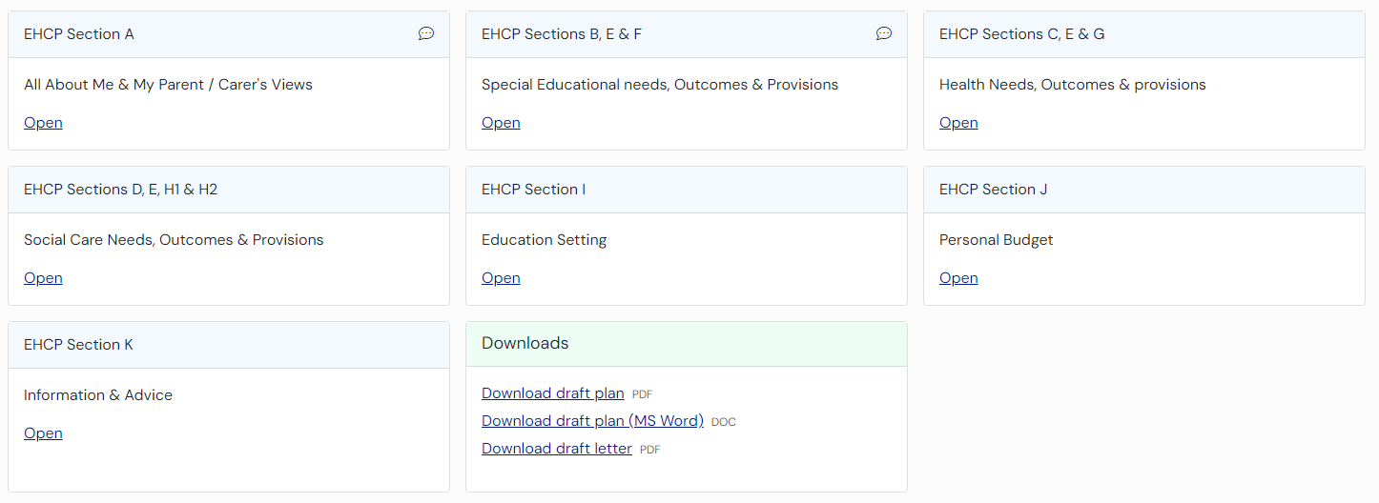

Consultation for Education Settings
When the draft plan is shared by the case co-ordinator, they will enter information for the education setting(s) that should be consulted with on the draft plan.
If your education setting had been consulted, the education setting (and its associated SENCOs) will receive an email indicating this. The email will look something like this:
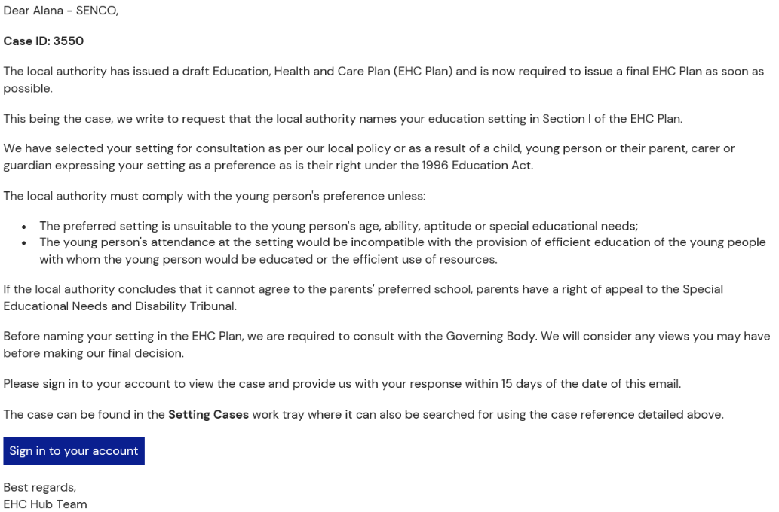
To view the case, log into the EHC hub and click on the ‘Setting cases’ work tray:
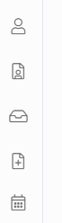
You can either enter the case ID which can be found on the email or use the filter for ‘Open Education Setting Consultation’:
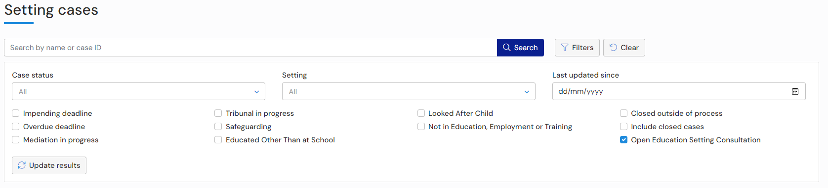
Click on the child or young person’s name and the EHC Plan will be displayed:
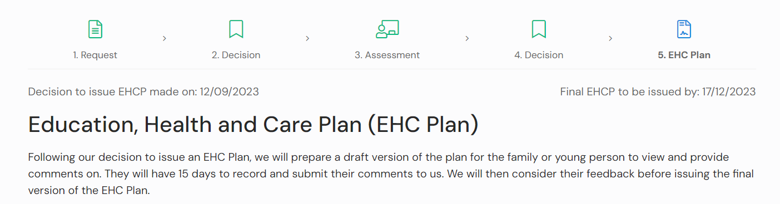
Note: If you are not the named SENCo for this case, you will only have access to the file to complete the consultation. Once the consultation response has been submitted, access to the case is removed.
Scroll to the bottom of the screen to view the Consultation Request:
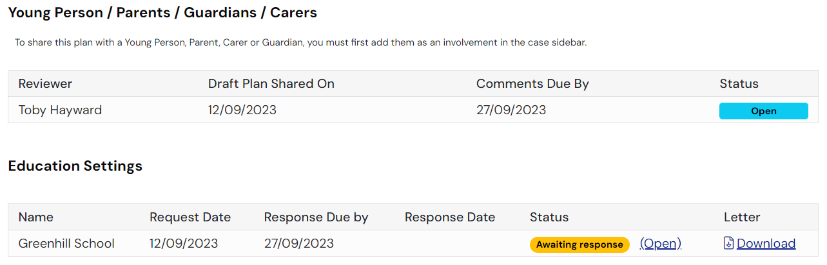
To view the letter the educational setting was sent as part of the consultation, click on Download in the letter column and you will be able to save this to your device.
To respond to the consultation request, click ‘Open’.
There are two sections to this, the response and the supporting comments.

Response
To provide your response, click on the appropriate radio button. The options are:
- This setting should not be named in the final EHC Plan because of age, ability, aptitude or SEN of this child or young person
- This setting should not be named in the final EHC plan because the attendance of this child or young person there would be incompatible with the efficient education of others, or the efficient use of resources
- The setting can name in the finalised EHC Plan for this child or young person
Please note that only the above response will be visible to the young person, parent, carer or guardian, they will not be able to see the supporting comments. The supporting comments will only be visible to the case co-coordinator.

Supporting Comments
This is a mandatory field and must be completed. It is a free text field. Click here for more information on using free text fields

Additional Information
This is a field used to provide you with more information, this is used by the local authority when sending the Education setting consultation request:
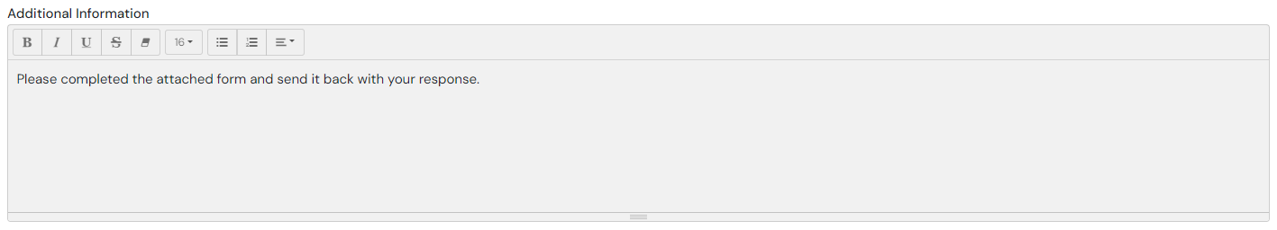

Documents (Case Co-ordinator)
Any documents that were added by the case co-ordinator will be displayed here. Click on the document to download it:
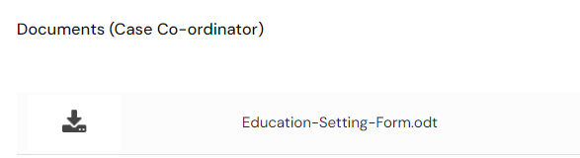

Documents (Education Setting)
If you want to add any relevant supporting documents, click on the Add Files button:
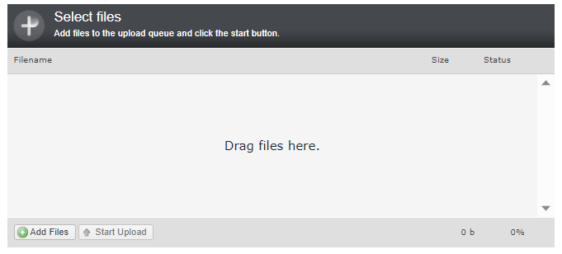
You will then need to navigate to the file wherever it is saved on your PC:
Click on Open and the file will be uploaded. The uploaded file will be displayed:
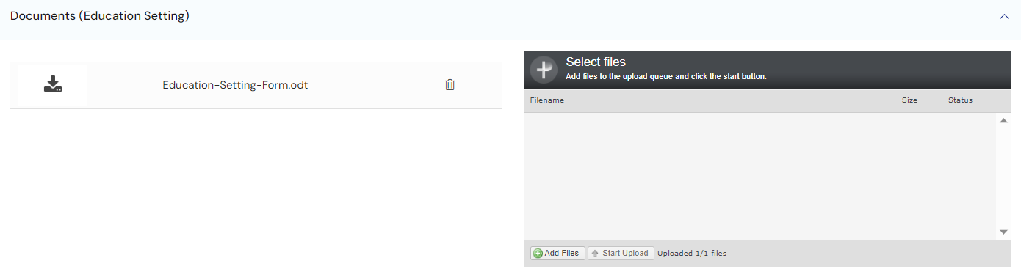
At the top of the consultation request you will see 3 buttons:
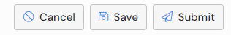
Close – will take you back to the EHC Plan stage of the case.
Save – will allow you to save your response in draft.
Submit – will send your response to the local authority. Once you submit you are unable to edit your response.

Finalised and Issued EHCP
Once the case co-ordinator has finalised the EHCP, it will be issued. You will receive an email notification, which will look something like this:
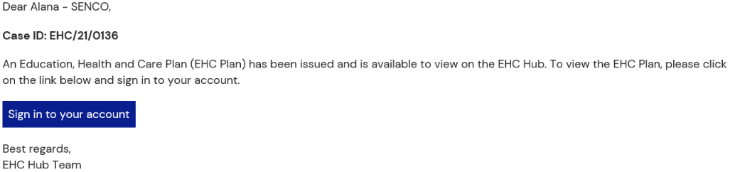
When you log into the hub, the case file will no longer be displayed in the ‘My cases in progress’ work tray, as the plan has been issued. The case will now be displayed in the ‘My live cases’ work tray.
The status of the file will show as Review pending, as that is the next stage the process that the hub will manage:
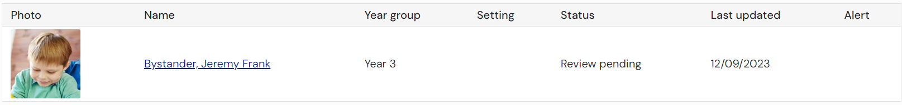
When you click on the child/young person name you will be taken to the Case Summary page of the case.

Viewing the Case Summary
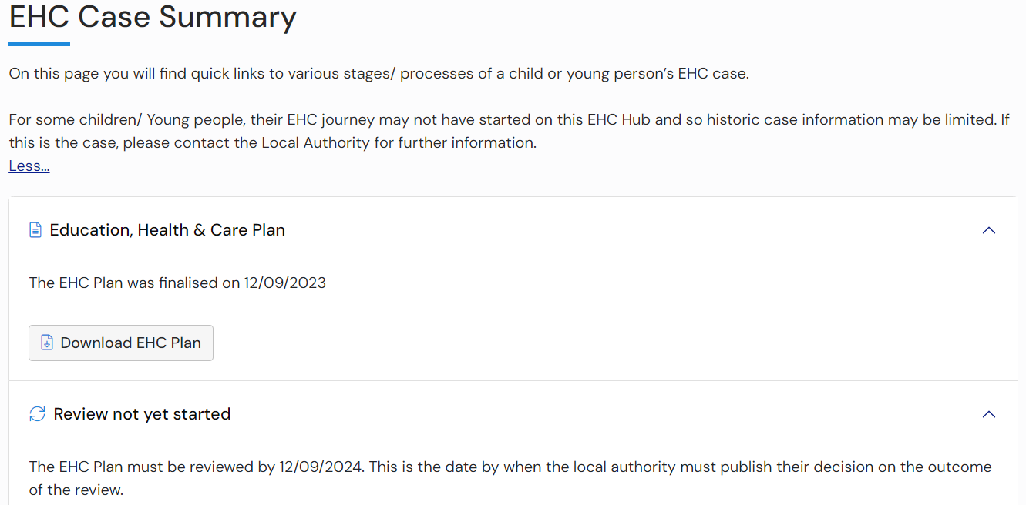
This includes sections of information for the history of activity on the case.
Education, Health and Care Plan
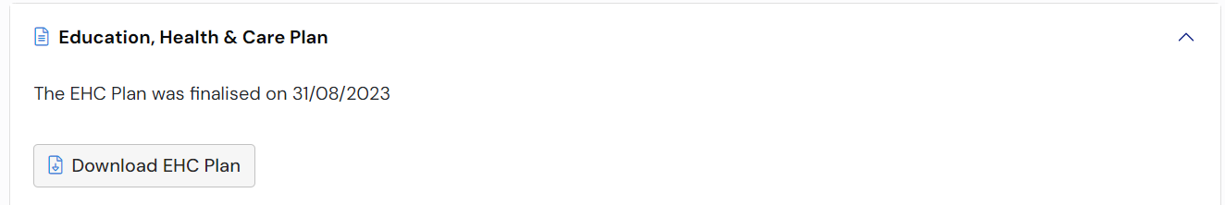
This will display when the current plan was finalised. You can also download a copy of the plan if required by clicking ‘Download EHC Plan’.
Review not yet started
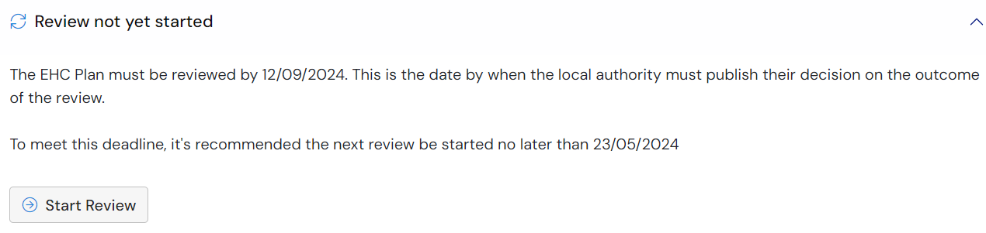
This will tell you when the plan is due to be reviewed by, the recommended time to start the process by and it will give you a button to start the review process.
Completed Reviews
This section will only be displayed if previous reviews have been completed:
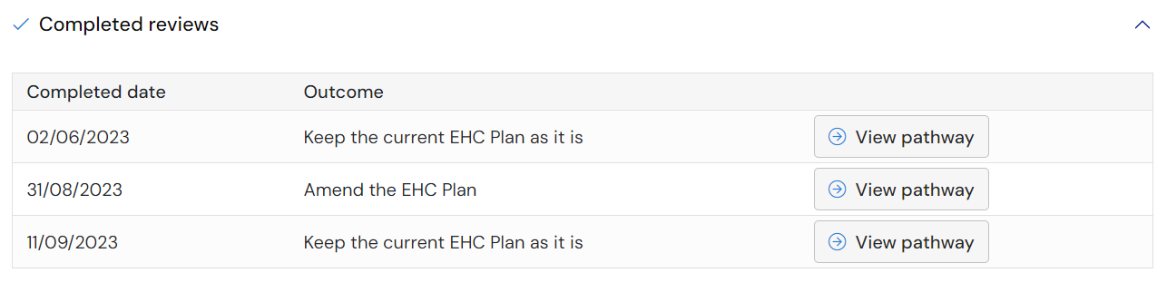
Amendments to plan outside of a formal review pathway
This section will only be displayed if any amendments have been made to the existing plan outside of the formal review pathway:
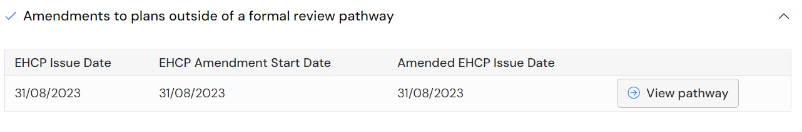
EHC Assessment and Planning Pathway
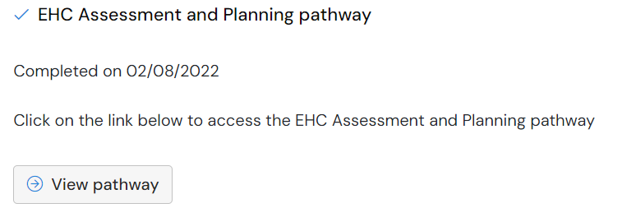
This will tell when the assessment and planning pathway was completed. To view the pathway, click ‘View pathway’.
This will take you to the pathway page where you can view the information entered previously on the pathway to the Plan:
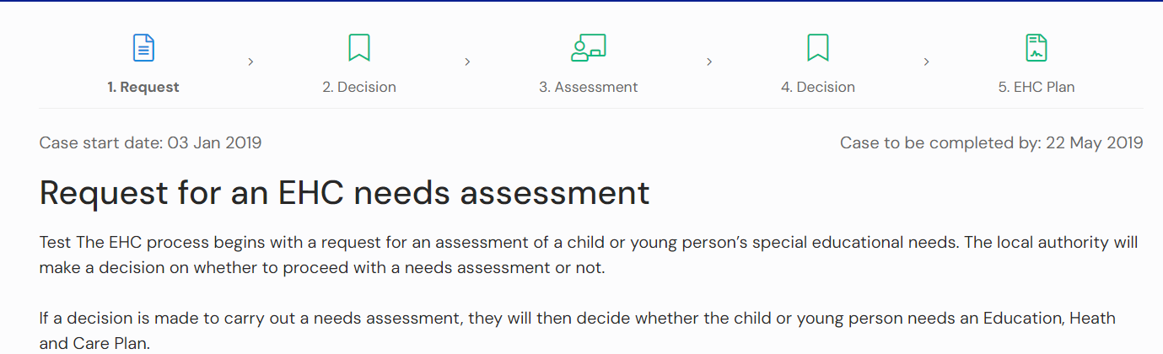
Click on any of the status buttons at the top of the screen to view the information.

EHC Plan Review
Once a plan has been finalised, it must be reviewed annually. Information about the review date will be displayed when you log into the Hub and view the case.
To start the review process, click on Start Review in the Review not yet started section of the EHC Summary page:
You will then be asked are sure you want to start a review:
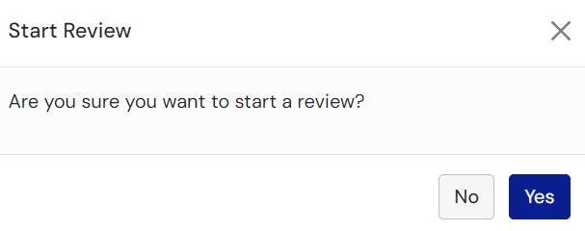
When you click ‘yes’ the pathway for the review meeting will then be displayed at the top of the screen:

Arranging the EHC Plan Review Meeting
The top of the screen will display information about arranging the EHC Plan review meeting:

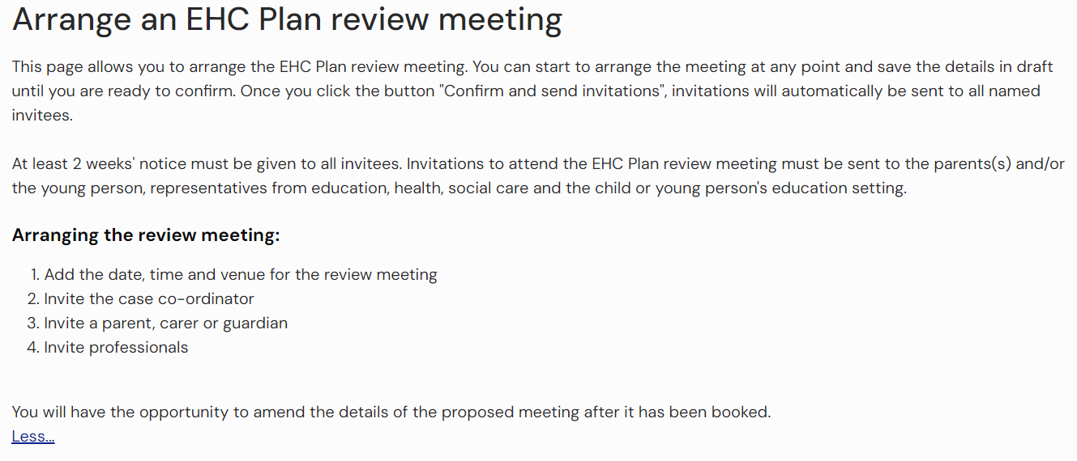
There are four sections you can complete:
- EHC Plan Review Meeting Details
- People invited to attend the EHC Plan Review meeting
- Professionals and/or teams invited to attend
- Case Co-Ordinator(s) and/or Local Authority representative(s) invited to attend
Note: You can save the meeting details as draft at any time, and then Confirm and send invitations when all information has been completed
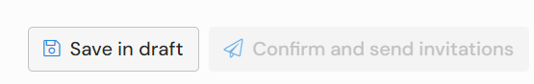

EHC Plan Review Meeting Details

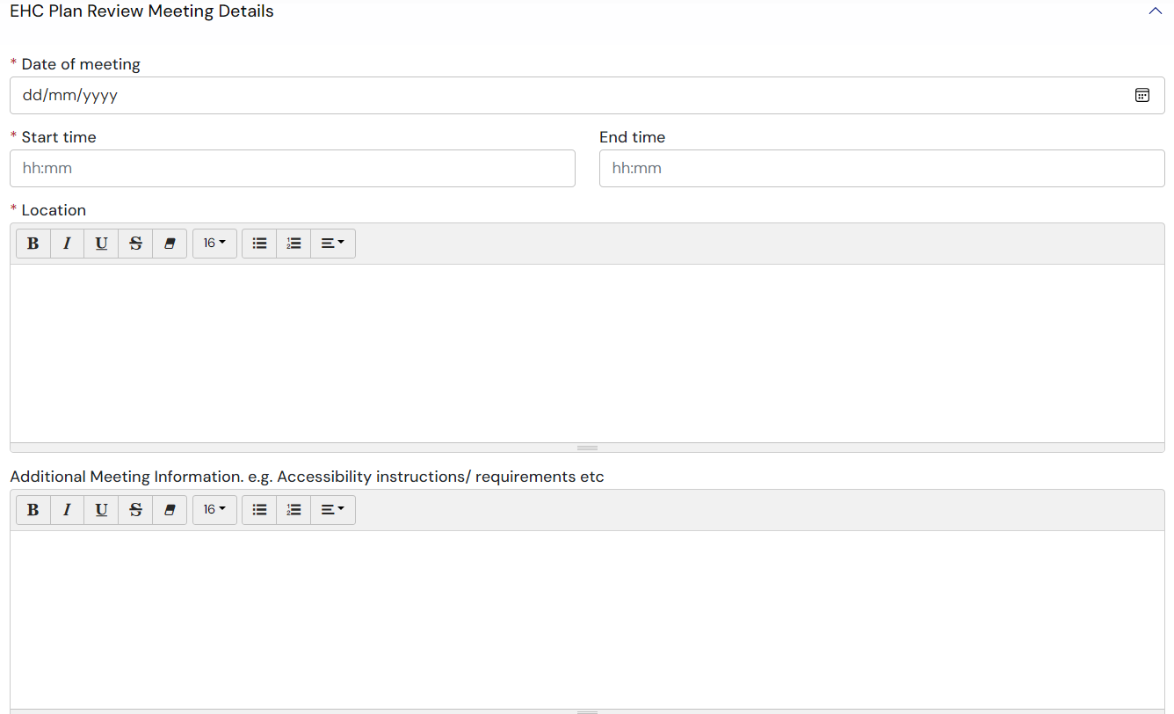
Date of meeting - Enter the date of meeting. Click here for more information about completing date fields.
Start time and End time – either enter the start time and end time for the meeting or left click on the field and select the required time from the list.
Location – enter the details of the location of the meeting. Click here for more information about completing free text fields.
Additional Meeting Information – enter any addition information like accessibility instructions etc. Click here for more information about completing free text fields.

People invited to attend the EHC Plan Review meeting
A parent, carer, guardian, the young person or advocate already linked to the case will be automatically included in this section.
To invite a parent, carer or guardian to the meeting, click ‘Add Parent, Carer or Guardian’:
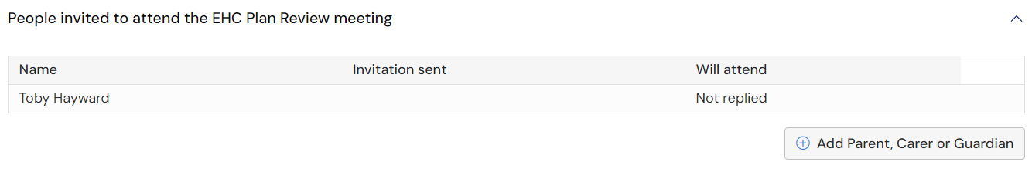
The following page will appear:
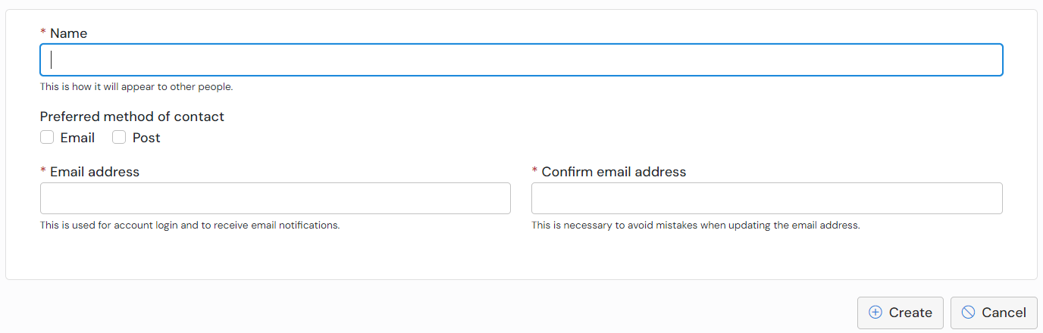
Name – Enter the name of the Parent, Carer or Guardian
Preferred method of contact – select Post or Email
Email address – enter the email address for the Parent, Carer or Guardian
Confirm Email – Confirm the email address for the Parent, Carer or Guardian
When you click ‘Create’, you will be asked to confirm that you want to invite the person to access the case:
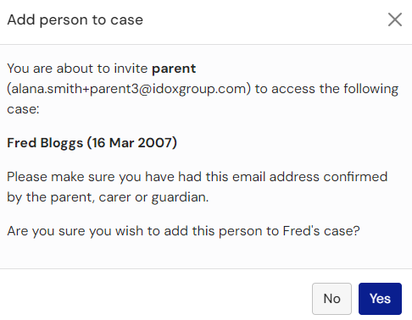
The information will then be displayed:

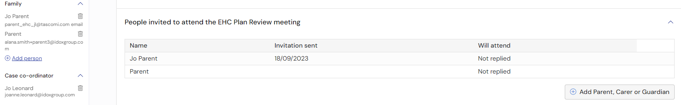
To add further parent, carers or guardians, click ‘Add Parent, Carer or Guardian’ again and repeat the process.
Any parent, carer or guardian added here will automatically be added to the side bar of the case under Family. If they do not have an account already for the Hub they will receive an email asking them to register their account.
Any parent, carer or guardian added here will receive an email inviting them to the review meeting.

Professionals and/or teams invited to attend
If a SENCo is already linked to the case (side bar), they will be automatically included in this section.
To invite a professional and/or team, click ‘Add Professional’:
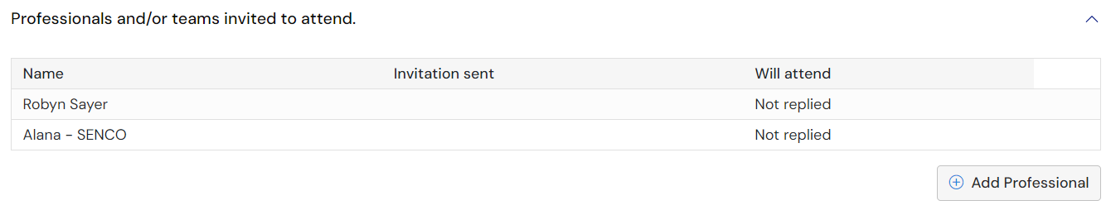
The following screen will be displayed:
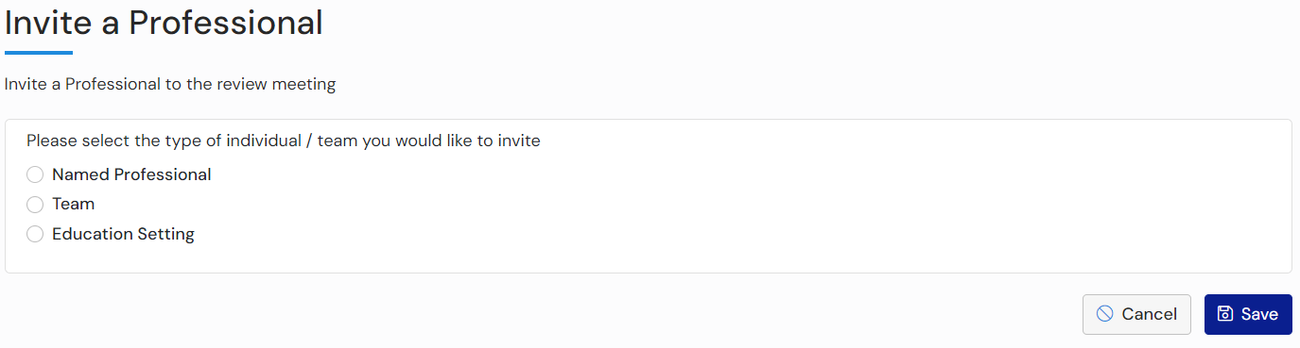
Click to select the type of individual/team you would like to invite.
Named Professional
If you click on Named Professional, left click on Nothing selected and select the required Named Professional from the picklist. Click here for more information on using pick list fields.
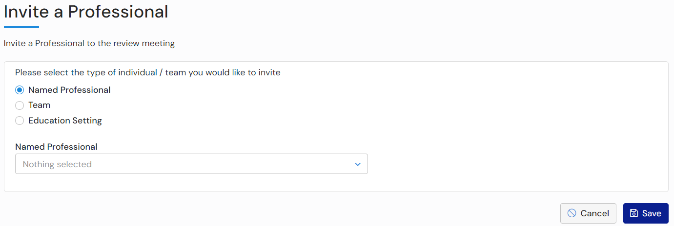
Click ‘Save’.
New professionals can also be added here. Click on the box above the list of professionals and start typing the name of the new professional. If no results match what is typed, the Invite new professional button will appear:
Click on this and complete the information for the new professional:
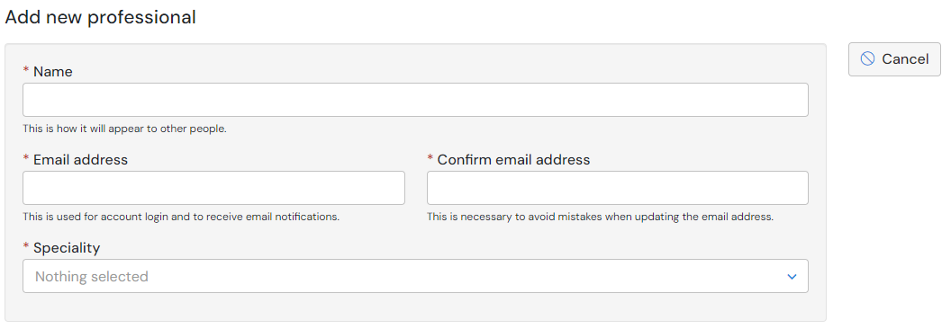
Team
If you click on Team, left click on Nothing selected and select the require team from the picklist. Click here for more information on using pick list fields.
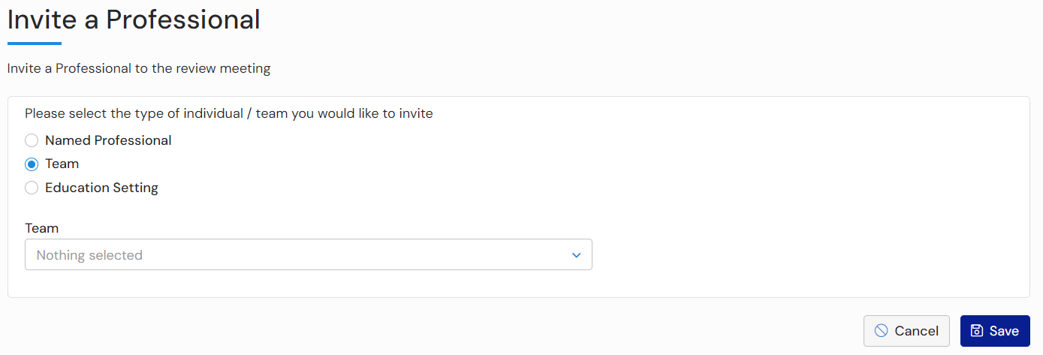
Click ‘Save’.
Education Setting
If you click on Education Setting, left click on Nothing selected and select the require SENCo from the picklist. Click here for more information on using pick list fields.
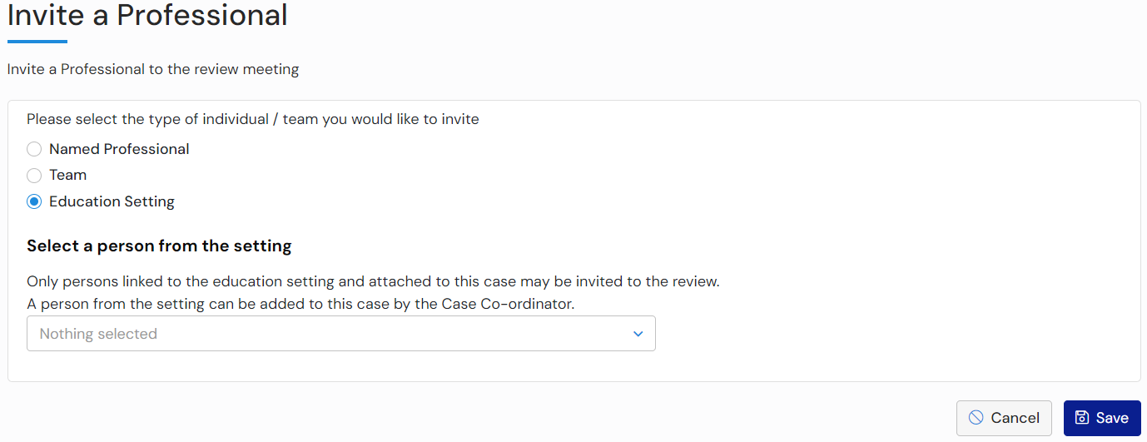
Click ‘Save’.
Only SENCos that are linked to the case (side bar) will be available to add to the review meeting invitations. If the intended SENCo that you wish to add is not available to select, please add them to the side bar by clicking ‘Add person’ under Education setting:
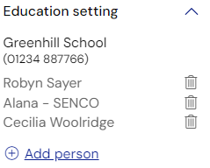
Once you add a new SENCO to the side bar and refresh the page, they will appear in the dropdown list when you select ‘Education Setting’ when adding a professional.
Any professionals and or teams invited to attend will then be displayed:
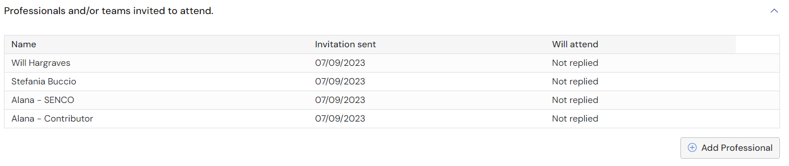

Case Co-ordinator(s) and/or Local Authority representative(s) invited to attend
The Case Co-ordinator assigned to this case will be automatically included in this section.
To invite additional Case Co-ordinator(s) and/or Local Authority representative(s), click on Add Co-ordinator:
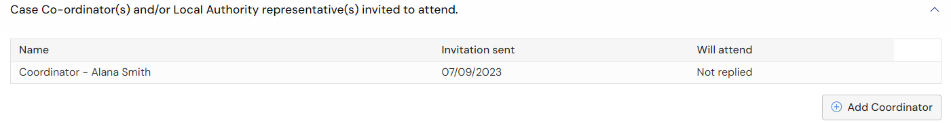
The following page will be displayed:

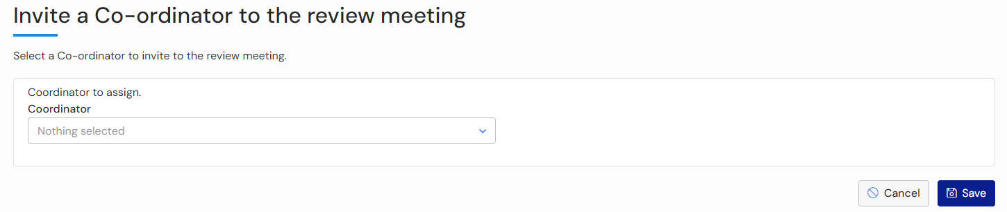
Left click on Nothing selected and select the required co-ordinator from the list. Click here for more information on completing pick list fields.
Click ‘Save’.

Confirm and send invitations
Once all the information has been completed, click on Confirm and send invitations:
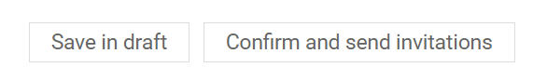
You will be asked to confirm this meeting and send invitations:
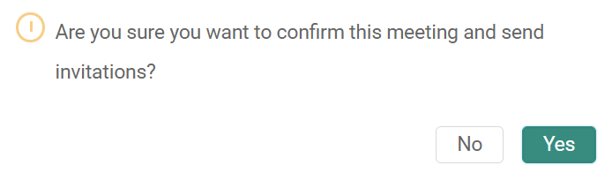
Click on Yes
All the attendees invited to the meeting will receive an email like this:
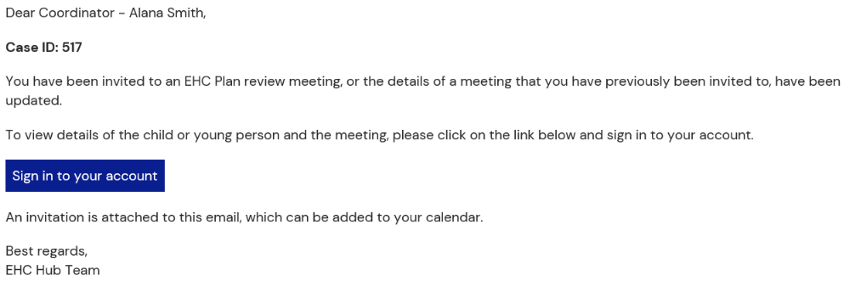
They will log into the hub to indicate if they will be attending the meeting

Viewing who has confirmed attendance for the meeting
A list of all the people who have confirmed they will be attending the meeting will be displayed:
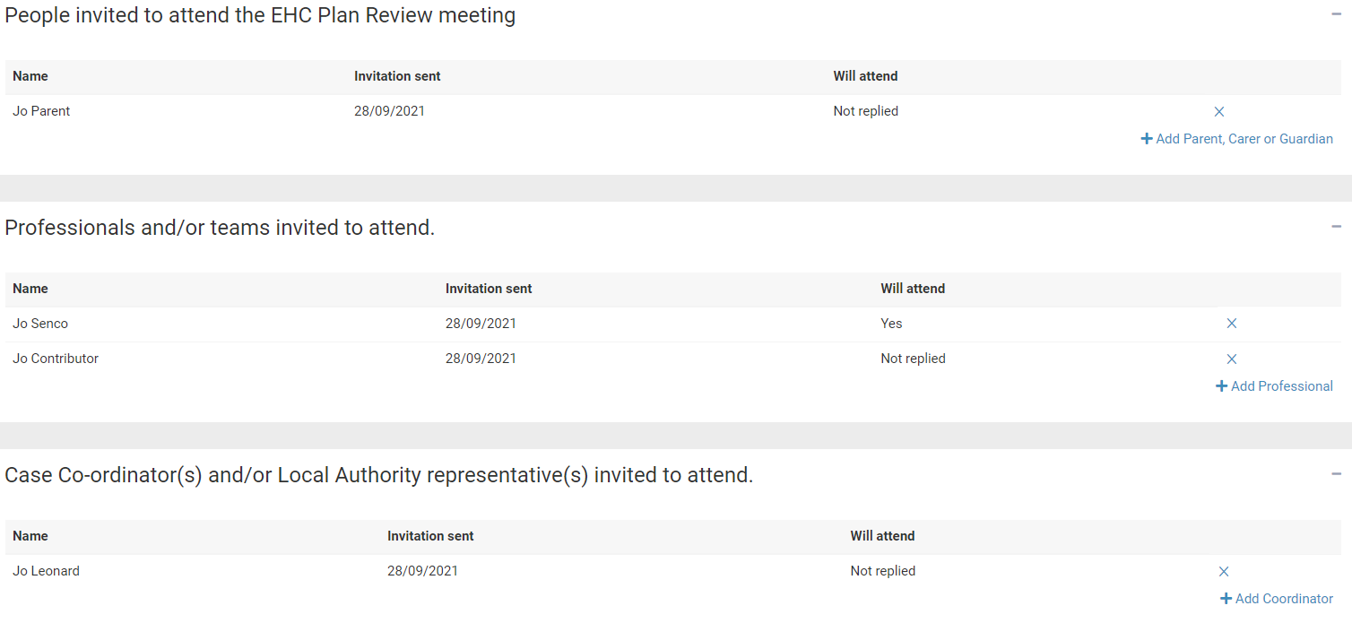

EHC Plan Review Consultation

Confirming Attendance for the meeting
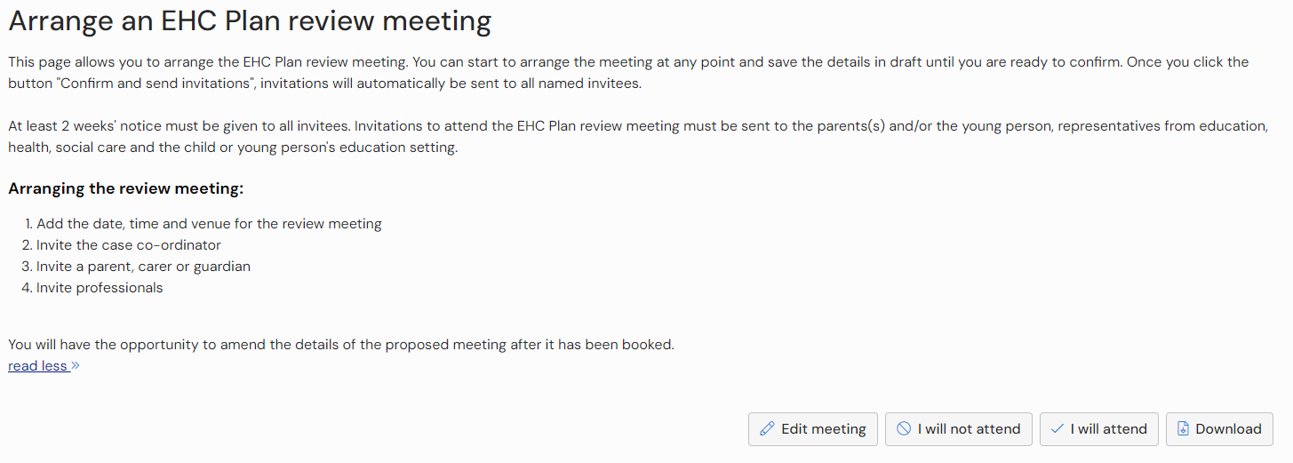
At the top of the screen, there will be two buttons:
Click on the button to indicate if you will or will not attend the meeting.

Sending Requests for Information
Once the invitations have been sent, information can be requested from involved professionals, teams or organisations that have been invited to the meeting:
To send a request for information, click ‘Request information’:
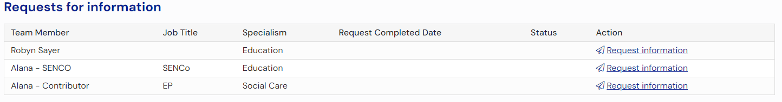
The person the information was requested from will receive an email like this:
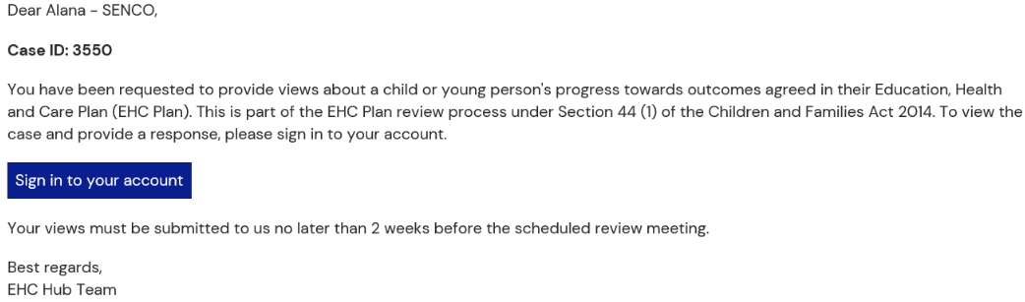
And the status of the request will be updated to show the response is ‘Pending’:
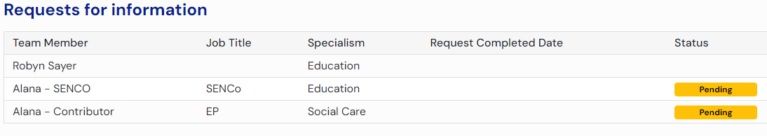
To request information from additional professionals not listed on this stage, return to the “Arrange” stage and add the person or team to the list of attendees. That person or team will then be available to request information from at the “Views” stage.
Once the request has been responded to, the status will be updating to show that a response has been received and the date it was completed:
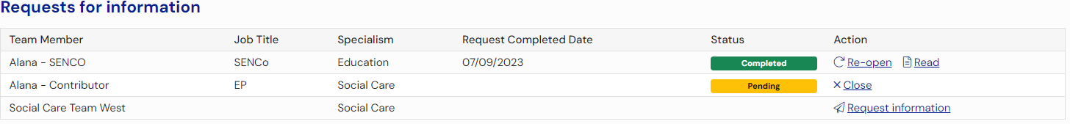

Responding to a request for information
To respond to a request for information, click ‘Edit’ beside your request for information:
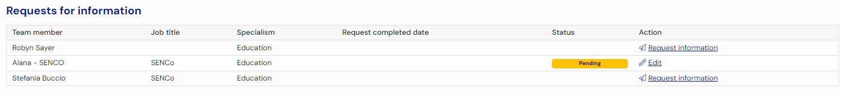
The request for information page will be displayed:
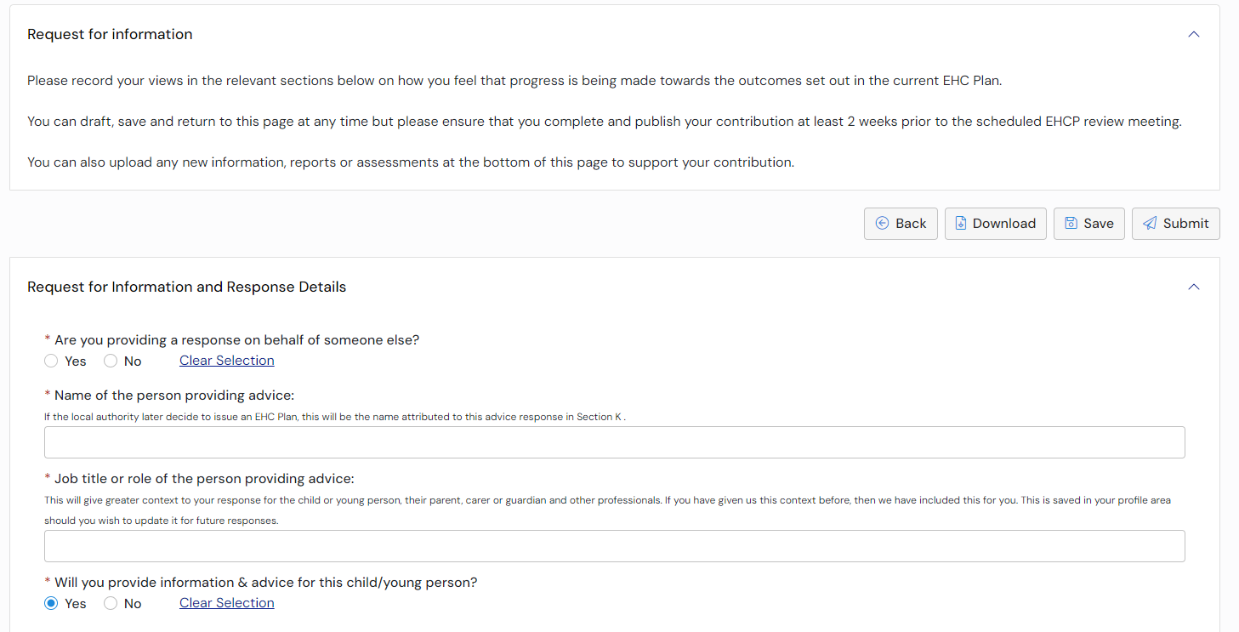
At the top of the screen, you will need to complete information about the response
Are you providing a response on behalf of someone else – click on the Yes or No button as appropriate
Name of the person providing the advice – enter the name of the person providing the advice. If the local authority later decide to issue an EHC plan, this will be the name attributed to this advice response in Section K
Job title or role of the person providing advice – enter the job title of role of the person providing advice
Will you provide information and advice for this child/young person – click Yes or No. If you answer No to this question, it is mandatory that you enter details as to why you are not willing.
Below that, there are six more sections:
- SEN - Communication and Interaction
- SEN - Cognition and Learning
- SEN - Sensory and/or Physical needs
- SEN - Social, Emotional and Mental Health
- Health
- Social Care
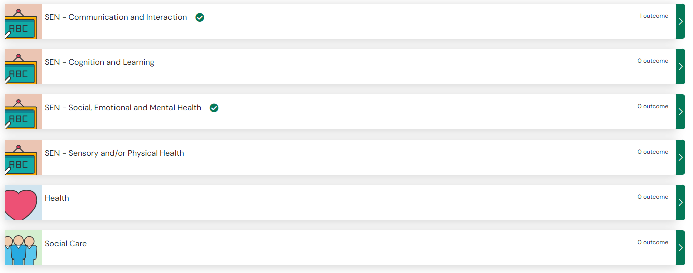
If a section has information in the current EHC Plan, it will have a green tick next to it. If a section has information and outcomes, it will have a green tick next to it and it will show how many outcomes there are.
To review the information in each section, click on the green arrow on the right. The information previously entered as part of the plan will be displayed.
Each section has the same questions which you can answer and commented on where appropriate:
Is there any change to the strengths and/or needs
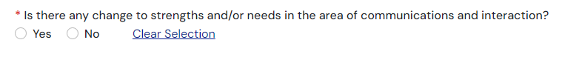
If you click on Yes, a free text field will appear for you to enter details of the change:

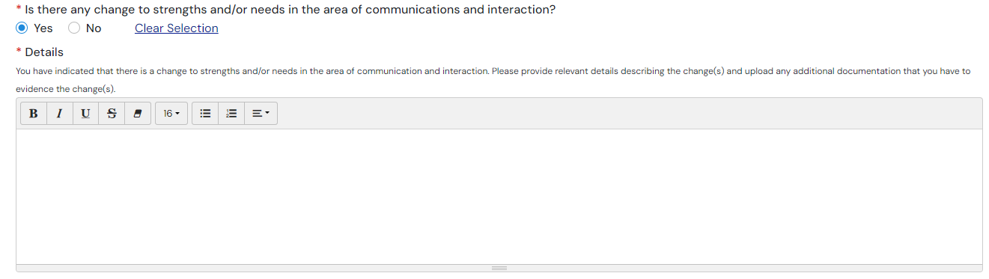
Click here for more information on using text fields
Outcome(s) - You can comment on Current Progress towards this outcome. To do this, click on the down pointing arrow at the end of the field:
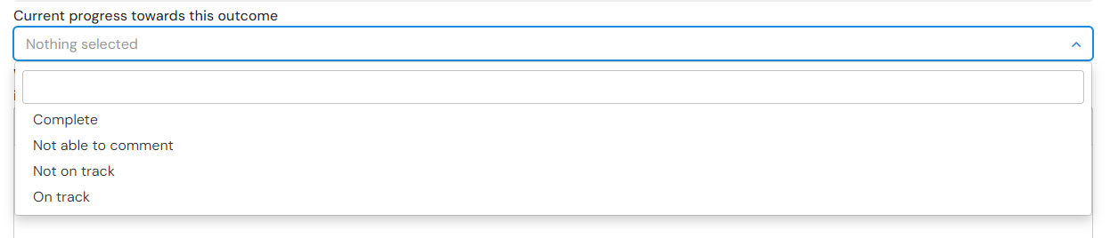
Click here for more information on using pick list fields
Steps to achieving this outcome:
What has been working well: This is a free text field. Click here for more information on using free text fields:
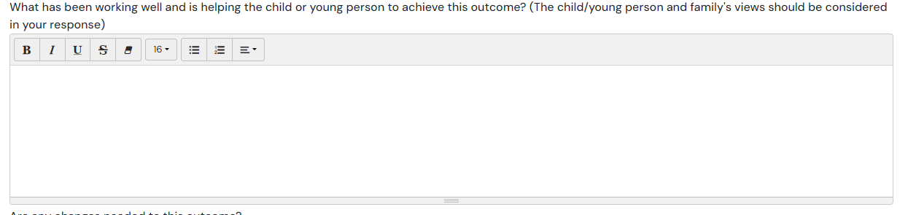
Are there any changes needed to this outcome – Click Yes or No. If you select Yes, a free text field will be displayed to enter information about this. Click here for more information on using free text fields
Are there additional short term targets –Click Yes or No. If you select Yes, click on Add a new step to enter information about the new step
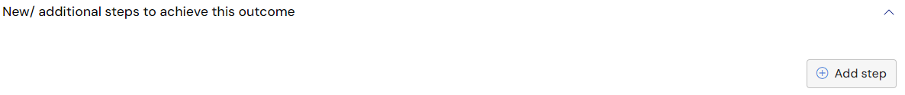
Click here for more information on steps and provisions
Are there any changes needed to the SEN provision to support the child or young person to meet this outcome – click Yes or No. If you select Yes, click on add a new provision to enter information about the new provision or recommended changes to existing provision.
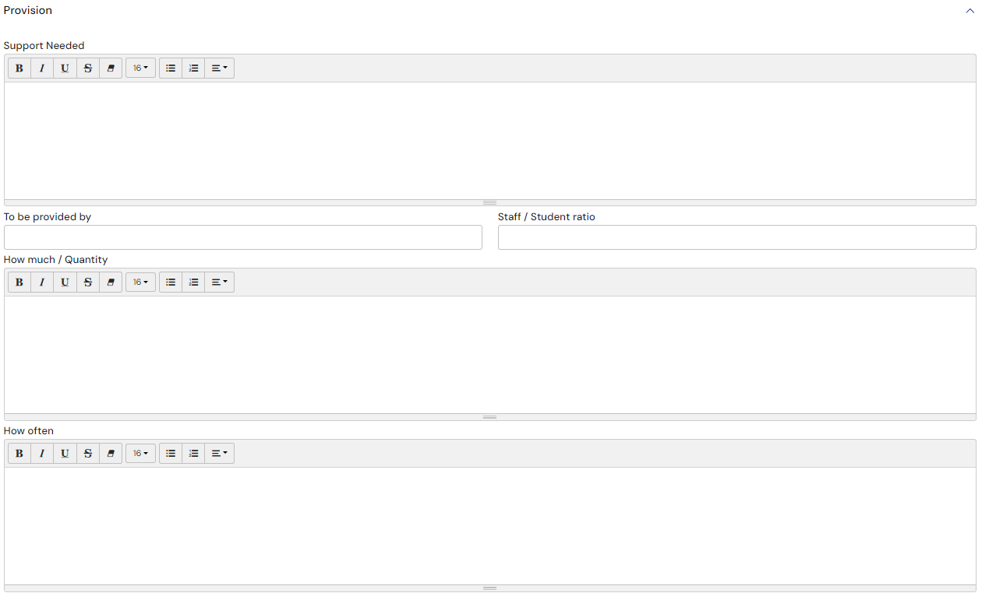
Click here for more information on steps and provisions
When you are entering information, there is a save button at the top of the page that you can use to save what you have written:
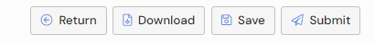

Documents
Any addition information to support the advice can be uploaded here:
If you want to add any documents, click ‘Add Files’:
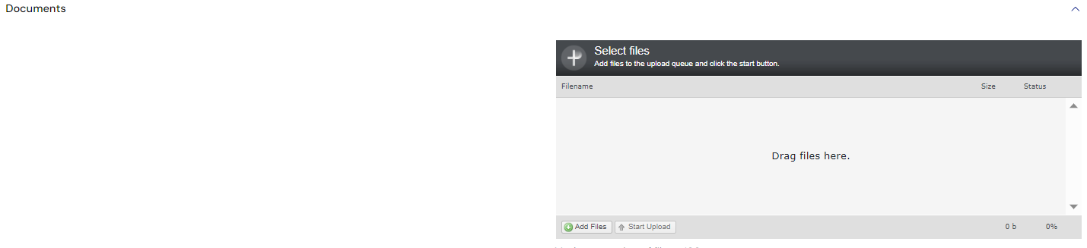
You will then need to navigate to the file wherever it is saved on your PC:
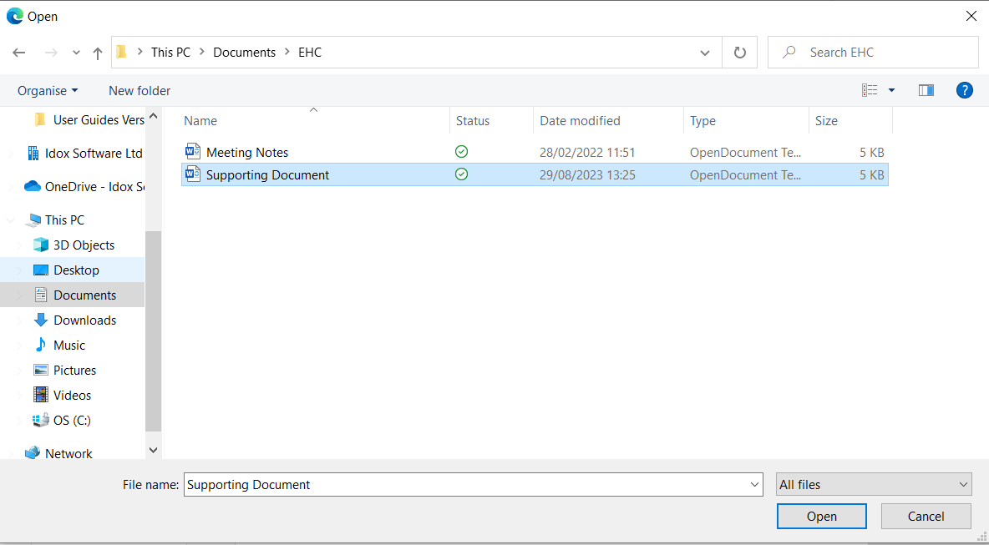
Click ‘Open’ and the file will be uploaded. The uploaded file will be displayed:
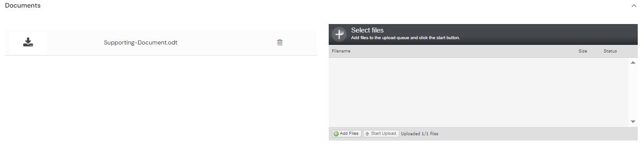
Once you have completed the information for all the relevant sections, click on Submit information at the top of the screen:
Having submitted information towards a review, you will able to read all other professionals information that has been submitted. Click ‘Read’ beside the request for information you wish to view, you will also be able to download the information.

Reopen a Request for Information
It is possible to reopen a request for information. This means changes can be made to the response and it be submitted again.
To reopen a request, click ‘Re-open’:
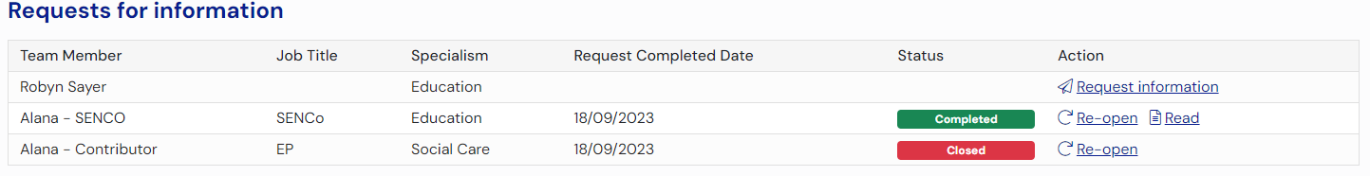
You will be asked to confirm you want to reopen the advice request. Click ‘Yes’. The status of the request will then be displayed as ‘Pending’:
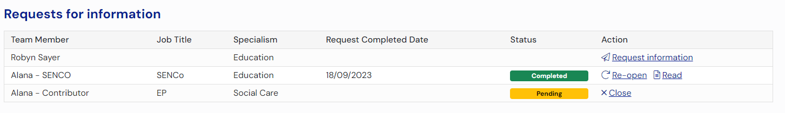
Once a request for information has been re-opened the professional will be able to click ‘Edit’ and submit their advice:
The status will then be updated to show it has been ‘Completed’:
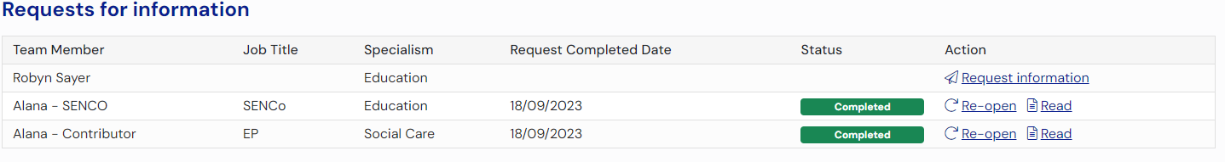

Closing a Request for Information
It is possible to close a request that hasn’t been submitted.
To close a request, click ‘Close:
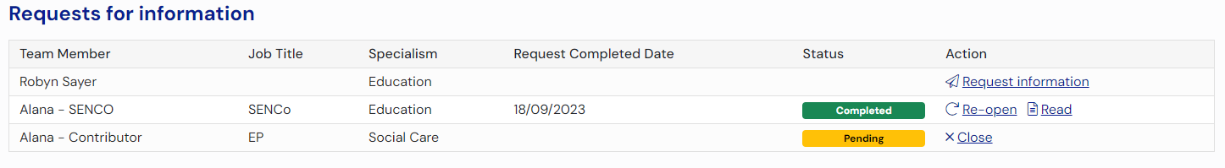
The status of the request will then be displayed as Closed:

The Childs or Young Persons Views
This section can be completed by the Child or Young Person or this can be completed by yourself or the Parent, Carer or Guardian or the Case Co-Ordinator.
As this is a review, there will be a section about how they feel they are progressing, you will be able to view/edit this information:
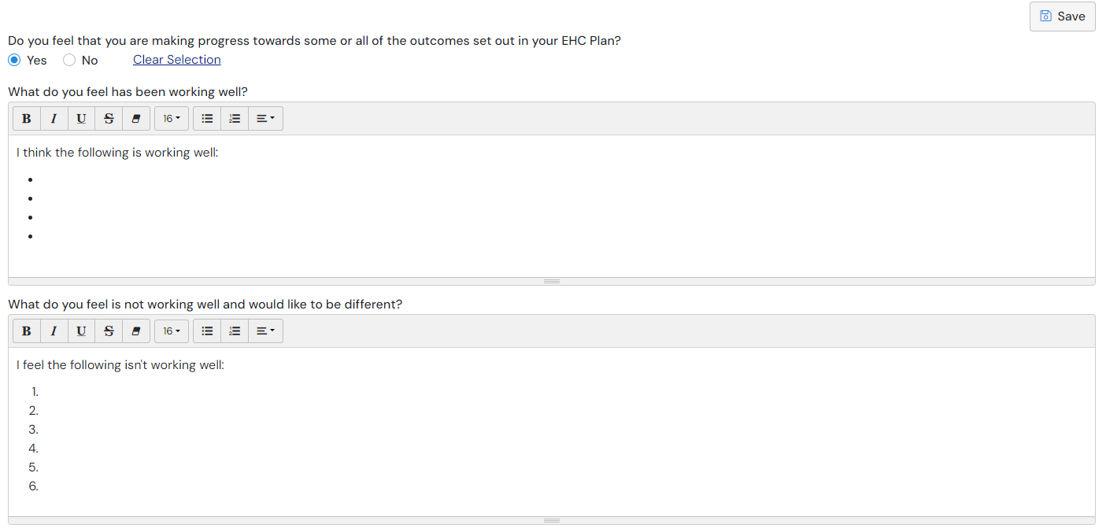
You will also be able to view or edit any information entered for the views of the Child or Young Person. If there are green ticks on any section, this means there is information that you can view:

Click ‘Open’ to view the section:
You can add details or files if needed, click ‘Save’ to save any information you add.

The Parent, Carer or Guardian’s Views
This section can be completed by the Child or Young Person or this can be completed by yourself or the Parent, Carer or Guardian or the Case Co-Ordinator.
As this is a review, there will be a section about how they feel they are progressing, you will be able to view/edit this information:
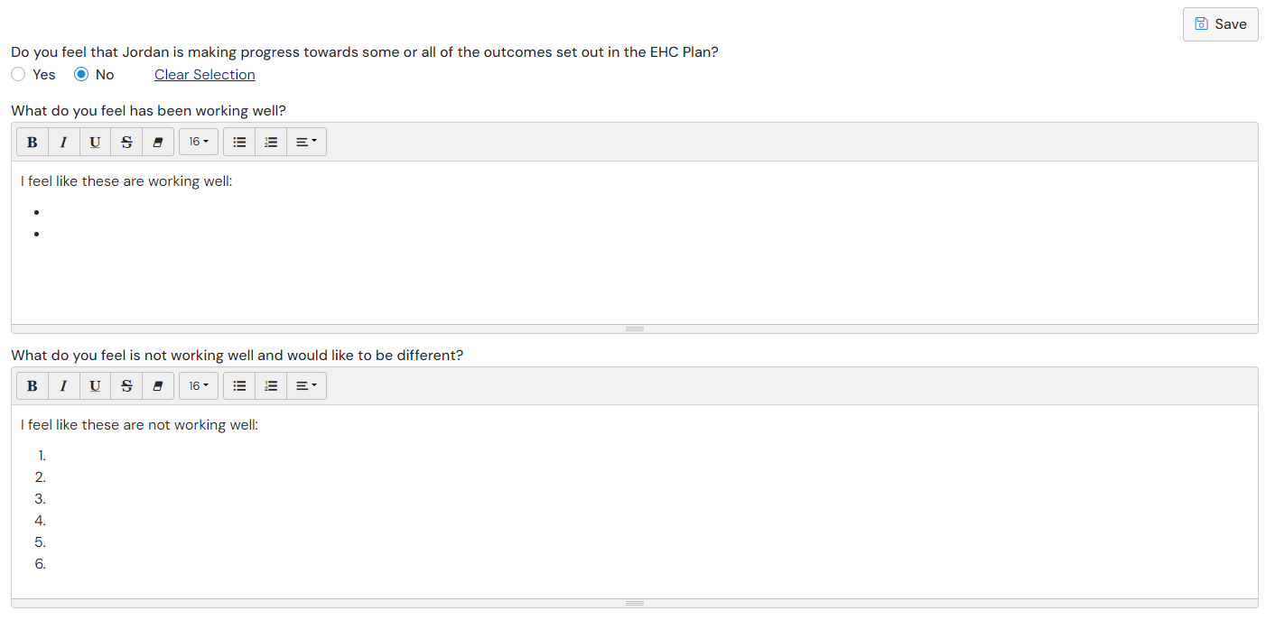
You will be able to view any information entered for the views of the Parent, Carer or Guardian. If there are green ticks on any section, this means there is information that you can view. To view that information:
Click ‘Open’ to view the section:
You can add details or files if needed, click ‘Save’ to save any information you add.

Progress to Meeting
Once all the requests for information have been responded to, the Progress to meeting button will become available. This will not be available until all requests for advice have either been completed or closed. To close a request, click ‘Close’.
To progress to the meeting stage of review, click ‘Progress to meeting’:
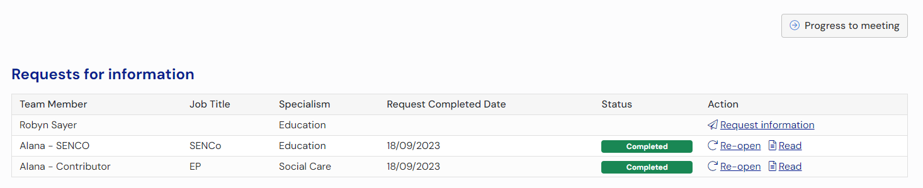
You will be asked to confirm this:
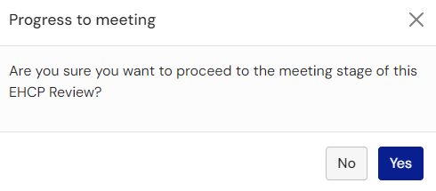
Click ‘Yes’.

EHC Plan Review Meeting
When the meeting has taken place, the details of the discussions held at the meeting and any recommendations made will need to be entered on the hub.
The pathway of the case will be displayed like this:
This has 5 sections:

EHC Plan Review Meeting Details
This will show the date, start time and end time and location of the meeting. Enter any changes to this information if required. The meeting details can be changed until the review report is submitted to allow for an administration error to be corrected.

Record of people who were invited and attended
This will show who was invited and if they attended. To confirm if they attended, click on the tick box in the Attended meeting column for each person:
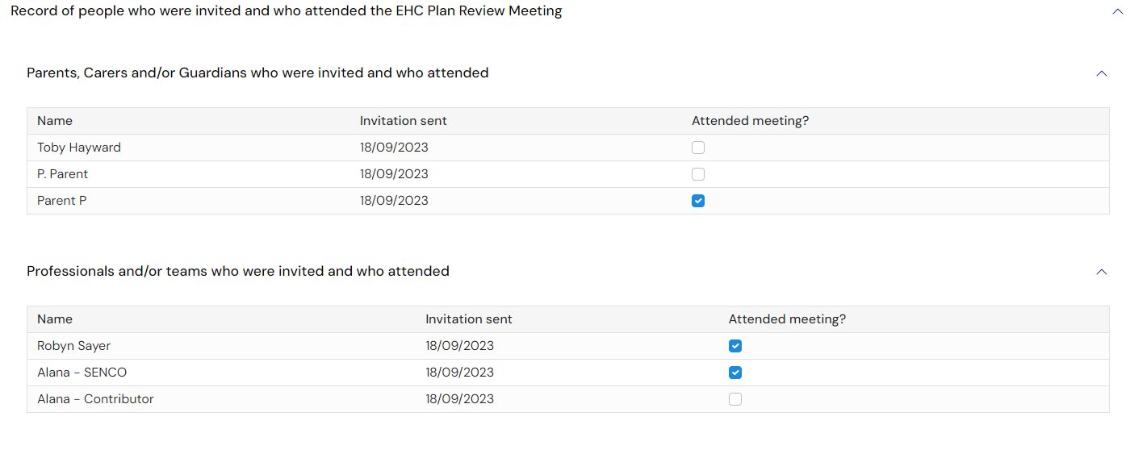

Other Attendees
This will show a list of people who were not originally invited to attend ahead of the meeting but were in attendance.
To add an other attendee, click ‘Add’:
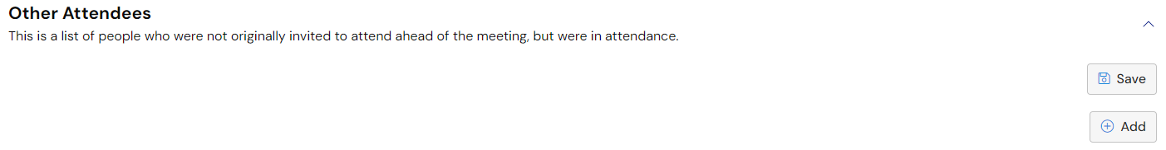
The following will appear:
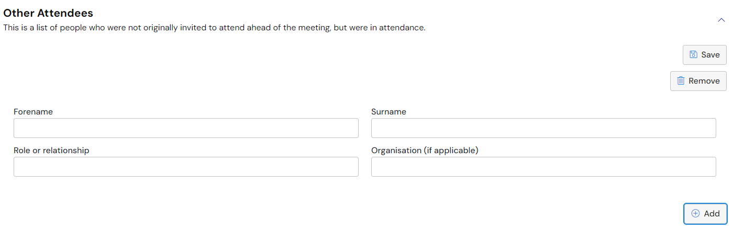
Enter the information and click ‘Save’.

Additional Meeting Information
This will show any specific information about the meeting, like if apologies had been received or new information was brought to the meeting. The additional information can be entered in the free text field. Click here for more information on using free text fields
Click ‘Save’.
(The details of the actual plan review discussion will be shown in the review report in the next section)

Meeting Documents
Any supporting documents from the EHC review meeting ca be attached here.
If you want to add any documents, click on the Add Files button:
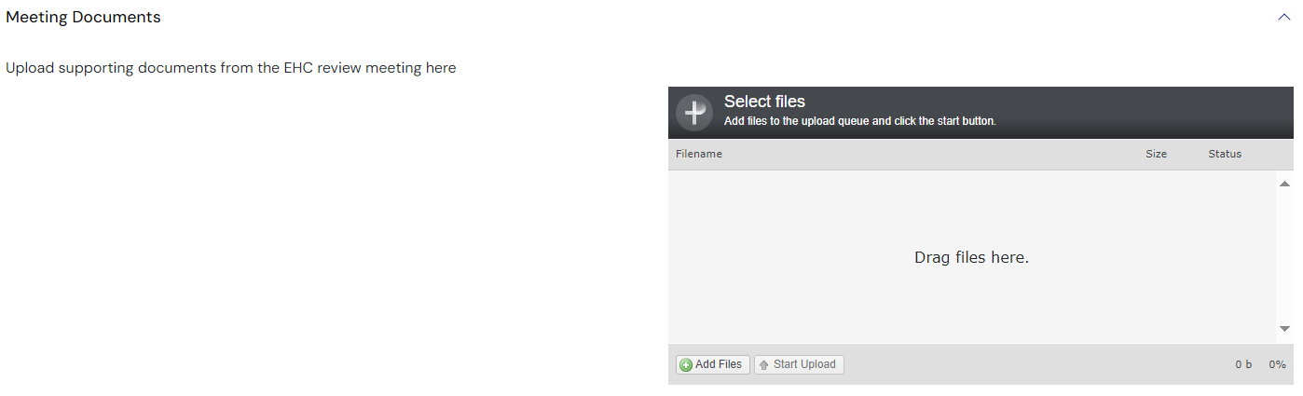
You will then need to navigate to the file wherever it is saved on your PC:
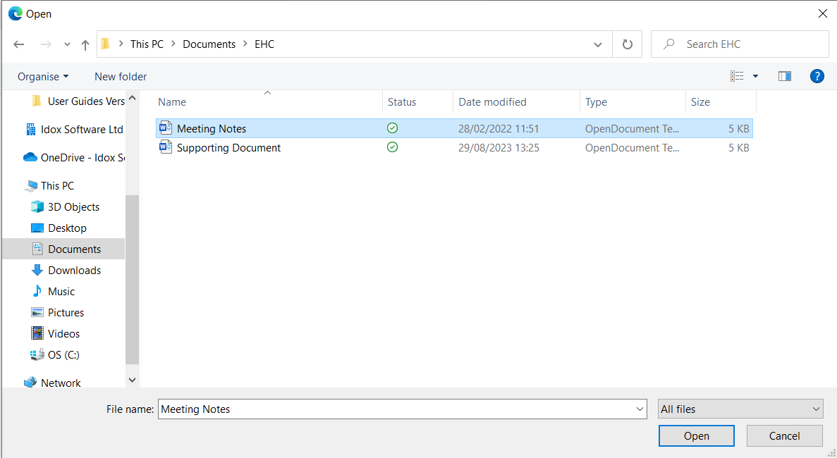
Click ‘Open’ and the file will be uploaded. The uploaded file will be displayed:

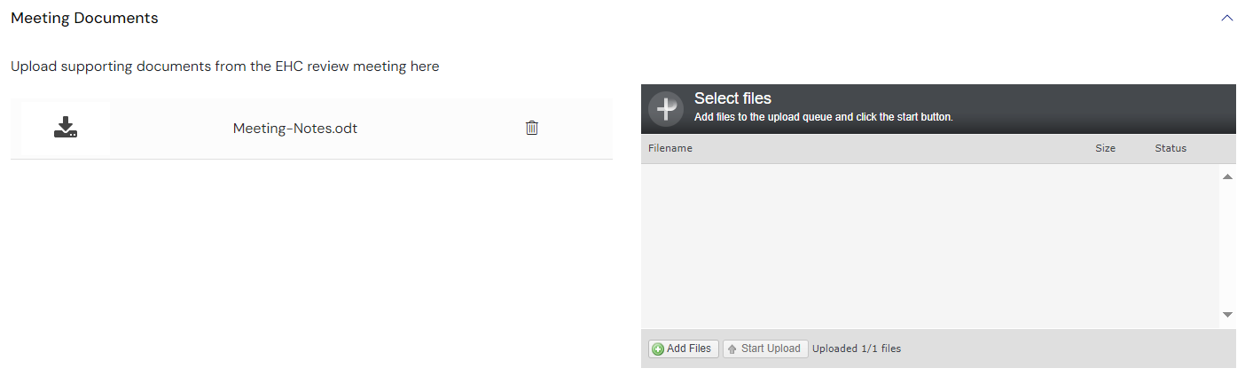
When all of the meeting details have been reviewed and entered, click ‘Save’ at the top of the page.
When you are ready, click ‘Progress to report’:
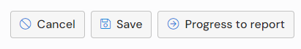

Re-opening the Contribute Views stage
If you wish to re-open the Contribute Views stage of the review, click ‘Cancel’ on the ‘Meeting’ stage screen. You will be asked to confirm you wish to cancel the meeting. Click ‘Yes’.
If you cancel the meeting the status of the case will return to the ‘Views’ stage of the pathway:

Progress to Draft Report
When the ‘Progress to report’ button is clicked, the pathway of the case will change:
The EHC Plan Review Report page will be displayed:
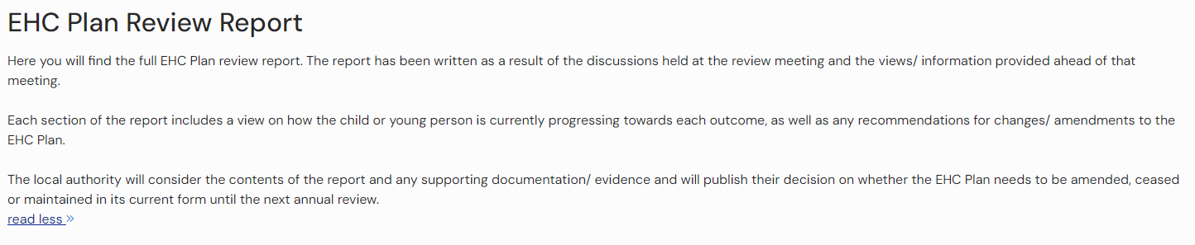

Draft Report Areas
The report areas will be displayed below. They are:
- Details for the child or young person’s current education setting
- The child or young person’s views
- The parent(s) or carer(s) views
- SEN – Communication and Interaction
- SEN – Cognition and Learning
- SEN – Sensory and/or physical health
- SEN – Social, Emotional and Mental Health
- Health
- Social Care
- Transition and preparing for further education and adulthood
- Transport assistance
- The child or young person’s personal budget
- Summary of EHC Plan annual review recommendations
Details of the child or young person’s current educational setting
Click on the green right pointing arrow to complete this information:
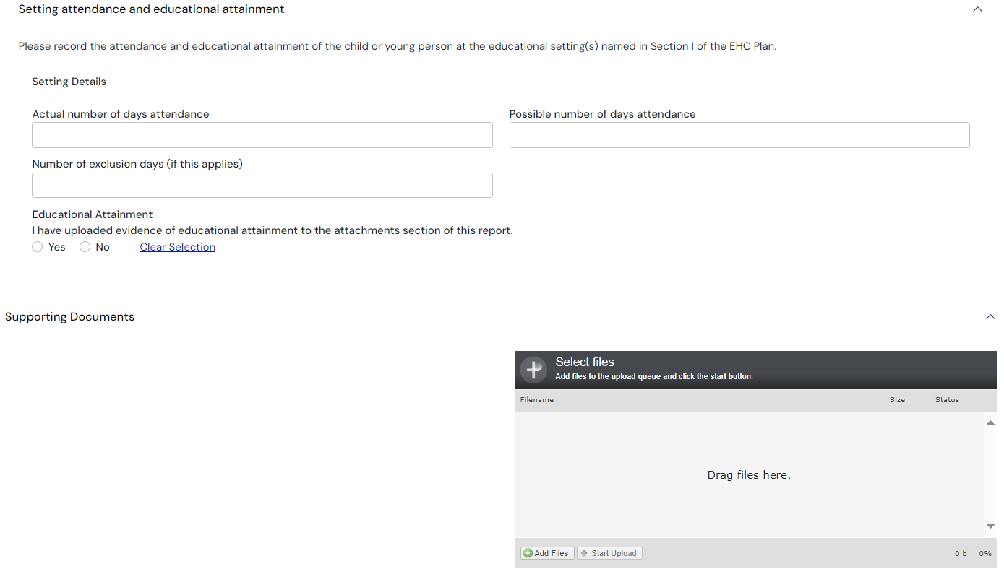
Setting Details - If any setting details have been added to Section I of the plan then those details will automatically be populated.
Actual number of days attendance – enter the actual number of days the child or young person attended at the education setting
Possible number of days attendance – enter the possible number of days the child or young person could have attended the education setting
Number of exclusion days (if this applies) – if the child or young person was excluded from school at any time, enter the number of exclusion days.
Educational Attainment – click Yes or No as applicable.
Supporting Documents - Any addition information can be uploaded here:
If you want to add any documents, click on the Add Files button:
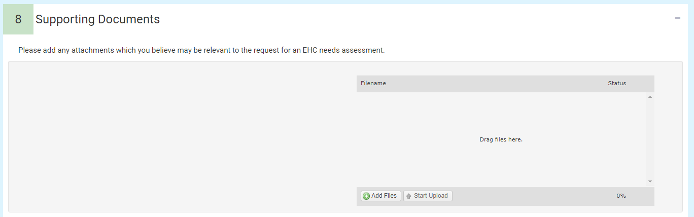
You will then need to navigate to the file wherever it is saved on your PC:
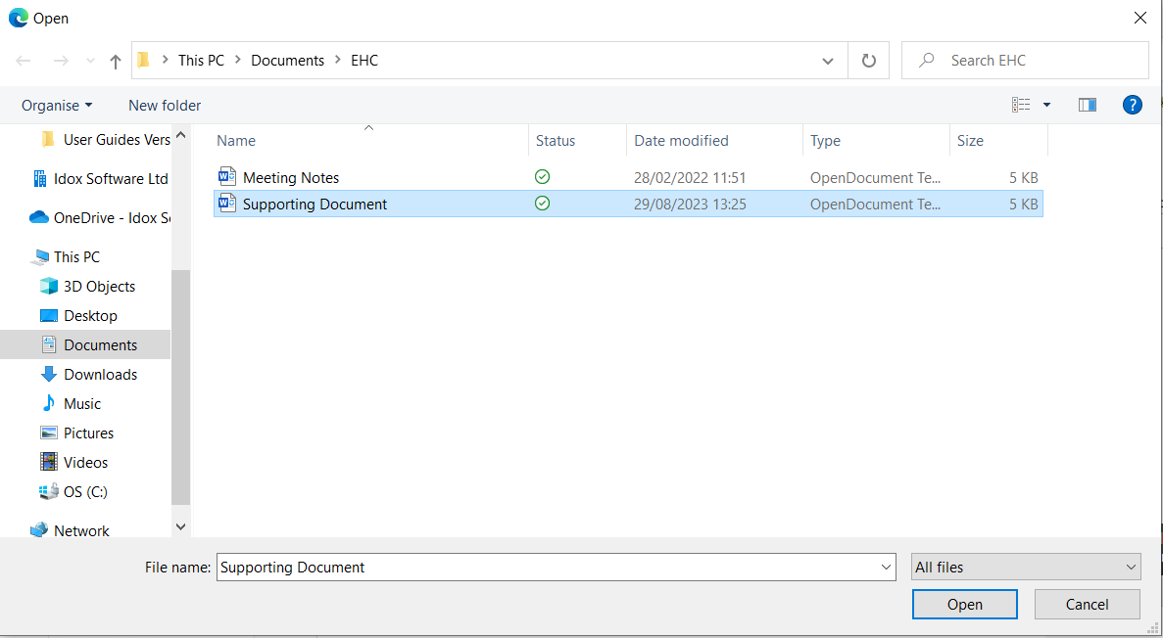
Click ‘Open’ and the file will be uploaded. The uploaded file will be displayed:
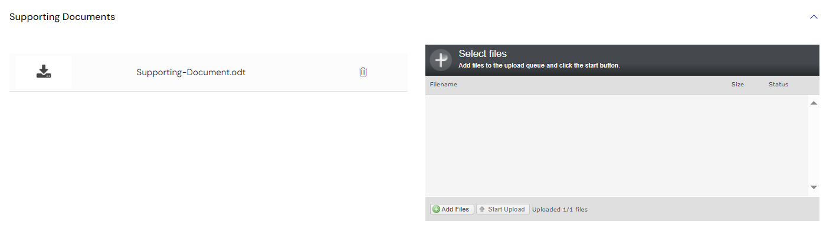
Each section contains a green arrow to the right of the screen. If there is information in that section, it will be displayed with a green tick. If any area has no outcomes in it, it will display 0 outcomes.
Click on this to review the information within that section.
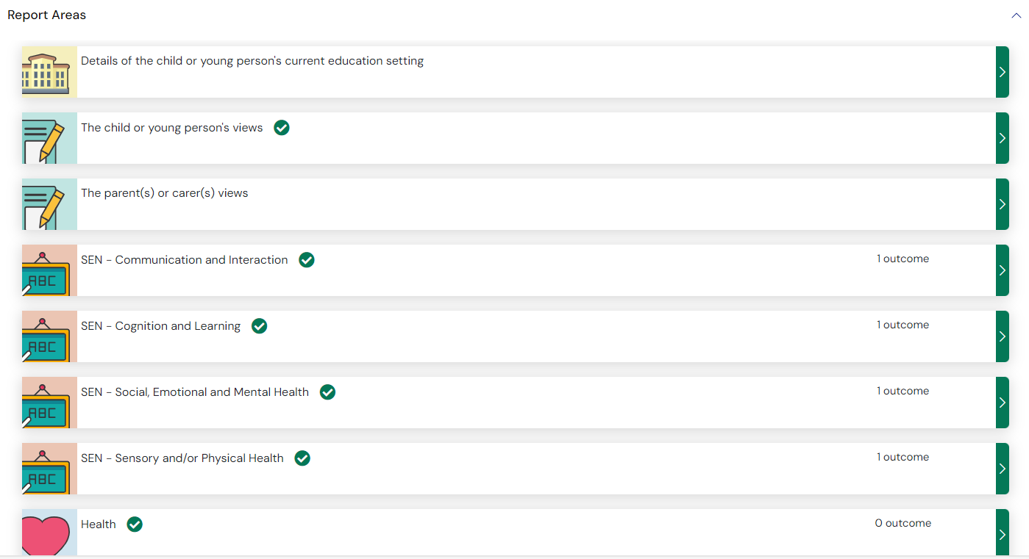
To add information to one of the report areas, click the green pointing arrow to the right of that section.
That section will be displayed to be completed.

Summary of EHC Plan annual review recommendations
At the bottom of the sections there is Summary of EHC Plan annual review recommendations:
Click on the green arrow on the right to access this section:
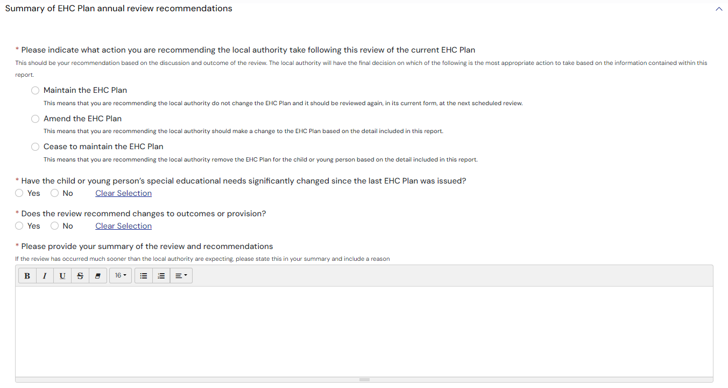
You will need to indicate what action you are recommending the local authority take following this review. Your options are:
- Maintain the EHC Plan
- Amend the EHC Plan
- Cease to Maintain the EHC Plan
Click on the radio button to the left of the action you wish to recommend.
Underneath this there are additional questions to be completed.
Has the child or young person’s special education needs significantly changed since the last EHC Plan was issued – Click Yes or No
Does the review recommend changes to outcomes or provisions – click Yes or No
Please provide your summary of the review and recommendations – this is a free text field. Click here for more information on using free text fields.

Agreed Actions
This is a space to add any actions that were discussed and agreed during the review meeting that are to be completed.
To add an action, click ‘Add’:

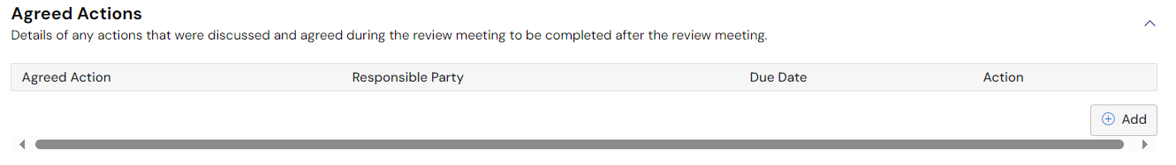
The Agreed Actions window will be displayed:
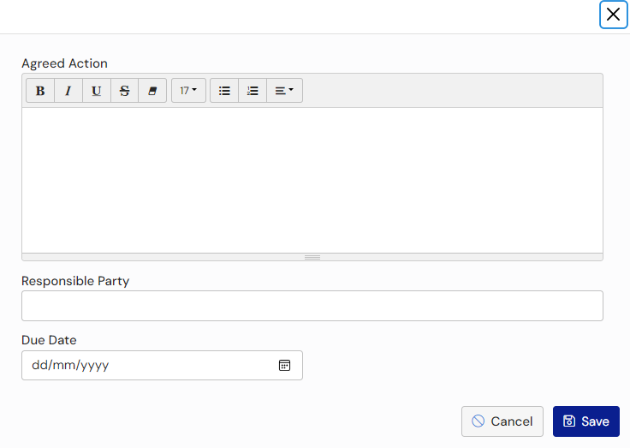
Agreed action – enter details about the agreed action. Click here for more information on using free text fields.
Responsible Party – enter the responsible party for this action
Due Date – enter the date this action is due by
Click ‘Save’
The agreed action will then be displayed:
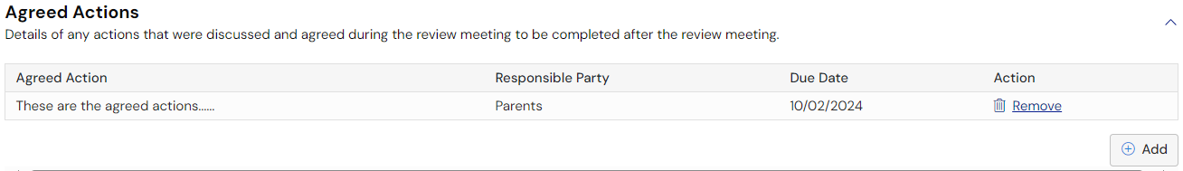
To add a further action, click ‘Add’.
To remove an action, click ‘Remove’.

Supporting Document
Any addition information can be uploaded here.
If you want to add any documents, click ‘Add Files’:
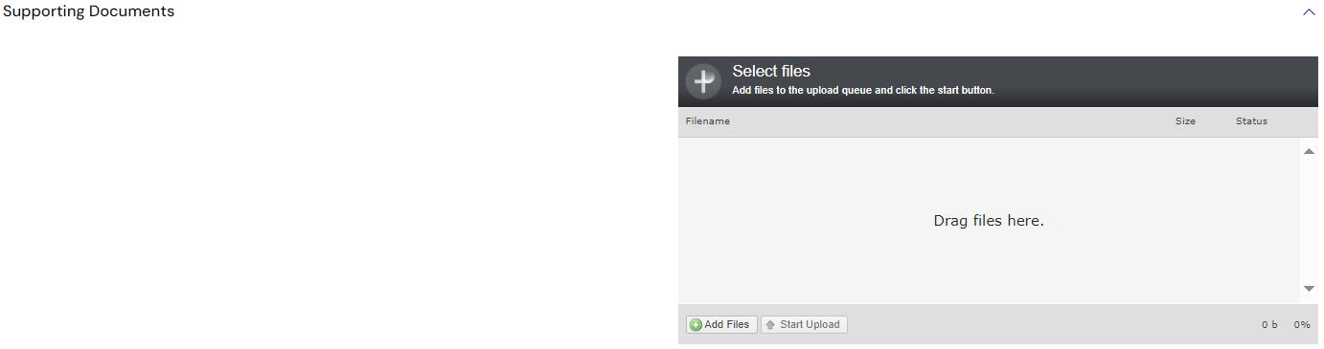
You will then need to navigate to the file wherever it is saved on your PC:
Click ‘Open’ and the file will be uploaded. The uploaded file will be displayed:

Submitting the Review Report
When the information has been reviewed and is complete, click on Submit Report:
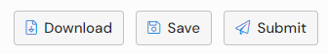
You will be asked to confirm you wish to submit the report. Click Yes.

Downloading the Review Report
The report can be downloaded both before and after submission.
To download the report before submission, click on the Download button:
The file will be displayed in the bottom left hand corner of the screen

Reopening the Review Report
If you identify an error in the review report after it has been submitted, please contact the case co-ordinator and they will be able to reopen the review report for you. This is possible until the local authority publish their review decision.

Review Decision
The pathway of the case will update to reflect that the case has moved on:
A message will be displayed that the decision about the current EHC plan is being considered
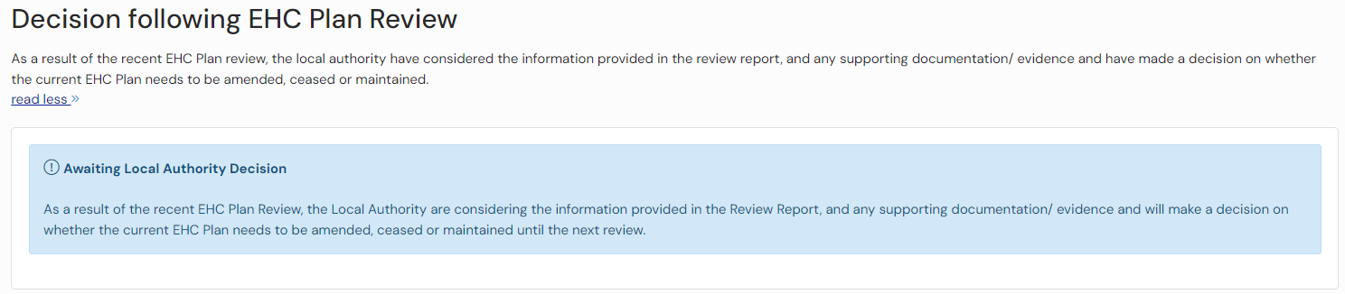
When the decision has been made by the local authority, this will be updated by the Case Co-ordinator and published. An email will be sent to you informing you of this:
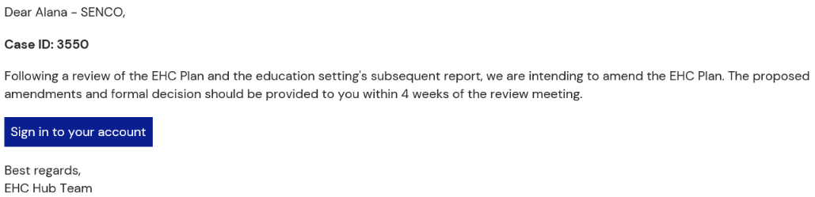
The results of the review process will be one of three options:
- Keep the current EHC Plan as it is
- Amend the EHC Plan
- Cease to maintain the EHC Plan

Keep the current EHC Plan as it is
If the decision has been taken to keep the current EHC Plan as it is, you will be taken to the ‘EHC Case Summary’ when you view the case. When you scroll down the screen to the ‘Completed reviews’ section, you will see the outcome will be displayed as ‘Keep the current EHC plan as it is’.
To view more information about this decision, click ‘View pathway’, and go to the ‘Decision’ stage on the pathway:
This will display information about the decision.
Click here for more information about the Case Summary Page.

Amend the EHC Plan
If the decision has been taken to amend the EHC plan, you will be taken to the ‘Plan’ stage of the review pathway:
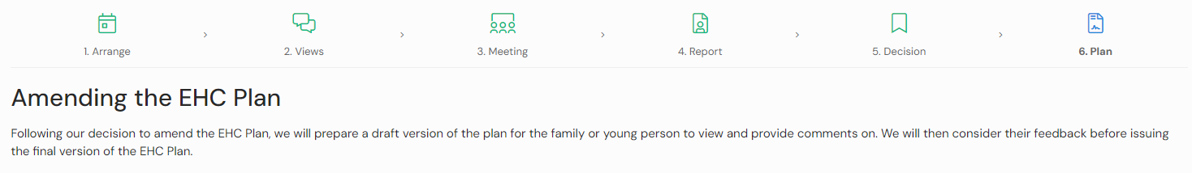
At the bottom of the screen, it will display a message to say the revised plan is being drafted:
When the draft plan has been shared by the case co-ordinator and you will get an email informing you of this. When you log into the hub, you will be able to see the draft plan:
When the plan has been finalised, you will get an email informing you of this and when you log into the hub, the case summary page will be displayed. Click here for more information about the case summary page.

Cease to maintain the EHC Plan
If the decision has been taken to cease to maintain the EHC plan, the case will not appear in your ‘My cases in progress’ as the case in closed. You will be able to use the filters to ‘Include closed cases’ when searching.
When you click on the child/young persons name, you will be taken to the ‘EHC Case Summary’ of the case, when you scroll down the screen to the ‘Completed reviews’ section, the outcome will be displayed as ‘Cease to maintain the EHC Plan’
To view more information about this decision, click ‘View pathway’, and go to the ‘Decision’ stage on the pathway:
This will display information about the decision.
Click here for more information about the case summary page.

Help Using Forms

Pick List Fields
Click on the down pointing arrow at the end of the field to view the available options for selection. There is a scroll bar on the right to allow you to scroll down to view more options in the list. Scroll down until you can see the option you require and then left click to select it. Alternatively, if you know the option you require, you can begin to type it in the field and the list will show options that match what you type:
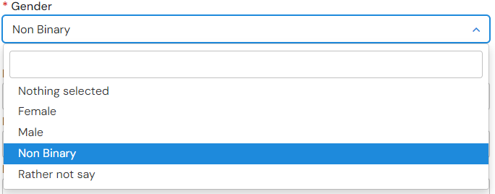

Text Formatting
Left click anywhere in the box and start typing any information you want to enter here. If required, there are various formatting options for that can be accessed by clicking on the buttons at the top of the field. To see what each button does, hover over the button with the mouse pointer and a tool tip will be displayed to show what that button does

Entering an Address
Enter the postcode of your address in the postcode search field and click on Search:
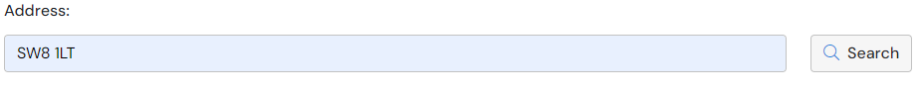
Another field will be displayed:
Click on the down pointing arrow to view with all addresses that match that postcode:
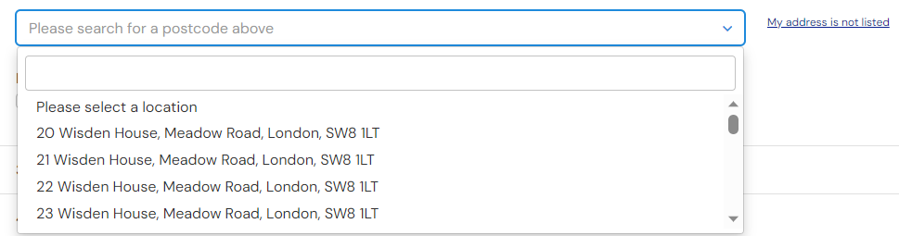
Left click on the correct address to select it. The address will then be displayed on screen:
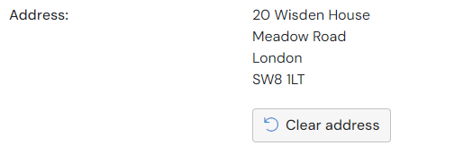
If the address is incorrect or needs to be removed, click on Clear address and a new location will be available to be selected.
If the correct address is not available to be selected from the list, click on the My address is not listed option, and the fields will be made available to be completed manually:
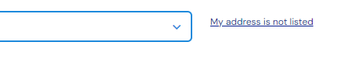

Date Fields
Type in the date required with a dash between the day, month and year. Alternatively, left click on the field and select the date from the calendar. Navigate around the calendar using the arrows in the top right and left corners until the correct date is available. Left click on the date to select it.

Contact us
Idox Software Ltd
Unit 5, Woking 8
Forsyth Road
Woking
Surrey
GU21 5SB

T: +44 (0) 333 011 1200
E: info@idoxgroup.com
www.idoxgroup.com

