To cancel Graduated approach booking face to face event
If you have an Eventbrite login, please login or
Go to the email confirmation you received when you booked it
Click on view and manage your order online near the bottom of the email
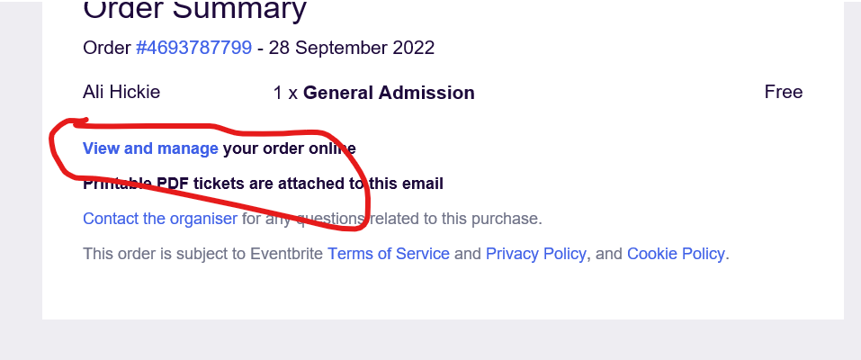
Click on email me a login link
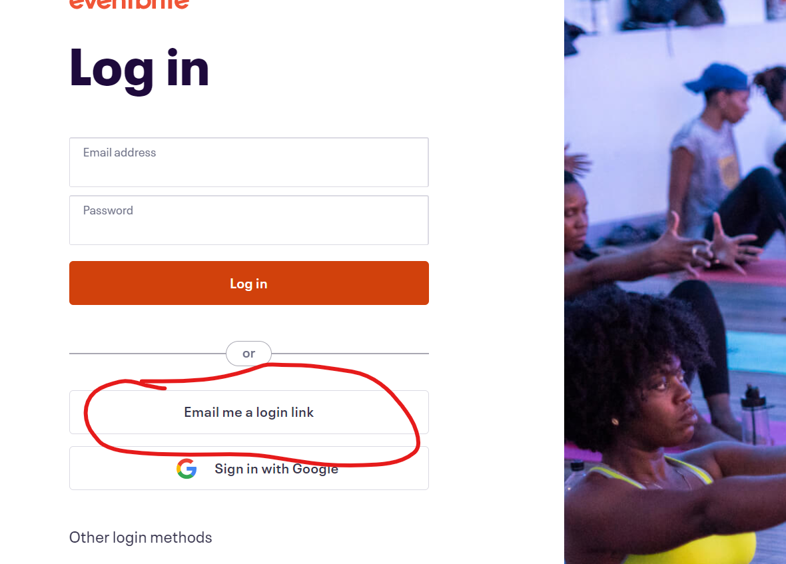
Follow the link on the email they send
Click on tickets at top right
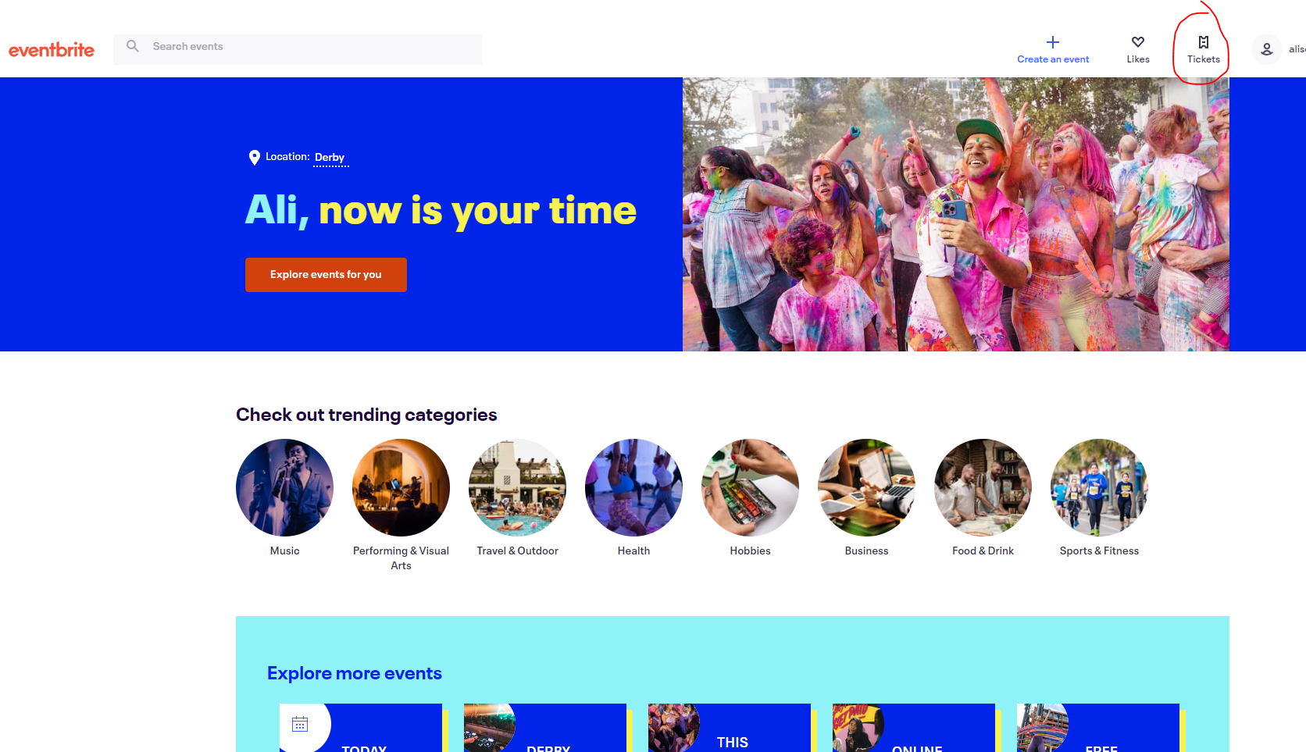
Click on the ticket, and then click cancel order

