Health & Safety
Quick Card

Elected Members – Basic Health & Safety

CONTENTS

1. | Introduction
2. | Elected Members' Surgeries
3. | Domiciliary Visits (Home Visits)
4. | Personal Callers
5. | Malicious and Nuisance Telephone Calls
6. | Malicious or Anonymous Email
7. | Car Safety and Parking
8. | Reporting Accidents / Incidents
9. | Personal Protective Equipment (PPE)
10. | Emergency Evacuations & First Aid - County Offices
11 | COVID Information
12 | Display Screen Equipment (DSE)
13 | Duties and Responsibilities of an Elected Member
14 | References & Further Information

1.0 INTRODUCTION

1.1 One of the most important roles of an Elected Member is to keep in touch with their local community.

1.2 The arrangements for personal safety, which each Elected Member makes when fulfilling this role, will vary according to local circumstances and Elected Members will decide themselves how to be accessible to their local constituents.

1.3 The following suggestions may help to avoid any potential safety problems:

2.0 ELECTED MEMBERS' SURGERIES

2.1 The Basics

2.1.1 Whenever possible, an Elected Member should not hold a surgery alone in an otherwise empty building. To improve safety and manage a busy surgery, it is preferable to have either a receptionist or a second person available. If surgeries are currently being undertaken alone, then it is advisable to discuss how this can be overcome with fellow Elected Members or Council Officers.

2.1.2 The Elected Member should sit nearest the door with the constituent seated on the other side of a table.

2.1.3 If there are no separate waiting rooms, try to ensure that the waiting constituents are seated as far away as possible (i.e. out of hearing distance).

2.1.4 Make sure that there are no heavy or sharp items in the room that could be used as weapons.

2.1.5 When assessing premises for suitability in which to hold a surgery, the following features should be considered:

- Use Council premises during opening hours or other premises where there are other people about
- Use premises where the names of any visitors for Elected Members are recorded
- Try to ensure that there is a comfortable waiting area
- Where possible the surgery (interview) room should be in view of the reception / public area, and / or should be connected to the receptionist by an alarm. There should be a procedure for dealing with a ‘call for assistance’
- It would be preferable for the surgery room to have a vision panel in the door
- In the case of emergency (e.g. a personal attack) there should be a quick exit route from the room and visitors must not be able to lock the door

2.2 Dealing with Emotional Constituents

2.2.1 On occasions, some members of the public may be angry or upset. Elected Members must be prepared to handle all types of emotion.

2.2.2 Elected Members need to acquire the skill of being concerned about constituents' problems without being so involved that they themselves are unable to help. Being calm will assist both the Elected Member and their constituents.

2.2.3 The constituent may make offensive or discriminatory remarks. It is essential that the Elected Member does not respond as this may escalate the situation. Instead, the interview should be ended as quickly as possible. If remarks are of a ‘general’ nature, indicate that this is unacceptable and terminate the interview - often this may elicit an apology. Otherwise ask the person to leave. However, the Elected Member must use their own judgment and, if alone and / or in a vulnerable situation, must not put themselves at risk, no matter how inflammatory the remarks may be.

3.0 DOMICILIARY VISITS (HOME VISITS)

3.1 Elected Members sometimes undertake domiciliary visits (i.e. they visit constituents in their homes) especially those who are elderly or disabled. It is for each Elected Member to decide whether a particular visit should be made, especially if the person to be visited is unknown to the Elected Member. However, should the Elected Member have any concerns, then they may choose to be accompanied by a Ward colleague or may invite the person to a more public meeting place.

3.2 It is always advisable to inform another person when undertaking home visits. If necessary, the Elected Member could inform the constituent that they are expected at another place by a certain time, or a mobile phone call could be made during the visit.

3.3 Elected Members can check if the people they are going to visit are considered to be potentially violent or aggressive prior to arranging a visit by contacting the Democratic Services Team.

4.0 PERSONAL CALLERS

4.1 Most Elected Members seek to maintain a balance between their personal and public lives and do not encourage any unprompted callers at their home. It is good practice to publish details of Ward surgeries, which should reduce the chances of unexpected callers.

Further information and guidance can be found on our Safe and Secure HUB page.

5.0 MALICIOUS AND NUISANCE TELEPHONE CALLS

5.1 Elected Members may occasionally receive a nuisance or abusive call. These calls need to be dealt with in accordance with police advice:
- Keep the caller talking.
- Note any details the caller may provide as to gender, age, accent, etc.
- Listen for any clues relating to the motive / intention of the caller.
- Write down any details immediately to assist the police at a later stage.
- Listen for any background noise, which may give valuable information (e.g. railway sounds, industrial noises, machinery, music, animals).
- Inform the police.
- Inform the Democratic Services Team

6.0 MALICIOUS OR ANONYMOUS MAIL/EMAIL

6.1 As with telephone calls, on rare occasions, Elected Members can be the target of malicious, anonymous letters or emails. Any such letters or emails should be immediately referred to the Democratic Services Team so that the appropriate action can be taken to address the matter, including informing the Police.

7.0 CAR SAFETY & PARKING

7.1 The following safety precautions should be taken when travelling by car:

- Make sure the car is well maintained.
- Be aware of where the vehicle is parked – consider whether an area will be dark and isolated on returning to the vehicle. Try to park in a well-lit area, e.g. under street lighting. If parking in a cul-de-sac, face the exit.
- Keep keys easily accessible and lock the car doors as soon as getting into the car.
- Take boxes / bags to the car when other people are around.
- Do not leave items on seats or in clear view of passers-by (especially Council paperwork if marked "Confidential") as this may tempt would-be thieves.
- Do not leave laptops or other pieces of equipment unattended in the vehicle.
- Do not use mobile phones while driving and ensure compliance with the Highway Code at all times.
- Do not stop to help stranded motorists. Instead stop further on, at a safe distance, and telephone the police to let them know someone has broken down.

Further information and guidance on driving and vehicle safety can be found on the Driver Assessment Toolkit (DAT) HUB.

8.0 REPORTING ACCIDENTS / INCIDENTS

8.1 All accidents, incidents (no matter how minor) and near misses, which occur whilst undertaking Council business, should be reported to the Democratic Services Team. This will enable the Council’s Corporate Health & Safety Team to monitor incidents and accidents and decide if any further action needs to be taken to prevent a similar incident occurring.

9.0 PERSONAL PROTECTIVE EQUIPMENT (PPE)

9.1 It may be necessary for an Elected Member to wear items of personal protective equipment (PPE) when undertaking their duties. This will often comprise a combination of a hard hat, a high visibility tabard and steel toe-capped shoes. The Democratic Services Team will provide these items to members of the Planning and Sub Planning Committee. Any other Elected Member requiring similar items can borrow them from a small stock retained by the Democratic Services Team. The issuing of all personal protective equipment will be logged by the Democratic Services Team and must be signed for by Elected Members.

9.2 Elected Members will not be allowed to enter a building / construction site, or any other similarly ‘hazardous’ site – for example a Planning Committee site visit - unless they are wearing suitable PPE. This applies even for quick photographic sessions and includes all Elected Members, regardless of seniority.

  - Site rules must be obeyed at all times.

- EMERGENCY EVACUATIONS & FIRST AID – COUNTY OFFICES

  - The elected member area is covered by two emergency alarms (double click on the mp3 icon to hear each alarm). These are tested on a regular basis, see details below.

ALARM | SOUND | TESTED
Fire Alarm |  | Every Monday @ 9.00am
Bomb Threat |  | First Monday of every month @ 9.00am

  - Evacuation plans are all available on our Health and Safety SharePoint page. See screenshot below on how to access this page.

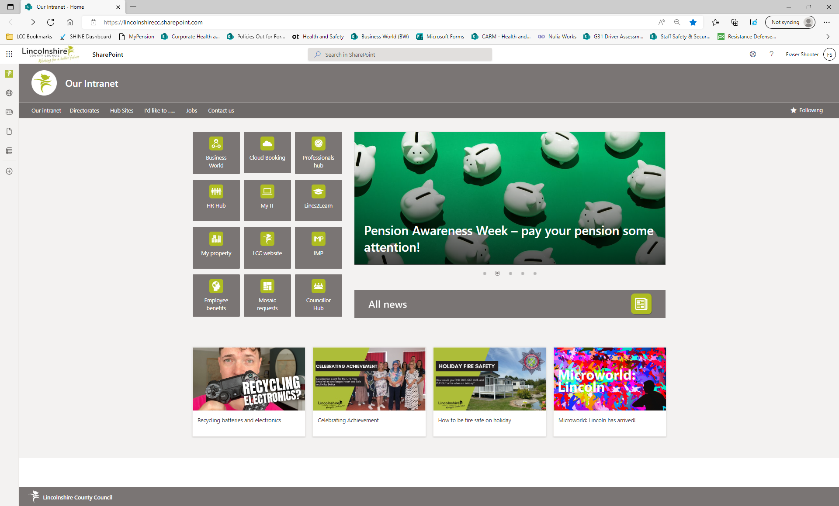
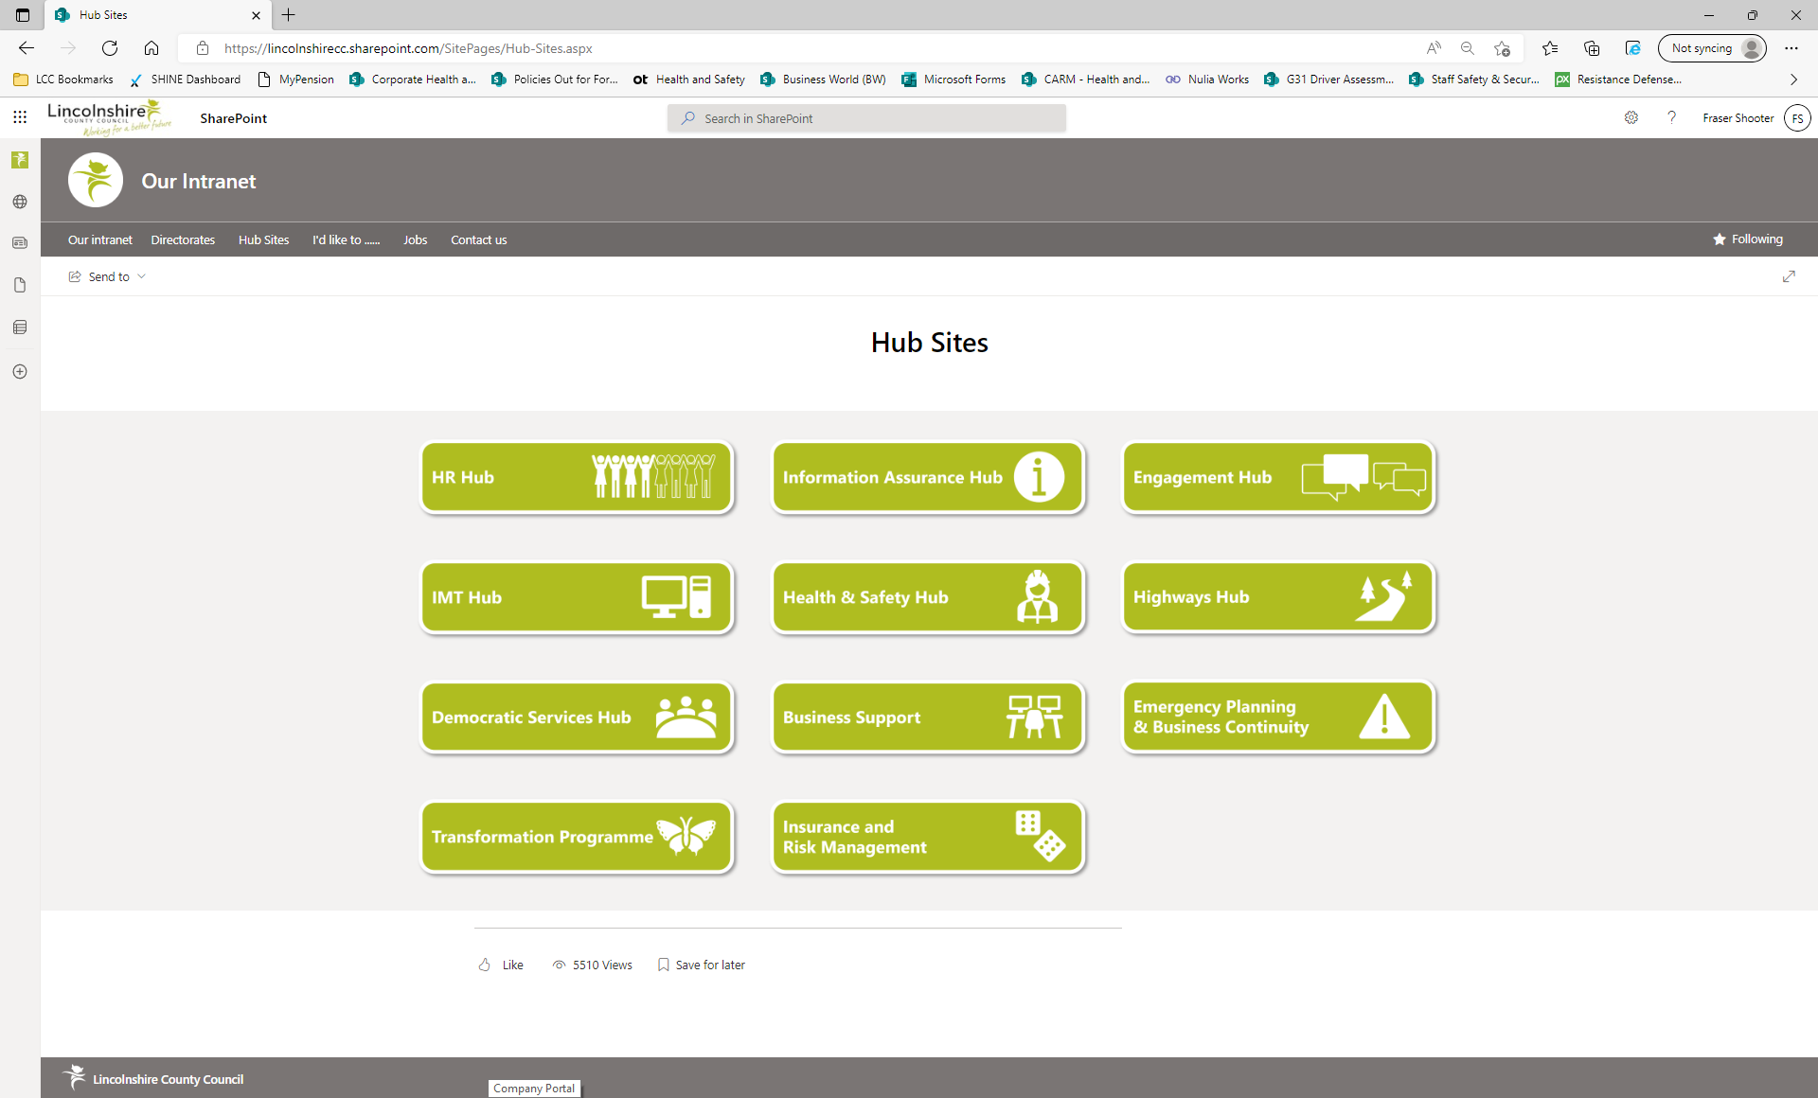
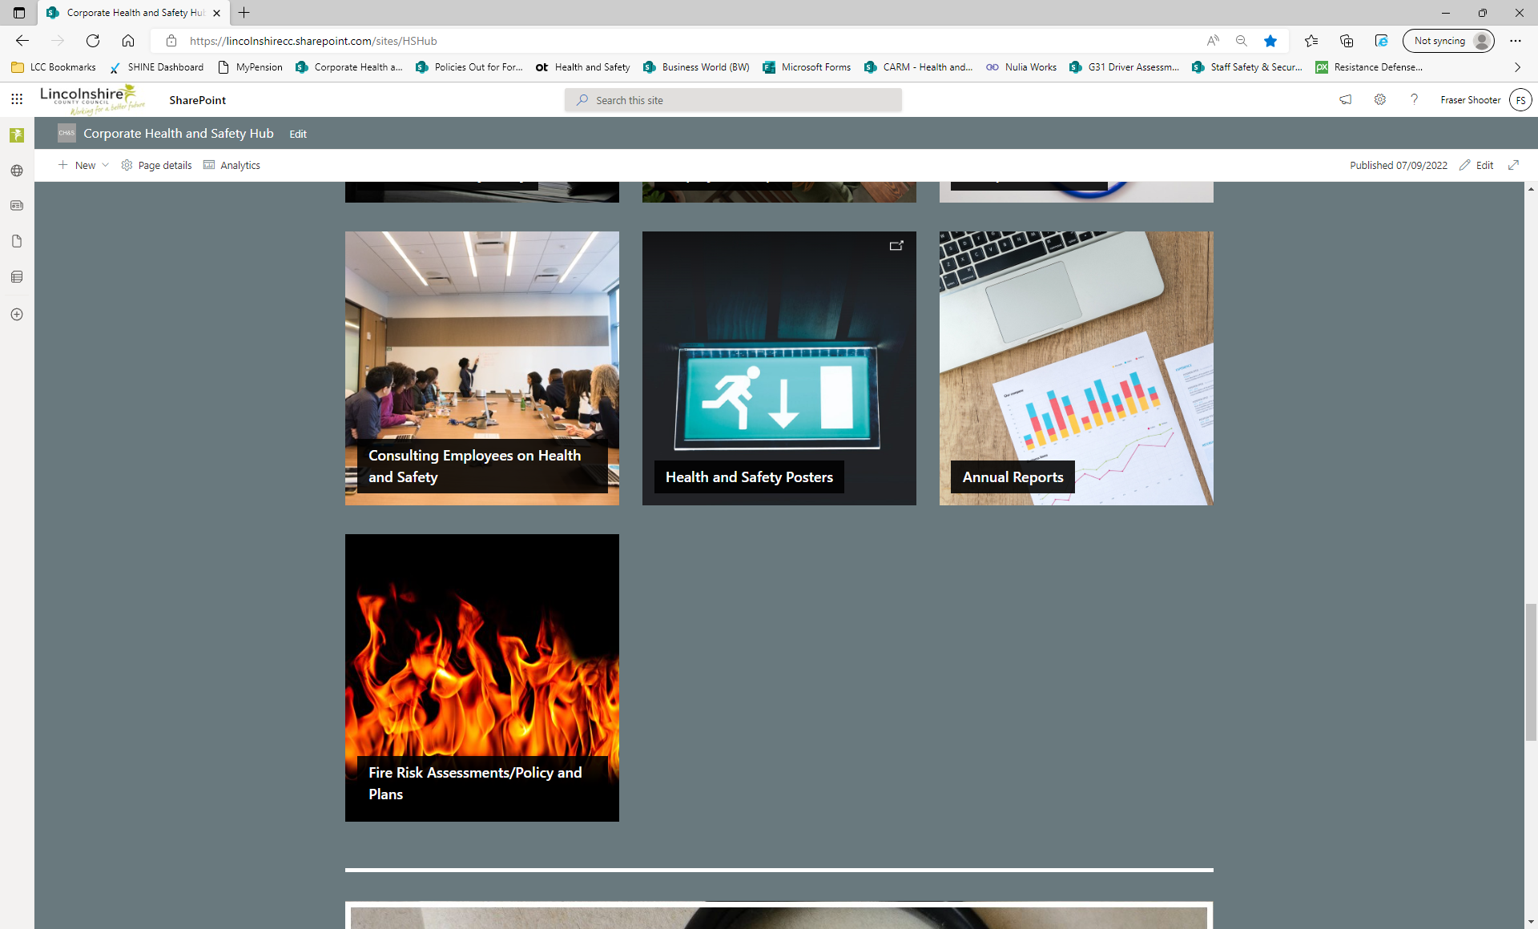

  - First Aid – Information is posted on notice boards around the campus site. Due to Smarter Working its now recommended that everyone completes the basic first aid at work e-learning course. This is accessed via the SHINE system, you will need an account to access it.

Please contact corporatehealthandsafety@lincolnshire.gov.uk to request an account. Guidance on accessing the first aid course, along with other first aid information can be found by clicking here.

- COVID INFORMATION

  - For the latest COVID information, please speak to the Democratic Services Team. General information and guidance can be found in SharePoint by typing 'COVID' into the search box. Information and guidance can also be found using the link below:

Living safely with respiratory infections, including COVID-19 - GOV.UK (www.gov.uk)

- DISPLAY SCREEN EQUIPMENT (DSE)

- It is important to ensure your workstation is set-up correctly to reduce the risk of any long-term health issues. Guidance on how to set-up your workstation correctly, along with lots of other useful information can be found on the links below.

G13 - Display Screen Equipment (sharepoint.com)

12.2 Eye tests and glasses for elected members

We have recently launched a scheme that allows LCC employees to get a free eye test and if required a pair of glasses to wear when using their laptop/tablet. The Specsavers voucher scheme will allow employees to have a DSE eye test - and a £20 discount from their £99 range (for non-DSE specific prescription) or, for DSE specific prescriptions, a free pair of DSE glasses from their £49 range - or a £49 contribution towards frames from their other ranges. This offer is available to elected members and allow you the opportunity to get a DSE eye test and, if required, a pair of DSE glasses.

How to Claim

Please send an email to corporatehealthandsafety@lincolnshire.gov.uk with the subject heading Specsavers Voucher for Elected Member and within the email include:

• Full Name
• Your LCC email address

Your voucher will be emailed to you and can be presented in store on a screen (mobile
phone/tablet) or printed off. It MUST be used within 6 weeks of receiving it, if it’s not used within that period, you will be contacted and given a date when the voucher must be used by. If it’s not used by that date, your voucher may be cancelled, and you'll need to re-request a new voucher.

Please note: Some stores require a ‘printed’ version of the voucher, where this is the case, you can forward the email to the store email address for them to print off.

Getting an eye test

Specsavers have hundreds of stores nationwide and the voucher can be redeemed in any of their stores. To see where your nearest store is, click here to use the Store Locator Tool.

- DUTIES AND RESPONSIBILITIES OF AN ELECTED MEMBER

  - What’s My Role?

As an Elected Member, you have a responsibility for ensuring Health & Safety within the Authority. This section provides some prompts to help you think through the issues you may need to consider on Health & Safety.

The role of Lincolnshire County Council in Health & Safety is:

- As a major employer, we have a responsibility that our senior managers are ensuring the Health & Safety of employees and those affected by the services we provide.

- We purchase many services from other organisations and have an opportunity to influence Health & Safety standards within these suppliers.

As an Elected Member you are NOT responsible for managing Health & Safety on a day-to-day basis – this is the duty of officers in charge of services. But it’s important you understand the strategic way you can and do affect Health & Safety via your action and decisions and your potential liabilities – both criminal and civil law.

Because of the influence you have on budgets and policy decision, you can affect how Health & Safety is managed. The Executive have both individual and collective governance responsibilities, and if you have Health & Safety as a specific part of your portfolio, you’ll need to act as a ‘champion’ and lead in this area. This means ensuring that Health & Safety policies and objectives are implemented, and that the Council has access to competent Health & Safety advice.

Having a Health & Safety ‘champion’ doesn’t diminish the responsibilities of others at this level – everyone has a duty under both common law and the Health & Safety at Work Act. You may be held personally liable if your failure or gross negligence means the Council commits an offence or causes death.

  - What do we do?

- The Council has a Health & Safety Policy Statement which outlines the commitment to health & safety, along with a Health & Safety HUB which contains detailed policies, procedures and guidance for all levels of staff.
- We have a Corporate Risk & Safety Steering Group where Senior Managers and Directorate Health & Safety leads meet to discuss strategy and key objectives.
- An Annual Health & Safety Report is produced, highlighting key objectives, performance and accident statistics.
- We have an internal Corporate Health & Safety Team that provides competent advice.

  - What do you need to do?

- Ensure an elected member is given responsibility for Health & Safety.
- Provide scrutiny of the Council’s Health & Safety performance by:
- Oversight of strategy and budgets.
- Looking for trends and patterns that require action.
- Evaluating the effects of key decisions.
- Attend relevant training, read relevant guidance and ensure you understand and comply with it.
- Don’t put your own health, safety and welfare at risk
Source: IOSH: Think About Safety leaflet.

14.0 REFERENCES & FURTHER INFORMATION

In compiling this Guidance Note, the following documents have been referred to:

LCC Corporate Health and Safety HUB
HSE: Guidance leaflet INDG73 Working alone in safety
HSE: Guidance Leaflet INDG69 (rev) Violence at work – a guide for employers

