# EduLincs order process – Specialist Teaching Team Annual Hours

Please note that, whilst this guide is for the Specialist Teaching Team Annual Hours offer, the general EduLincs ordering process is broadly similar for the majority of offers.

## Requesting information/placing an order

1. Access the EduLincs home page at <https://www.lincolnshire.gov.uk/school-pupil-support/edulincs>

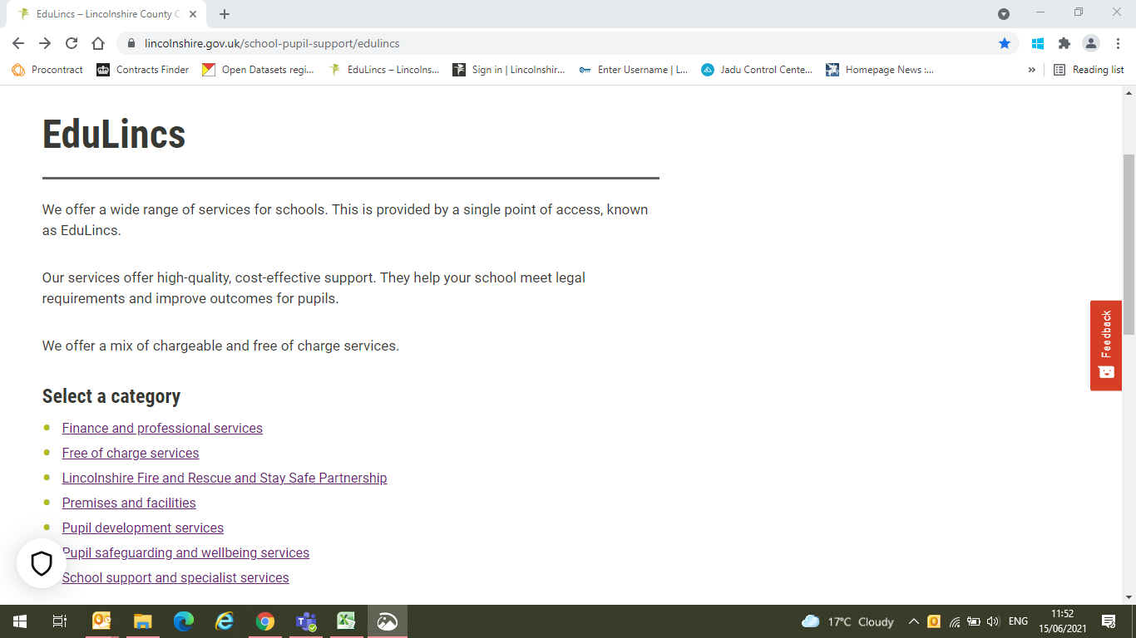

2. To access the Specialist Teaching Team page, click on the **School support and specialist services** hyperlink.

The various categories of EduLincs offers can be found on the left hand side of the homepage.

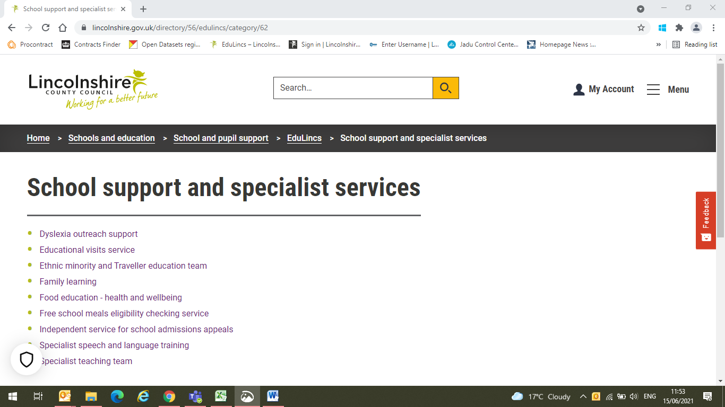

3. To access the Specialist Teaching Team offers, click on the **Specialist teaching team** hyperlink.

4. The Specialist Teaching Team page is shown below. It contains information about the Team and the services that they offer.

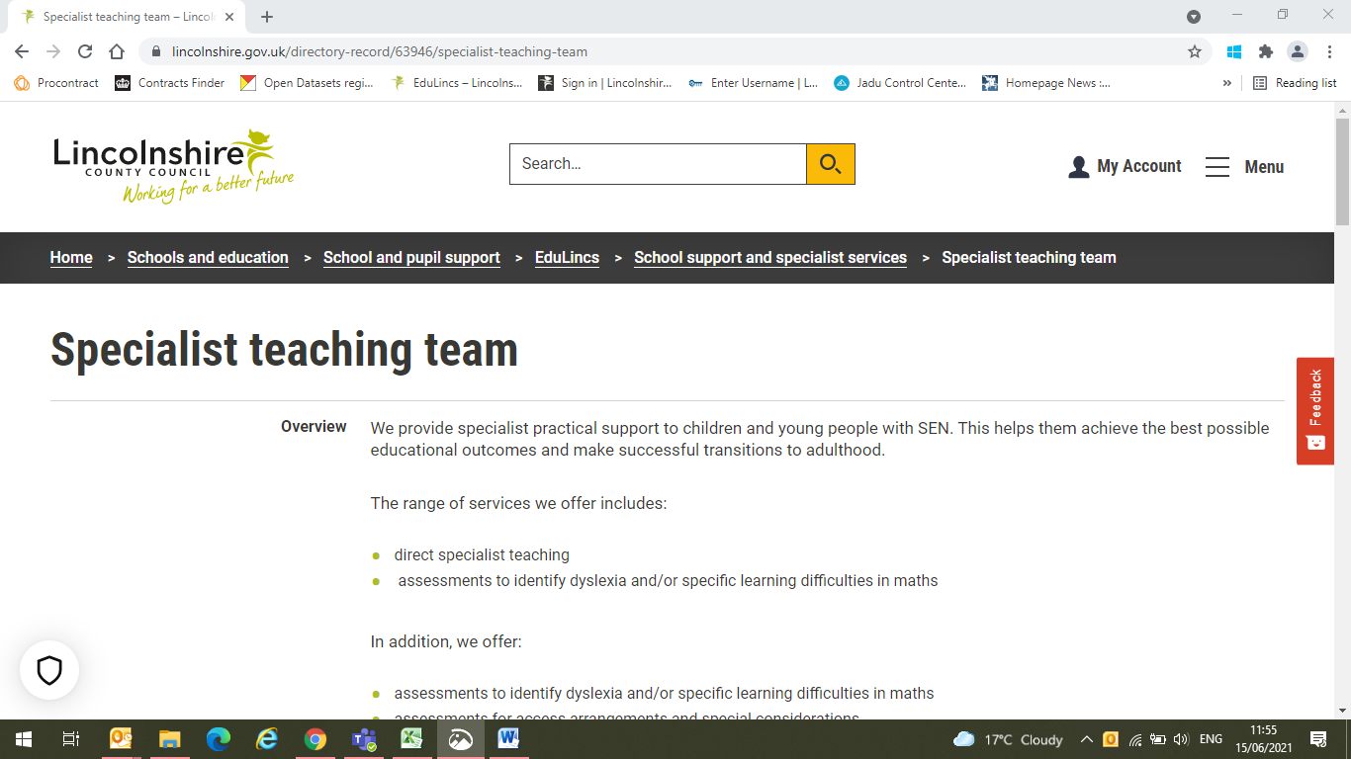

5. Scroll down to the bottom of the Specialist Teaching Team page and click on the yellow **Apply now** button to request information or place an order.

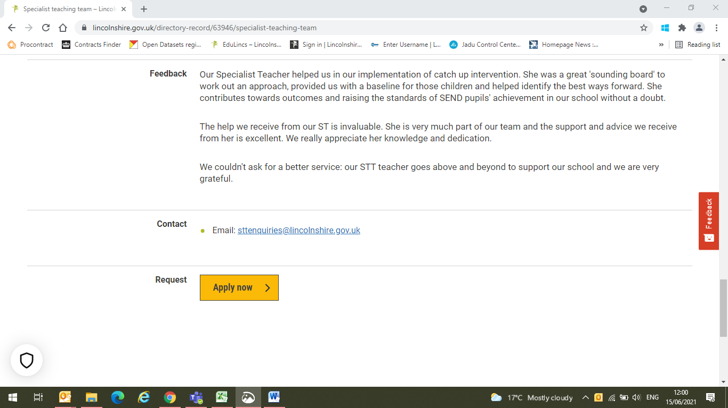

**Apply now** button.

6. You will need to enter the EduLincs passphrase in order to progress with your request or order. The passphrase, which is case and space sensitive, is **Educational Settings**.

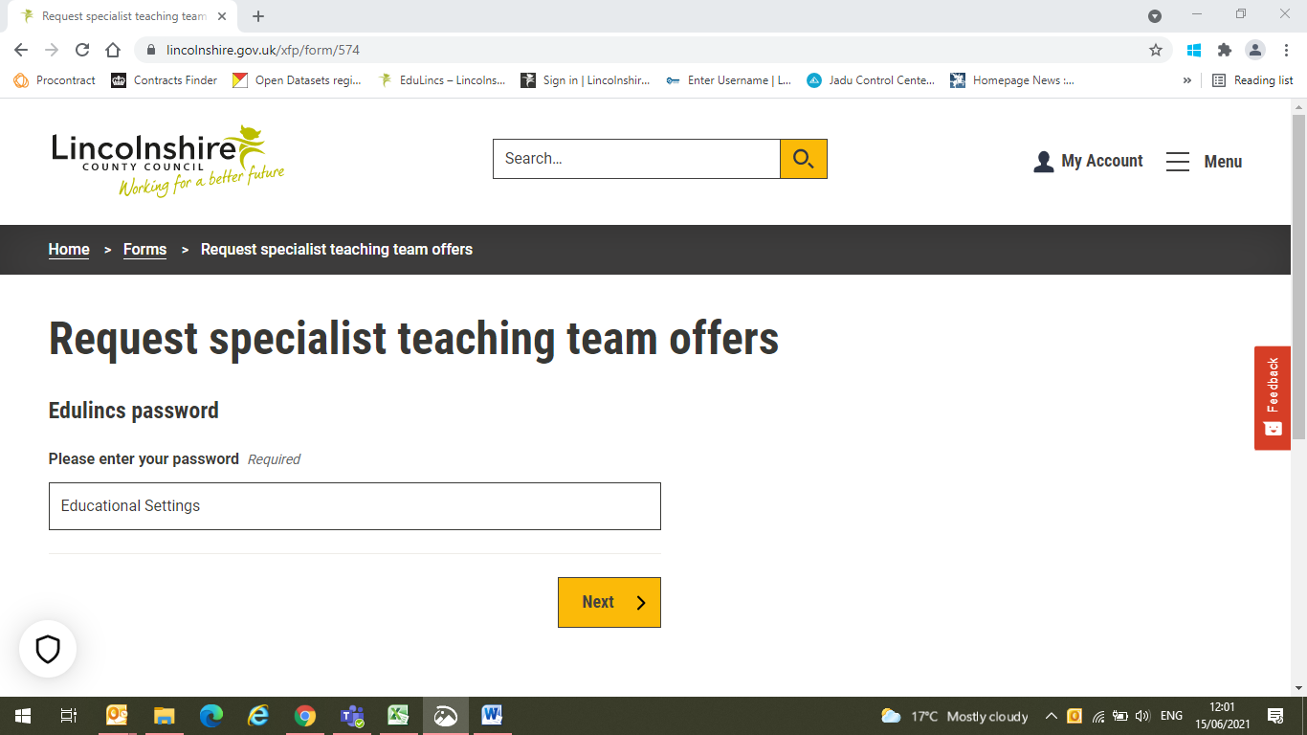

7. Click on the **Next** button to proceed

Enter the EduLincs passphrase here

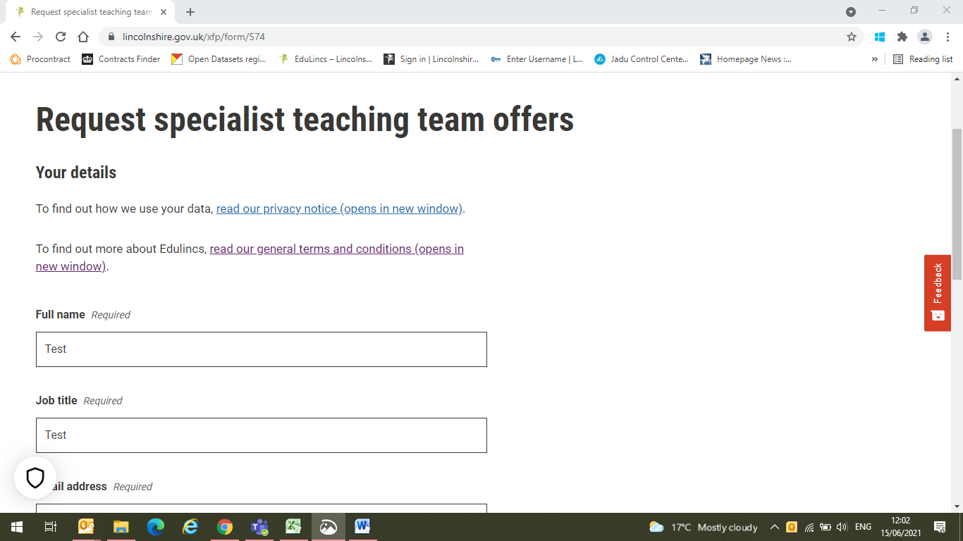

8. Begin to enter your details here, scrolling down as you go.

You can read the EduLincs privacy notice and general terms and conditions here

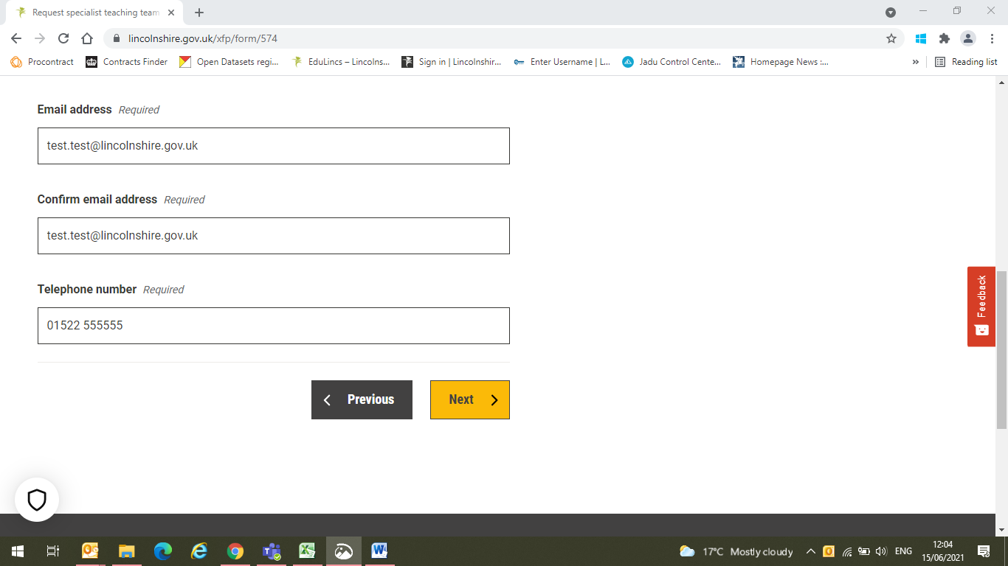

9. Click on **Next** to continue.

8 continued. This is the same screen as the one directly above. Carry on entering your details.

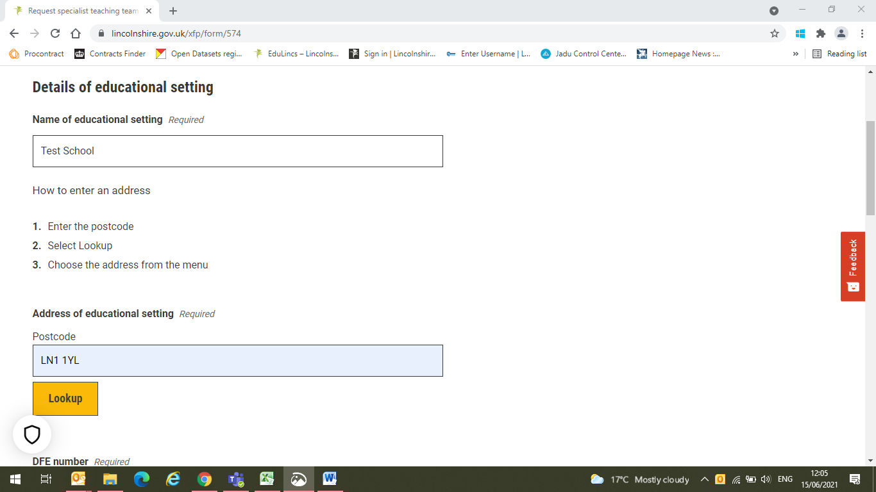

11. To select the address of your school, enter the postcode and then click on the **Lookup** button.

See the screenshot immediately below for the next step.

10. Enter your school name.

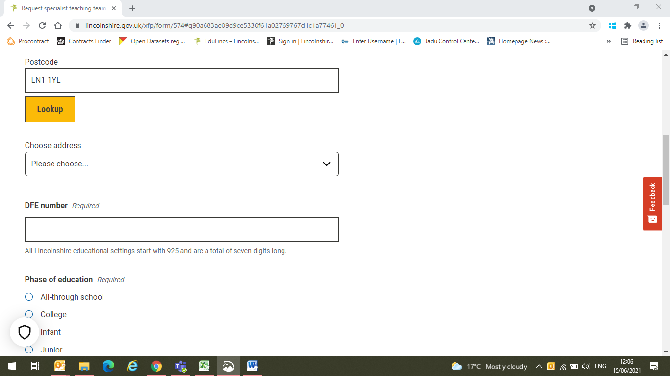

13. Enter your **DfE number**.

12. When you click on the Lookup button, a new **Choose address** box will appear. Select the address of your school.

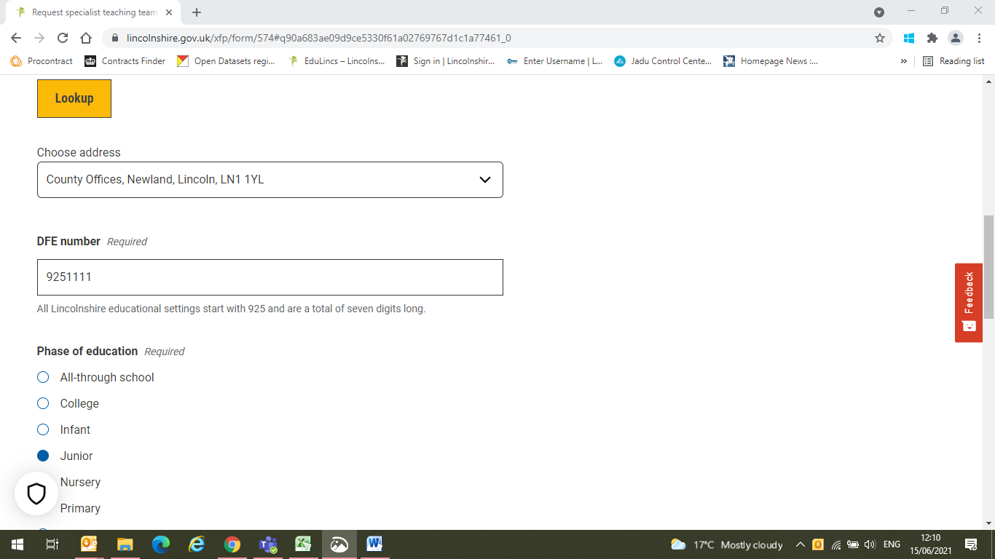

14. Enter the **Phase of education** of your school

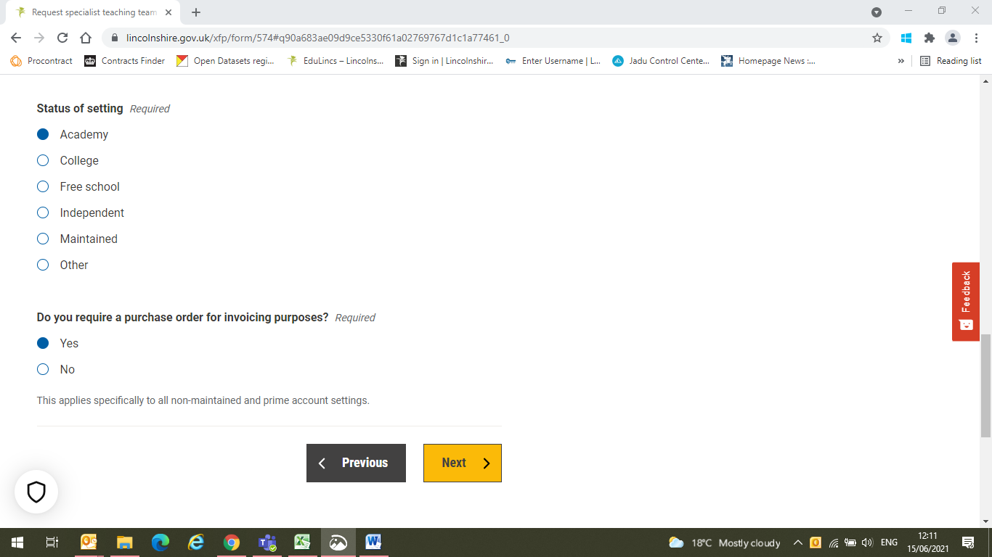

17. Click **Next** to proceed.

16. Select whether or not you require a purchase order for invoicing purposes.

**Note** – this applies specifically to non-maintained and prime account schools. A journal transaction will be used for all maintained settings.

15. Select the **Status of your school**

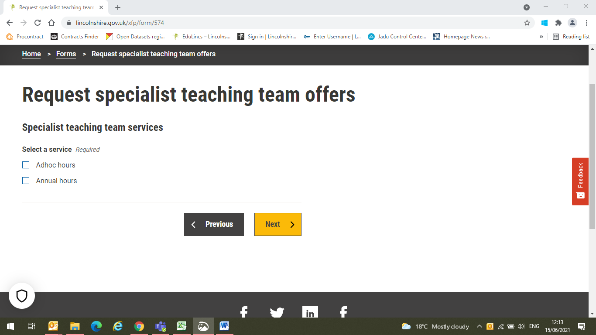

18. Select the service you require. For this example, select **Annual hours**. When you select Annual hours, further options appear on the same screen, see the screenshot below.

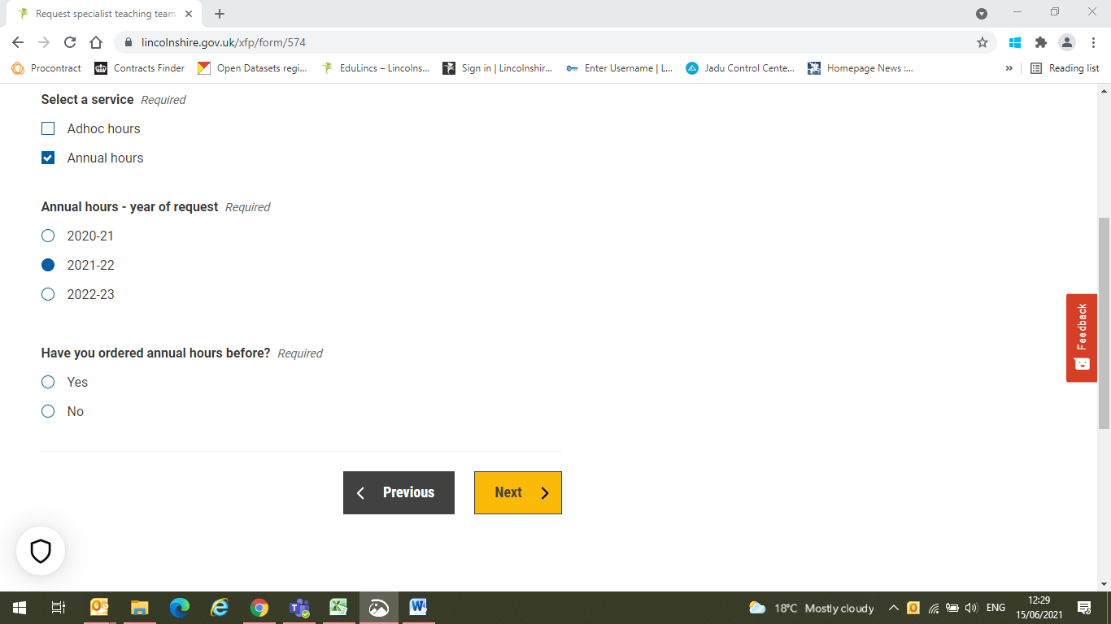

19. Select the **year of request**.

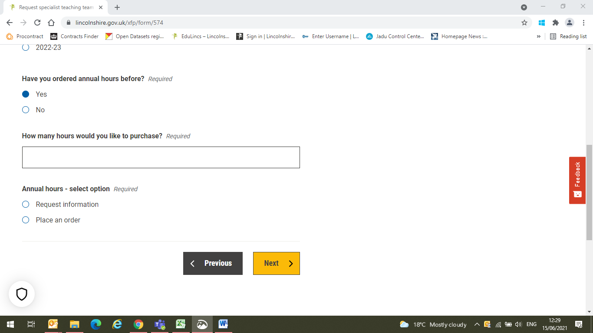

20. **Have you ordered annual hours before?** You can select either **Yes** or **No**, depending on the answer.

We will look at both options. Steps 21 and 22 below cover the 'Yes' option, step 23 addresses the 'No' option.

21. When you select 'Yes', the **How many hours would you like to purchase?** box appears. Enter the number of hours you would like to order.

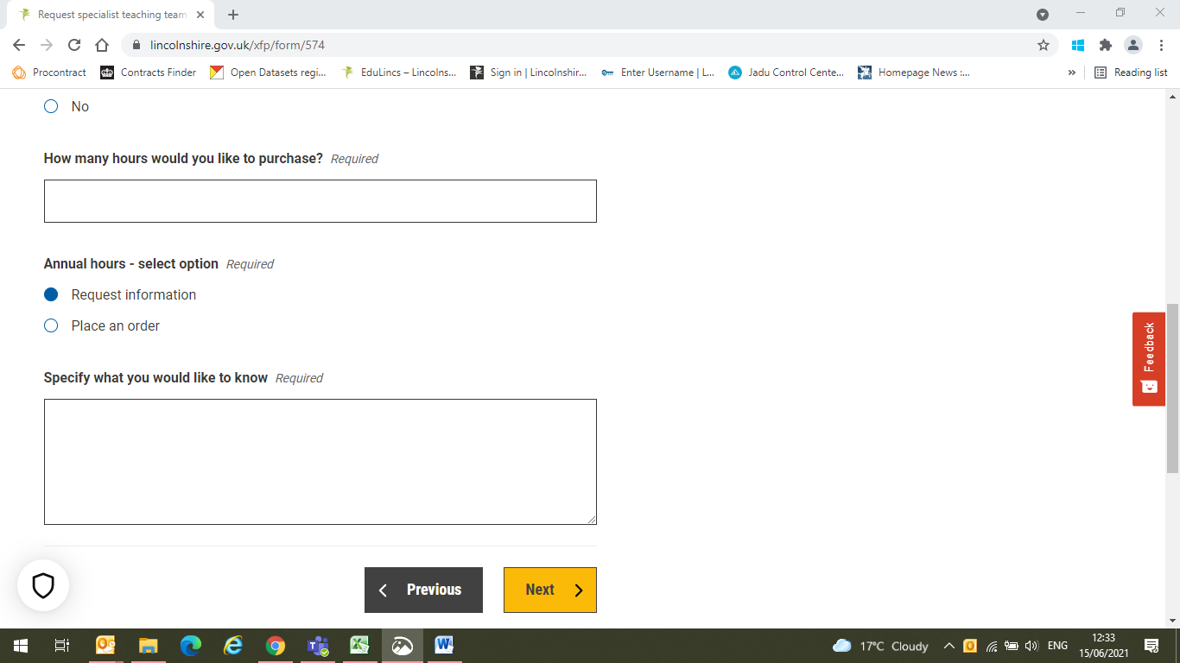

22. Select an option under **Annual hours – select option**.

If you select **Place an order**, you can then click **Next** to go to the next screen.

If you select **Request information**, the **Specify what you would like to know** box appears. Enter in here what it is you want to know.

Then click **Next** to proceed.

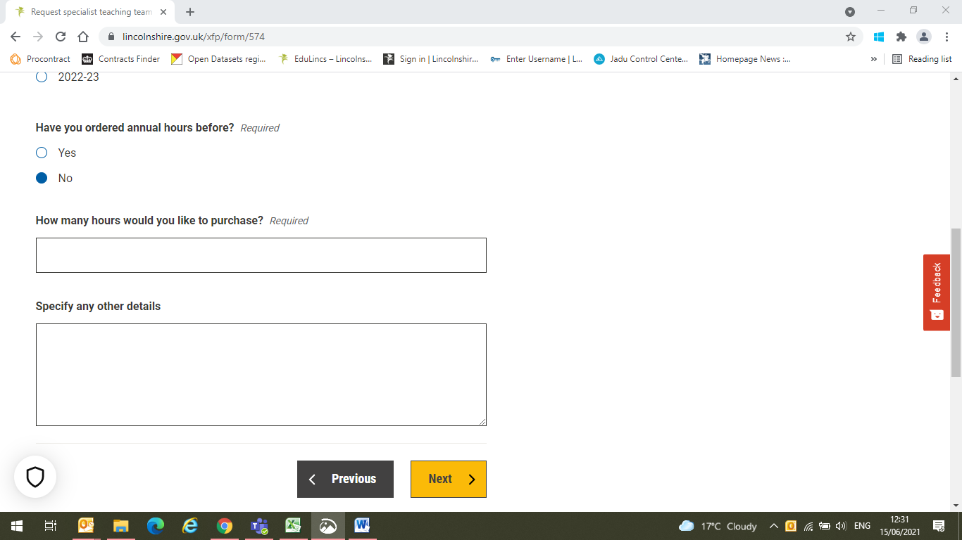

23. Going back to step 20, if you answer **No**, the **How many hours would you like to purchase?** and **Specify any other details** boxes appear.

Complete these boxes as appropriate and click **Next**. Note: You will be contacted to discuss your requirements.

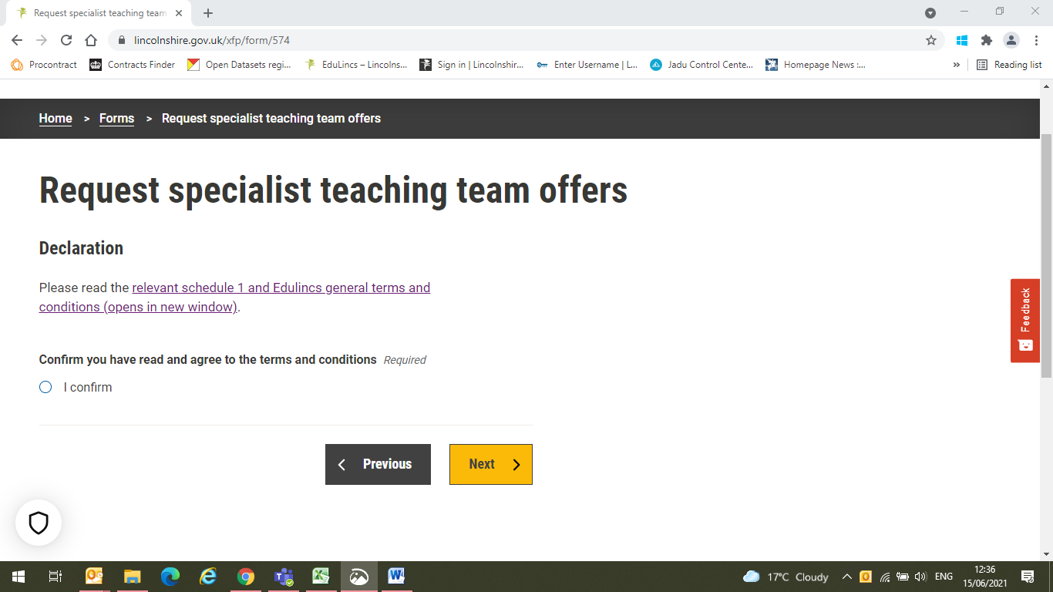

25. Confirm that you have read them by clicking on the **I confirm** button and click on **Next**

24. Please read the **Schedule 1** (terms and conditions specific to the Specialist Teaching Team) and the **EduLincs general terms and conditions**.

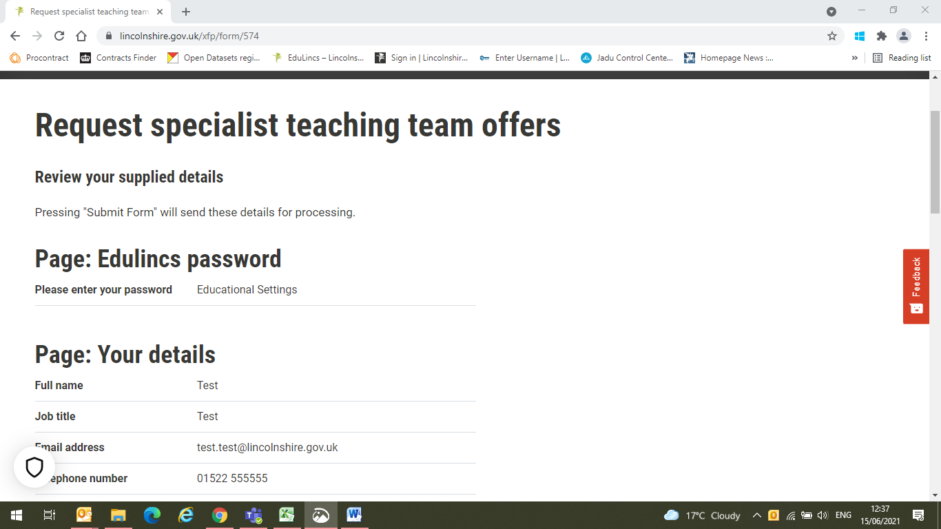

26. You can review your order before submitting it. Read through your submission to make sure your order is correct. If you want to make any changes to your order you can click on the **Previous** button to revisit pages where a change needs to be made.

**Do not use the 'back button'** at the top left of the screen – this will take you right back to the start of the process!

If you are happy with your order, click on the **Submit Form** button.

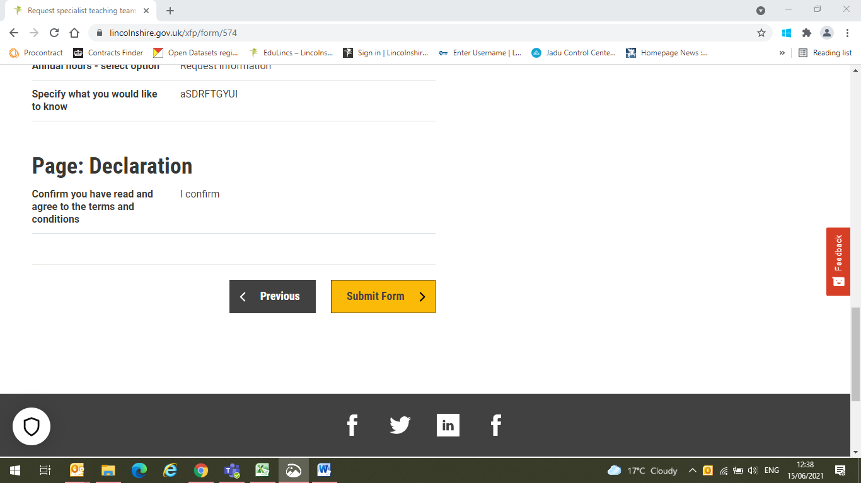



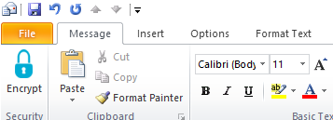

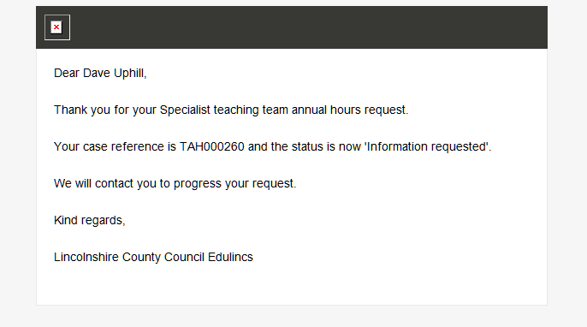

27. Once you have **submitted your order** or **request for information**, you will be sent an acknowledgement email like this one (if you have **placed an order** the wording will be '...and the status is now 'Order requested').

If you **requested information** go to step **28**.

If you **placed an order** please go to step **34**.

## Response to information request

29. If you wish to continue with the order, click on the 'place an order' hyperlink.

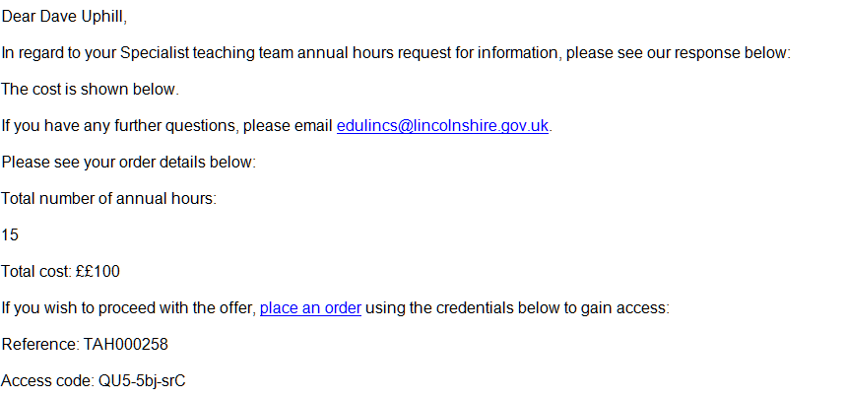

28. In response to your request for information, you will receive an email like the one shown here, with the information requested provided for you.

Please note we aim to respond to requests within 2 working days.

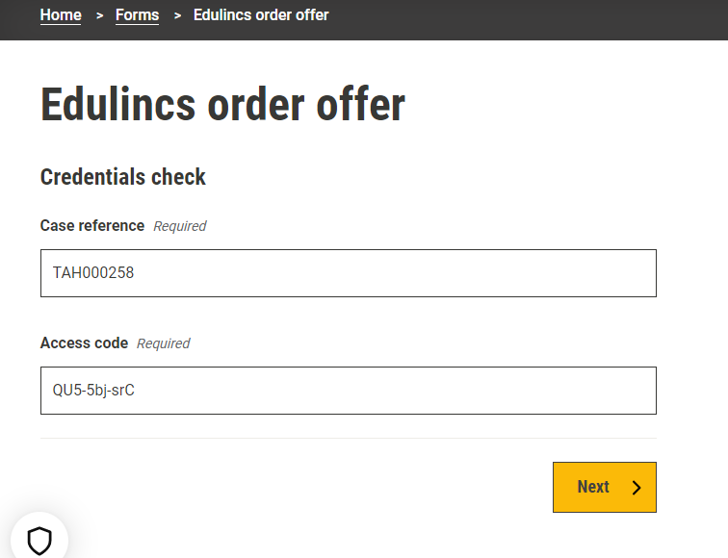

30. Placing an order takes you to this screen. Enter the **Case Reference** and **Access code** from step 29 and click **Next**.

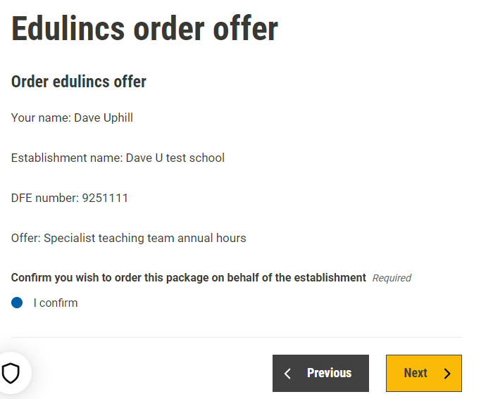

31. Check your details, confirm that **you wish to order the package** (this is required) and click on **Next** to proceed.

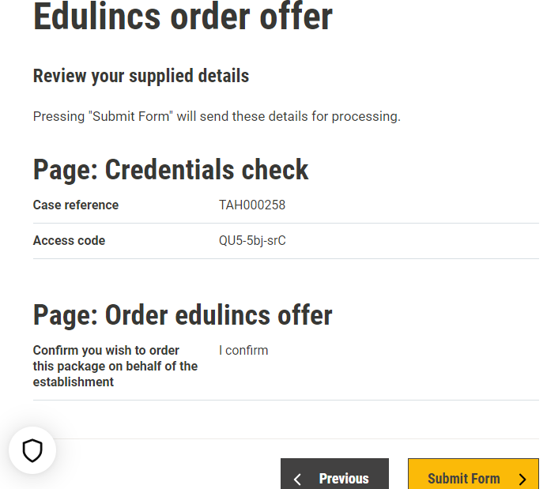

32. Click **Submit Form** to confirm your order

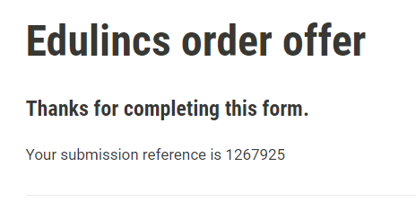

33. This screen shows the confirmation that you will receive, together with your **submission reference**.

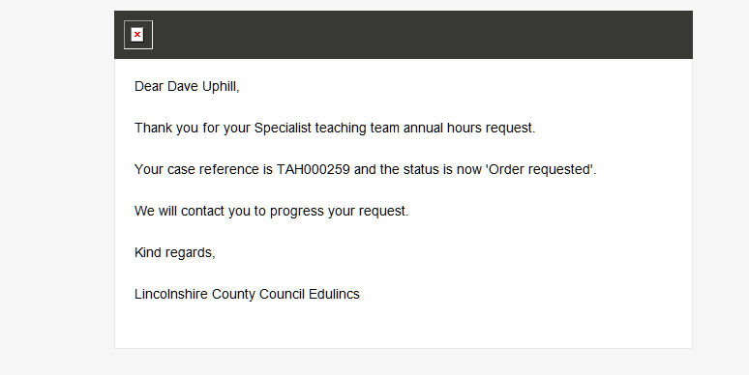

34. Once you have submitted your order you will be sent an **acknowledgement email** like this one.

## Signing the EduLincs order form

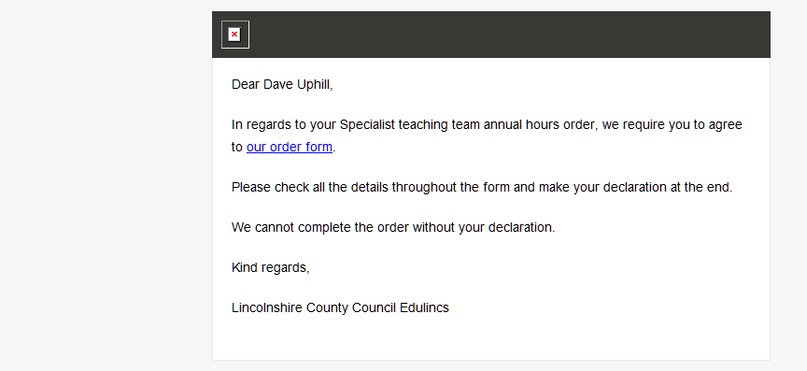

35. Within 2 days of submitting your order, you will receive another email from EduLincs, this time requesting you to agree to and sign the EduLincs **order form** (the order cannot be completed without your agreement).

Click on our order form **hyperlink** to begin.

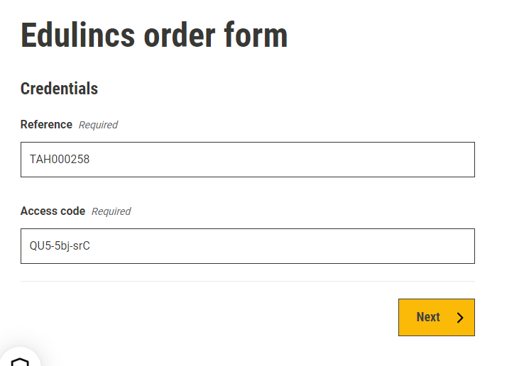

These details are prefilled.

36a. It is **important** that you check the details on the form before signing and submitting the form.

Click **Next** to continue.

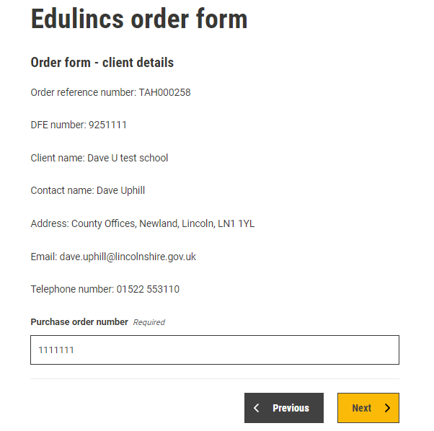

36b. Continue checking your supplied details, clicking **Next** again to continue.

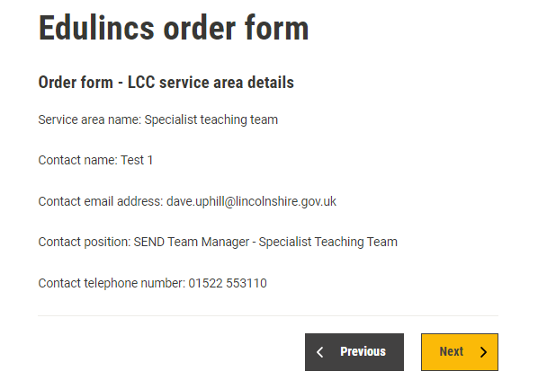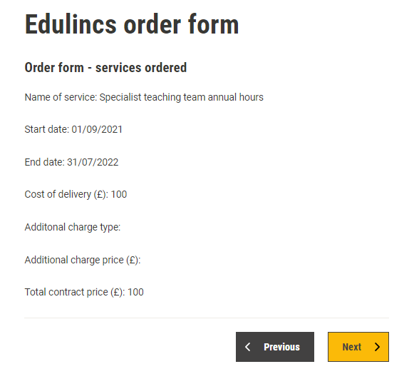

36d. Continue checking the order details, clicking **Next** once more to continue. N.B. Please ignore the dates on this example as STT annual hours can only be purchased between 01/04 and 31/3 each year.

36c. Continue checking the order details, clicking **Next** again to continue.

37. At this stage of the process, you are asked to 'sign' the order form, read and agree to the **Terms and Conditions**, agree to LCC undertaking delivery of the service(s) ordered and accept the **contract** between your school and LCC.

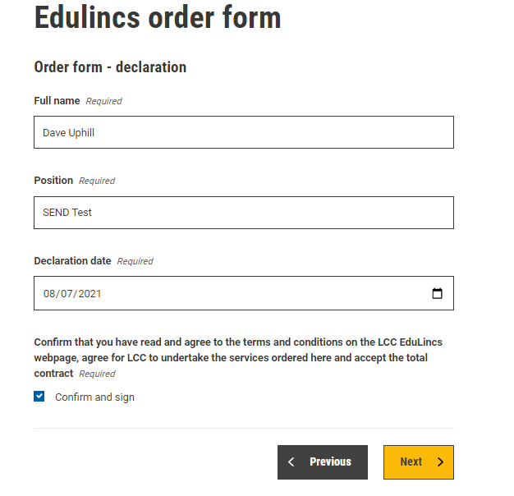

Date of declaration. This is prefilled.

Enter your details.

Click **Next** to proceed.

Tick the box to confirm the order.

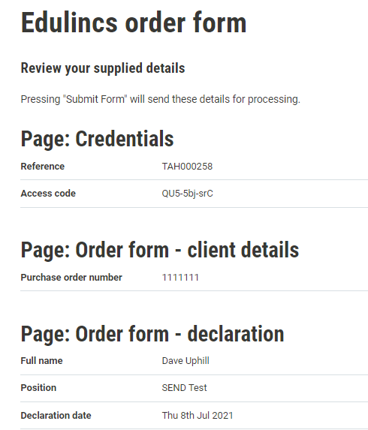

38. You have one final opportunity to check your details.

Click on **Submit Form** if you are happy that the details are correct.

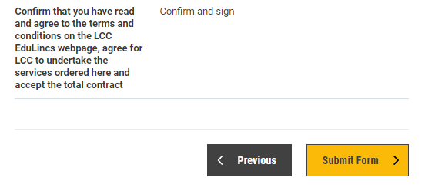

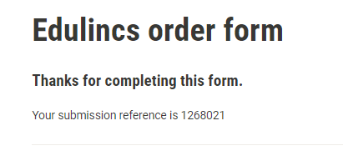

39. You will receive confirmation that the form has been completed and a **submission reference**.

40. EduLincs will sign your order and return it to you via email for your records.

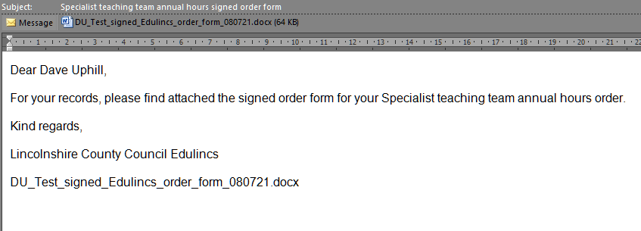

Attached **signed order form** for your records